# Linux

## **How to deploy war file into tomcat**

Copy the war into var/lib/tomcat/webapps or usr/share/tomcat/webapps

Go to url ur-IP:8080/nigga.war

## **Why i deploy my application in tomcat successfully but when u start it , it shows binding issues , what may be the problem**

java.net.BindException: Address already in use: JVM_Bind :80

means that another application is listening on port 80.

You can check which process is using this port by lsof command, e.g. sudo lsof -i:80.

Then stop or kill it.

#netstat -a -o | findstr :8080

Or

#netstat -pant | grep "8080"

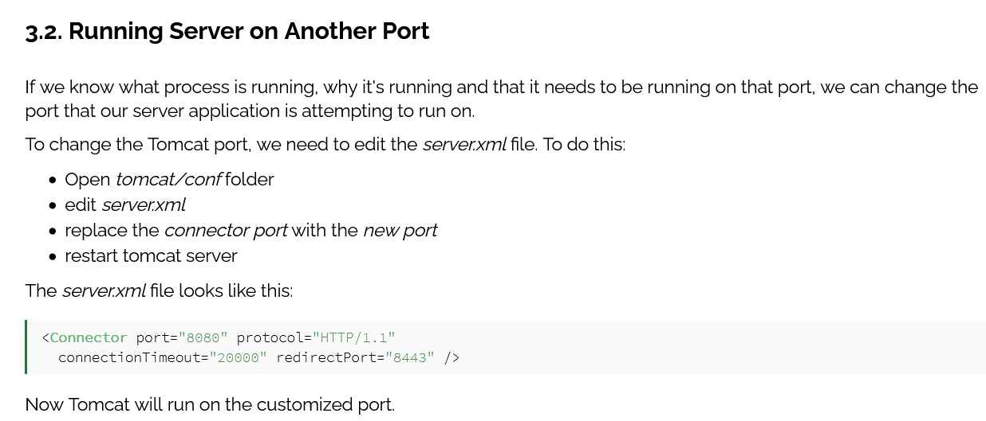

## **Location of tomcat logs , name those different logs**

Just got to your tomcat installation directory and then go into logs directory

# cd /tomcat_installation_dir/logs

Main log file is Catalina.out

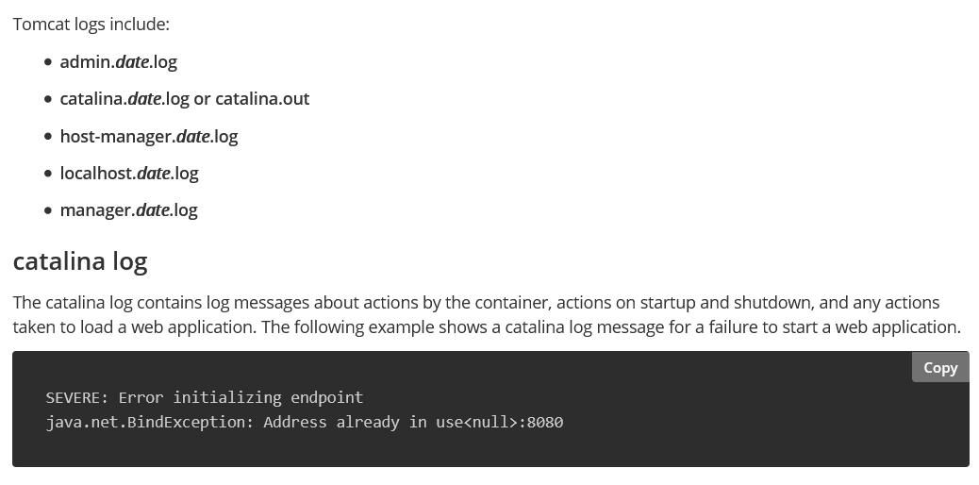

## **Explain LVM architecture and components**

**Logical Volume** Management enables the combining of multiple individual hard drives and/or disk partitions into a single volume group (VG). That volume group can then be subdivided into logical volumes (LV) or used as a single large volume.

ELI5 version

you have a few separate warehouses. you advertise them as single warehouse of total capacity of all those warehouses together. "i have this much of shelf space in my warehouse". some of them are big, some are small, some are closer, some are farther away.

someone wants to rent some storage space - you check if you have that many space and say "OK". some of it might be in warehouse 1, some of it in warehouse 2. you keep track of it, client is happy.

at some point, you buy another warehouse. you add it to your entire storage pool. clients see no changes. they can access their stuff as they usually do. you just advertise more maximum storage space.

what you see - a bunch of warehouses

what you present to client - summed up shelf space

what client gets - a chunk of that space

where does it physically go - some may be in warehouse 1, some in another one. depends on your storage policy.

that is the gist of it. there are more advanced topics in lvm for which this example is inadequate.

Here warehouse refers to Hard drive partitions

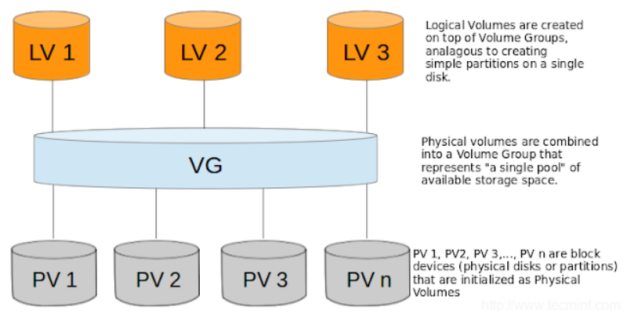

## **Local dns entry of IP address in linux**

The /**etc**/**hosts file** contains a mapping of IP addresses to URLs. Your browser **uses** entries in the /**etc**/**hosts file** to override the IP-address-to-URL mapping returned by a DNS server.

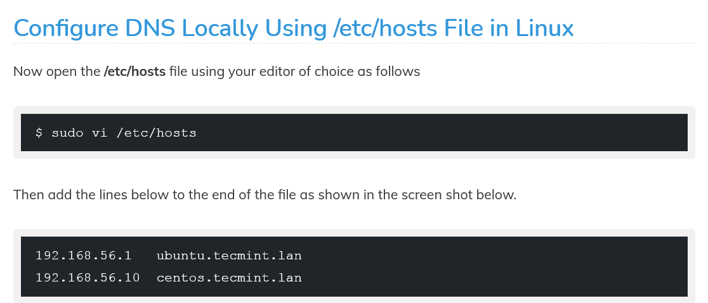

1if u add this to the host file

27.0.0.1 nigga.com

So when u type nigga.com on ur url , it will ping to ur localhost instead of real nigga.com

## **What is nsswitch file in linux**

The /etc/**nsswitch**. **conf file** is **used** to configure which services are to be **used** to determine information such as hostnames, password **files**, and group **files**.

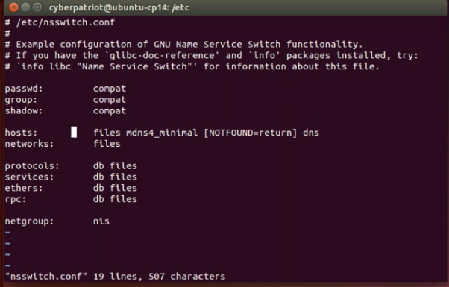

Basically it says in what order ur linux os use the name name resolution

. By default it will check etc/hosts file , then local nameserver (if running) and then dns .

So if u type nigga.com in url it will first check etc/hosts , if not found it will go to ur isp’s dns. You can override it to first go to ur ISP’s dns by writing dns first .



## **What is chroot jail in linux , what is jail directory structure**

A chroot jail is a way to isolate a process and its children from the rest of the system. It should only be used for processes that don't run as root, as root users can break out of the jail very easily.

The idea is that you create a directory tree where you copy or link in all the system files needed for a process to run. You then use the chroot() system call to change the root directory to be at the base of this new tree and start the process running in that chroot'd environment. Since it can't actually reference paths outside the modified root, it can't perform operations (read/write etc.) maliciously on those locations.

For example, I would like to check the operation of some bash script without running it for real on my desktop (since I don't want my desktop system messed up)

Just create a directory and copy all the folders into it like /bin , /etc /lib etc

For more info , go to this link

<https://linuxhint.com/setup-linux-chroot-jails/>

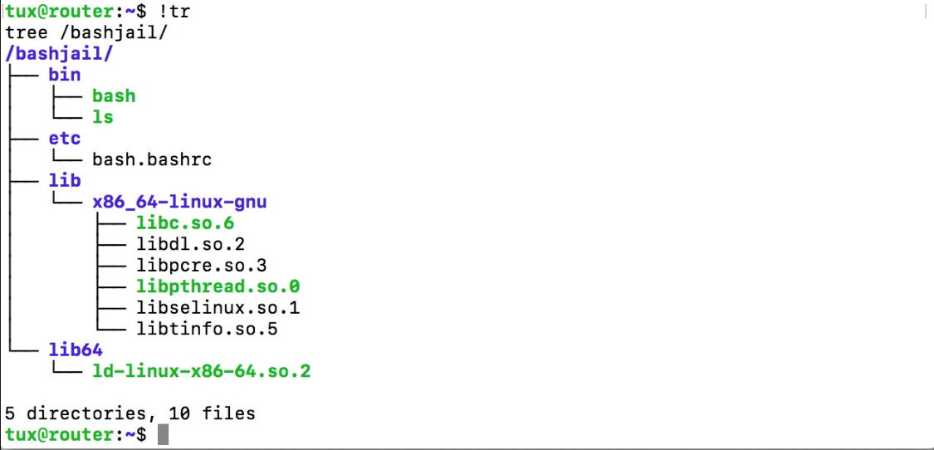

## **How to change home directory of user in linux**

#usermod -d /path/to/dir username

Or

You need to edit the /etc/passwd file to change home directory of users that are currently logged in.

## **Ext2 and ext3 file system**

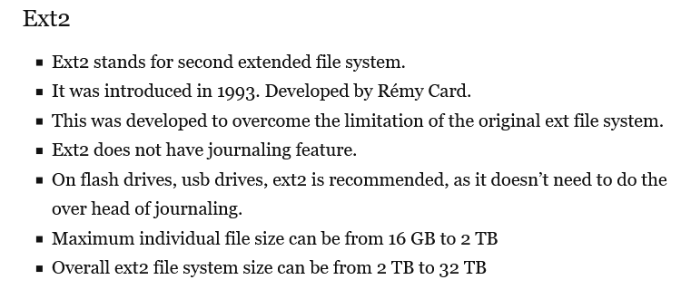

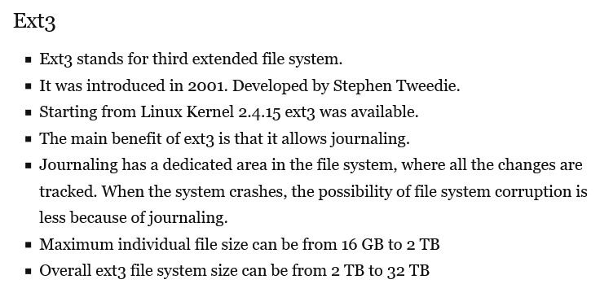

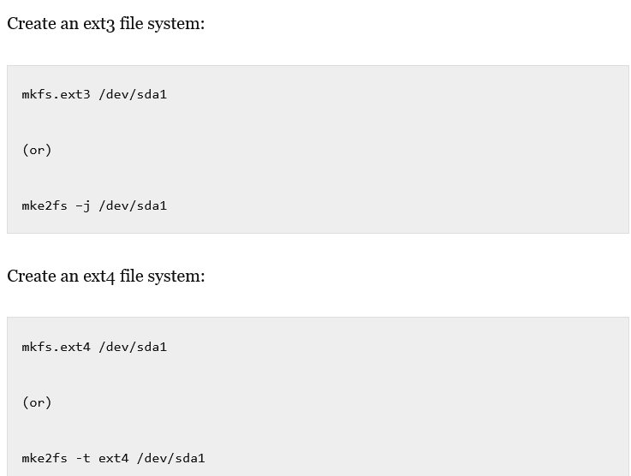

## **What is inodes**

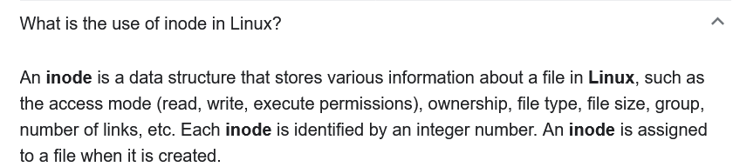

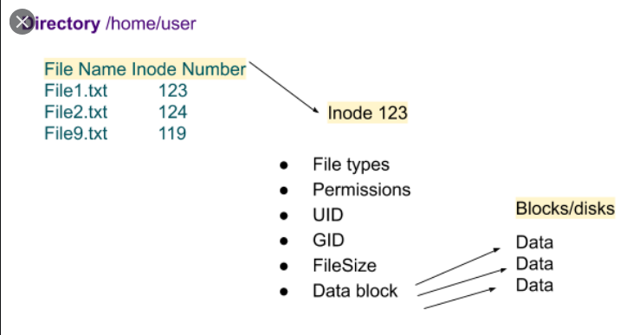

## **How ansible works**

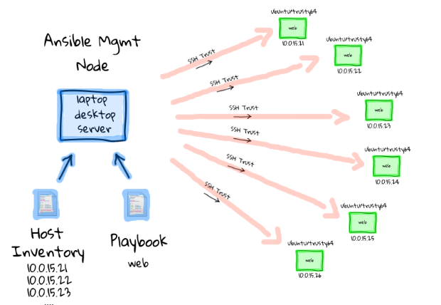

## **How to do passwordless authentication in linux**

1. Generate a ssh key pair

$ ssh-keygen

1. Copy the public key

$ssh-copy-id remote-user@remote-server-ip

1. Login to your server using SSH keys

$ssh remote_user@remote_ip_address

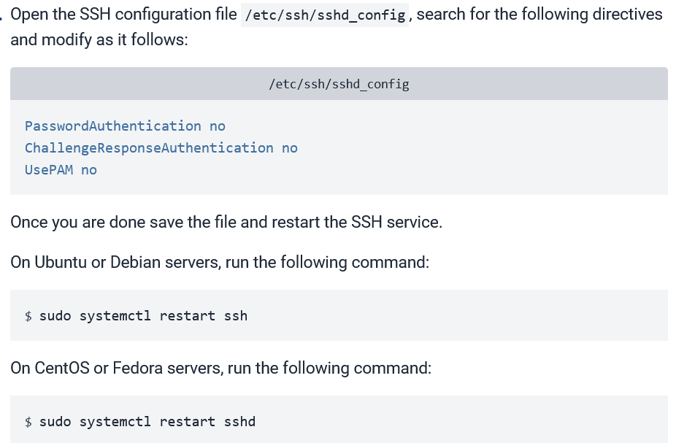

## **How to redirect a output of a command as string to a particular text file**

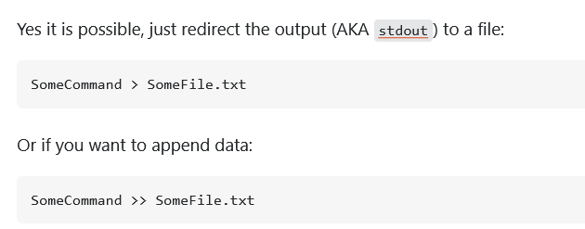

## **Diff  between ctrl+c and ctrl+z**

ctrl c is used to kill a process. It terminates your program.

The ctrl-z sequence suspends the current process . Basically it pauses ur program. Your program is in background. You can restart your program from that point where you used ctrl z using $ fg command.

<https://askubuntu.com/questions/510811/what-is-the-difference-between-ctrl-z-and-ctrl-c-in-the-terminal>

## **What is a mount point , how to write /etc/fstab file ,**

In simple words a mount point is a directory to access your data (files and folders) which is stored in your disks.

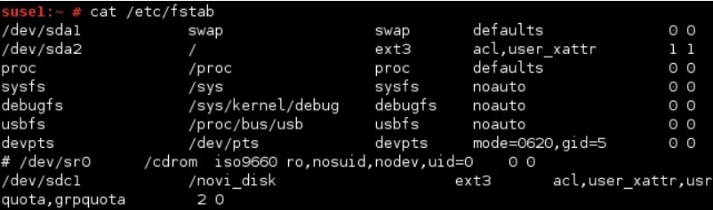

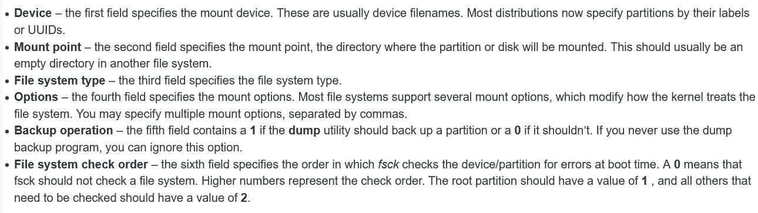

## **Diff between shared and private mount points**

## **Where logs are stored in a linux**

Linux has a special directory for storing logs called /var/log . This directory contains logs from the OS itself, services, and various applications running on the system.

## **Explain tail command**

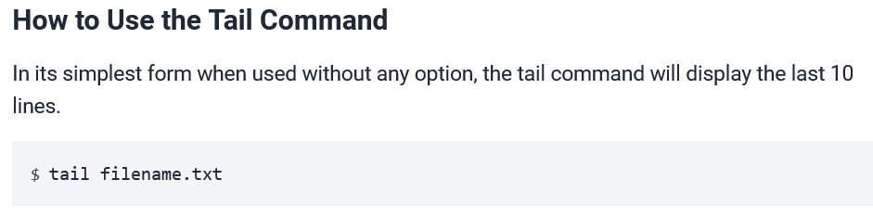

For more info go here <https://www.howtogeek.com/481766/how-to-use-the-tail-command-on-linux/>

## **How to check version of a software in linux also how to check os version and stuffs**

$ firefox --version

$ uname -a

## **How to mount a file system using mount command and etc/fstab**

#mkdir /mnt/oracle

# mount /dev/sdc1 /mnt/oracle (temporary mount)

# vim /etc/fstab

/dev/sdc1 /mnt/oracle xfs defaults 0 0

Esc+:+wq!

# mount -a (permanent mount)

## **How to find no of users in linux and how many users are logged in at a particular time**

$ w

W command is used to find no of users

-h Ignore the header information

-u Display the load average (uptime output)

-s Remove the JCPU, PCPU, and login time.

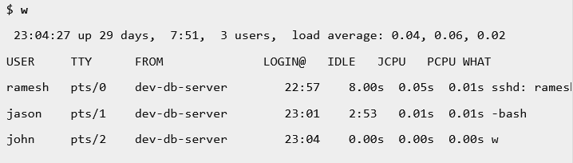

## **Ssh keygen command explain**

1. Generate a ssh key pair

$ ssh-keygen

2. Copy the public key

$ssh-copy-id remote-user@remote-server-ip

3. Login to your server using SSH keys

$ssh remote_user@remote_ip_address

## **Ssh-copy-id and scp command**

$scp file.txt [remote_username@10.10.0.2:/remote/directory](mailto:remote_username@10.10.0.2:/remote/directory)

$scp remote_username@10.10.0.2:/remote/file.txt /local/directory

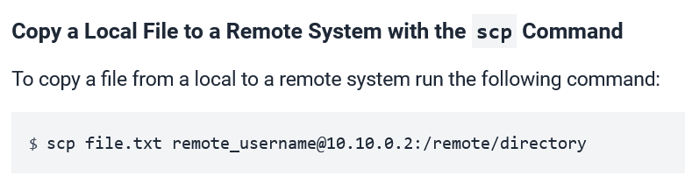

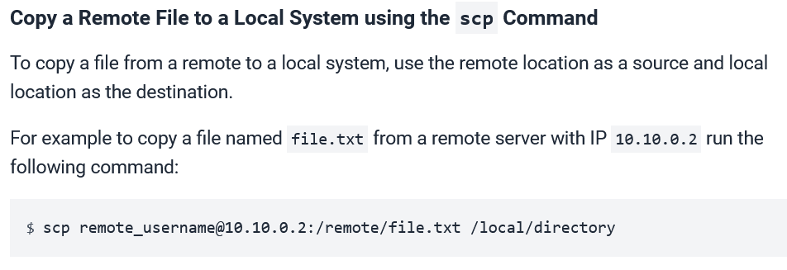

## **U have a script that needs to be executed at system boot up , what should we do**

1. .using cron

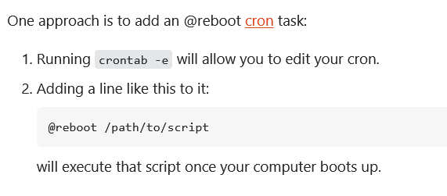

1. Add entry to /etc/rc.d/rc.local file

3$ sh /home/ec2-user/script.sh

And then give execute permission to that rc.local file

$ chmod +x /etc/rc.d/rc.local

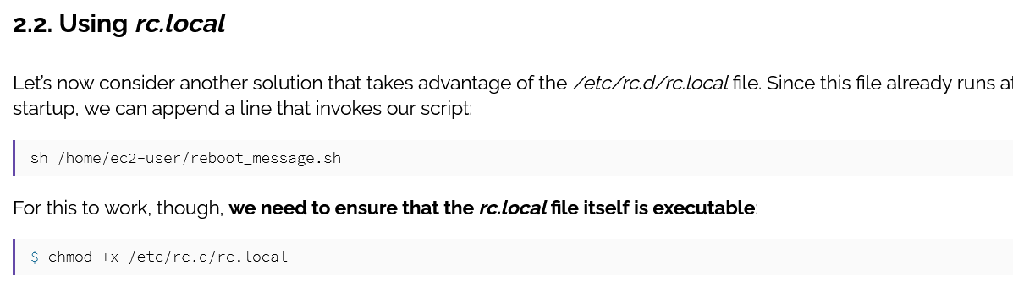

1. Create a service under systemd

Create a systemd unit file with .service extension in /etc/systemd/system, for example /etc/systemd/system/my-service.service, with the following content.

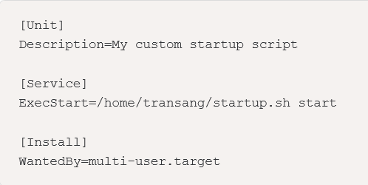

For more info , follow

<https://transang.me/create-startup-scripts-in-ubuntu/>

<https://www.baeldung.com/linux/run-script-on-startup>

## **Explain init.d**

Init d is the sub-directory of /etc directory in Linux file system. init. d basically contains the bunch of start/stop scripts which are used to control (start,stop,reload,restart) the daemon while the system is running or during boot

Can be used to run scripts at startups too

<https://www.baeldung.com/linux/run-script-on-startup>

## **Diff between .bash_profile and .bash_rc**

.bash_logout : is a user's logout ending program file. It will execute first whenever the user is logout.

.bash_profile : is user's login startup program file. It will execute first whenever the user is login. It

consists the user's environmental variables.

.bashrc : This file is used to create the user's custom commands and to specify the umask values forthat user's only.

## **Diff between login shell and non login shell**

A login shell is a shell given to a user upon login into their user account.

A Non login shell is started by a program without a login.

**Simply put:**

* If you open a shell or terminal (or switch to one), and it asks you to log in (Username? Password?) before it gives you a prompt, it's a login shell.
* If it doesn't (like gnome-terminal), and lets you use it straight away, it's a non-login shell.

If you are a normal user of Ubuntu Desktop, the only login shell is...your desktop (you type a password to get in, right ;)? Well, technically it's a login shell that starts a GUI, but that's getting in to jargon. And yes, it will read the settings in .profile

For more info see this <https://www.unixmen.com/non-login-shell-login-shell/>

## **Whats inside /etc/shadow**

Shadow file :

(i) This file tells about the login id, user's encrypted password, password when last

changed, min. days the password valid, max. days valid, warning days, inactive days and expiry days.

(ii) If shadow file is missed or deleted we can recover those entries of shadow file using password file.

(iii) We can change the users encrypted passwords with the permissions of the higher authorities in

case of emergency.

## **Different folders under /root/ . what do they contain**

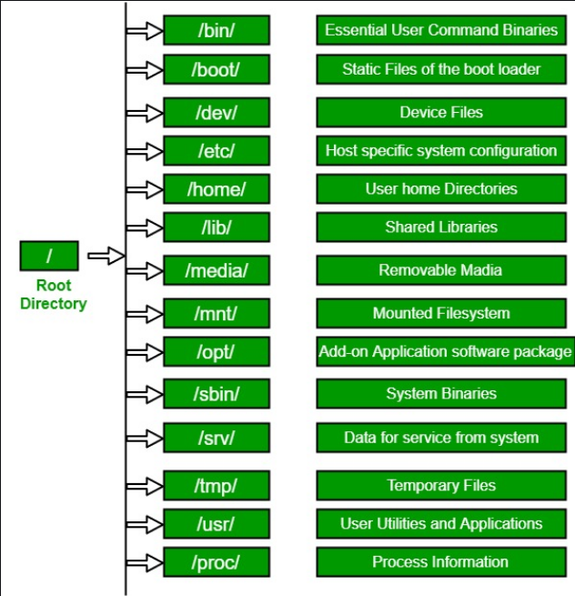

## **Explain srv directory in linux**

The /srv/ directory contains site-specific data served by your system running Red Hat Enterprise Linux. This directory gives users the location of data files for a particular service, such as FTP, WWW, or Version control system. Data that only pertains to a specific user should go in the /home/ directory.

## **Types of users in linux**

There are 5 types of users available in Linux.

(i) System user (Admin user who control the whole system nothing but root user).

(ii) Normal user (Created by the Super user. In RHEL - 7 the user id's from 1000 - 60000).

(iii) System user (Created when application or software installed ).

(In RHEL - 7 the System users are

Static system user id's from 1 - 200 and

(ii) Dynamic system user user id'sfrom 201 - 999).

(iv) Network user (Nothing but remote user, ie., who are login to the system trough network

created

in Windows Active Directory or in Linux LDAP or NIS).

(v) Sudo user (The normal users who are having admin or Super user privileges)

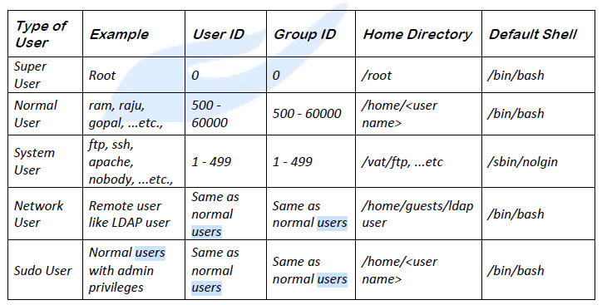

## **Location of ifconfig command (command to show its location)**

$ which ifconfig

/sbin/ifconfig

$ whereis ifconfig

/sbin/ifconfig

## **Diff between bin and sbin**

/sbin - Binaries needed for booting, low-level system repair, or maintenance (run level 1 or S)

. It contains only admin realated commands like fdisk, ifconfig, mkfs etc

/bin - Binaries needed for normal/standard system functioning at any run level. It contains only basic user realated commands like cp, ls, mv etc

## **Locate visudo command**

The sudoers file is located at /etc/sudoers . And you should not edit it directly, you need to use the visudo command. Located at sbin/visudo

## **Load average in linux , how to see this metric**

The load average is the average system load on a Linux server for a defined period of time. In other words, it is the CPU demand of a server that includes sum of the running and the waiting threads.

# uptime is the command to check the system load, present time, from how many hours the system is running and load average.

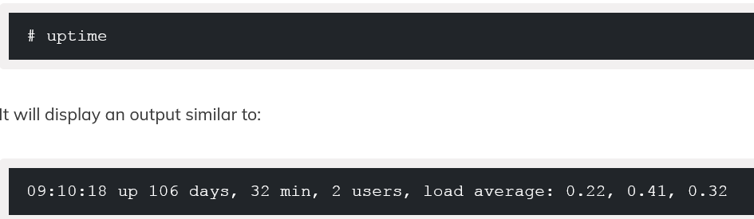

The load average shows three fields. The 1st field shows the load average from 1 minute, 2nd

Field shows the load average from 5 minutes and 3rd field shows the load average from 15 minutes.

## **If load average is high in production servers what should we do**

First check which process and who executed that process is consuming more CPU utilization or

memory utilization by executing # top command.

Then delete the process that is hogging up all the resources or change the priority of

that process using # renice command.

## **How to do log rotation , delete logs more than 7 days**

Log rotation is the process that renames a current log file (e.g., auth.log becomes auth.log.1) and sets up a new log file (e.g., auth.log) for new log entries.

The logrotate tool is commonly used to manage the process of log rotation, though logrotate itself is run through cron.

For more info go here <https://www.networkworld.com/article/3218728/how-log-rotation-works-with-logrotate.html>

Delete logs more than 7 days using find command

$ find /path/to/logfiles* -mtime +7 -exec rm {} \ ;

you enter +7, it will find files older than 7 days.

## **Command to Show files older than 10 days**

$ find /path/to/files* -mtime +10 --print ;

## **Explain grep commands**

grep means Globally search for Regular Expression.

# dpkg -l | grep -i python

# ifconfig | grep –A 4 eth0

# ifconfig | grep -B 2 UP

<https://www.tecmint.com/12-practical-examples-of-linux-grep-command/>

## **Have u installed any os from scratch**

Not in enterprise but have installed in PC ?

## **Linux run levels**

A run level is a state of init and the whole system that defines what system services are operating. Run levels are identified by numbers. Some system administrators use run levels to define which subsystems are working,

[**https://hydrasky.com/linux/the-init-process-in-linux/**](https://hydrasky.com/linux/the-init-process-in-linux/)

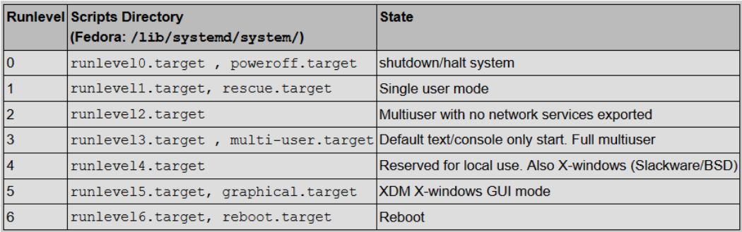

## **If u want to run a service at boot up , what to do**

$ systemctl enable service-name

## **Do u know about /etc/sysctl.conf file**

/etc/sysctl.conf is used for Linux Kernel Security Hardening

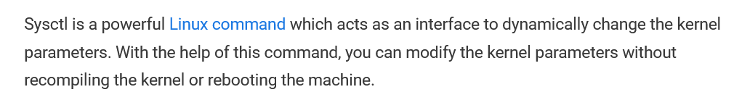

For more info <https://linoxide.com/linux-sysctl-tuning/>

## **How to do partition in linux**

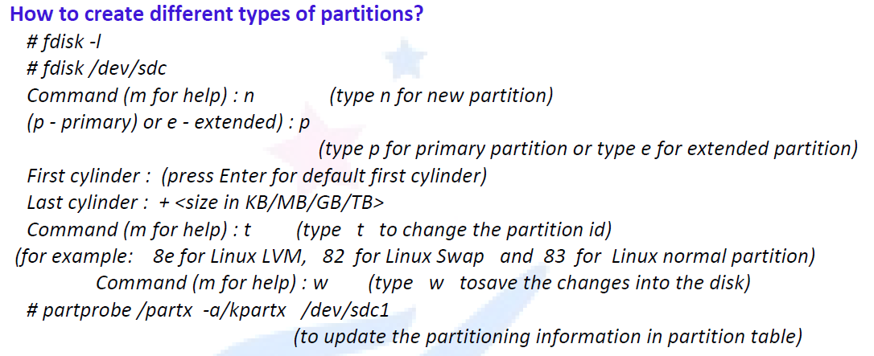

## **How to see the current partitions**

# df -hT

## **How to find disk usage of a particular user**

$ du -h ~my_user_name

## **How to check if a particular service is running or not**

# systemctl status service-name

## **If a particular command is stuck , what to do**

ctrl c is used to kill a process. It terminates your program.

The ctrl-z sequence suspends the current process .

## **Kill command in linux**

# kill and # pkill commands are used.

# kill -----> It will kill the processes using PID's.

# pkill -----> It will kill the processes using process names.

## **-9 argument in kill , explain kill signal**

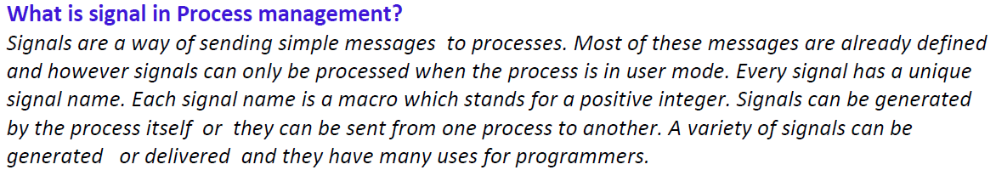

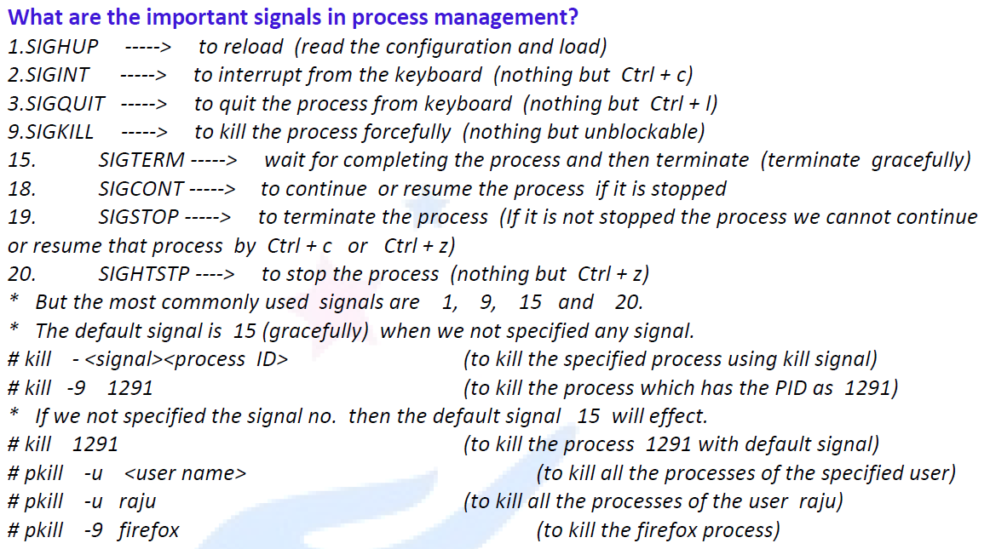

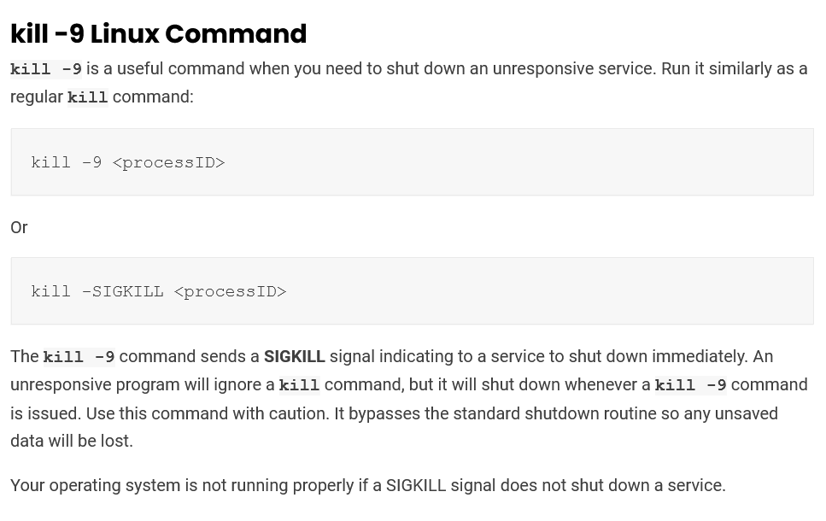

## **How to find ram usage in linux**

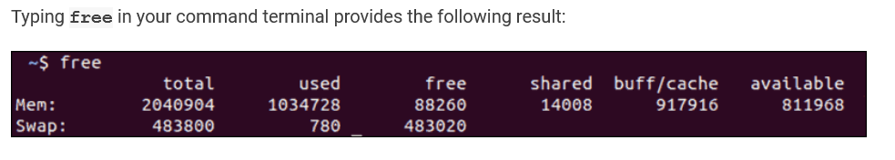

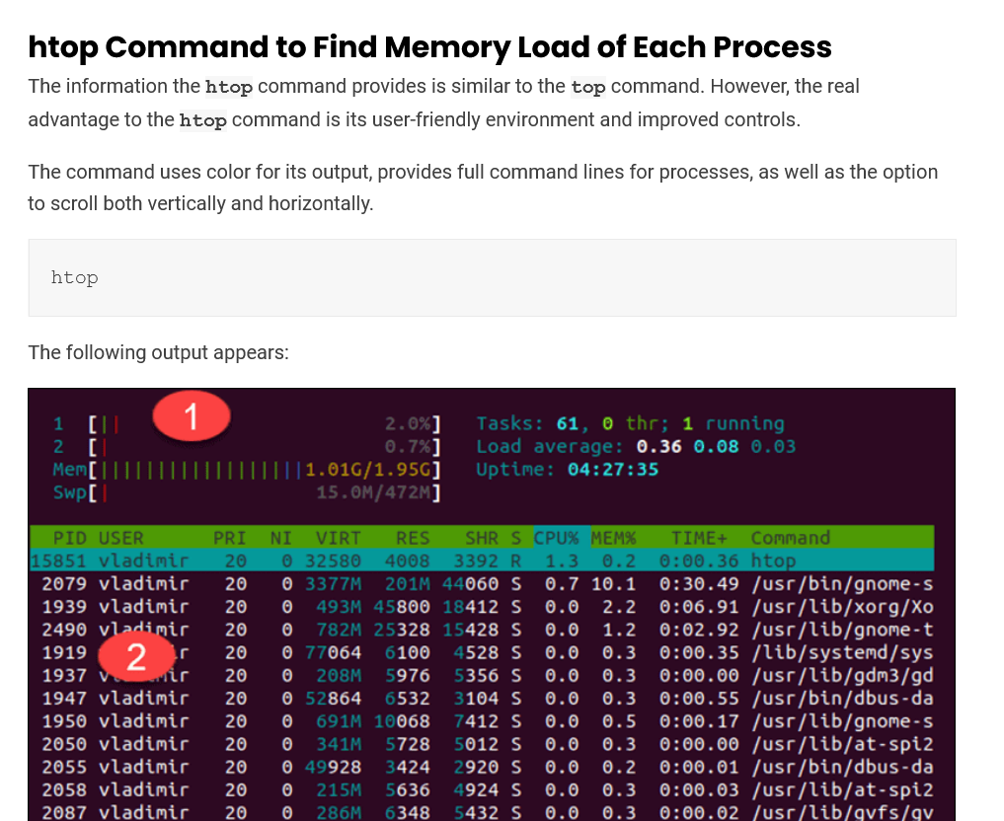

## **What is the best way to backup files of a directory in linux**

Achieve using tar

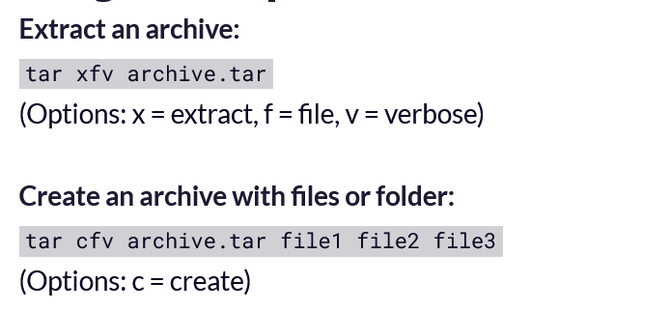

## **Symbolic links in linux, soft link vs hard links**

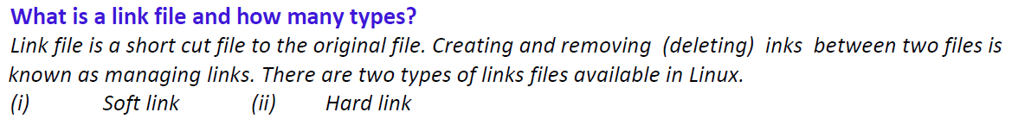

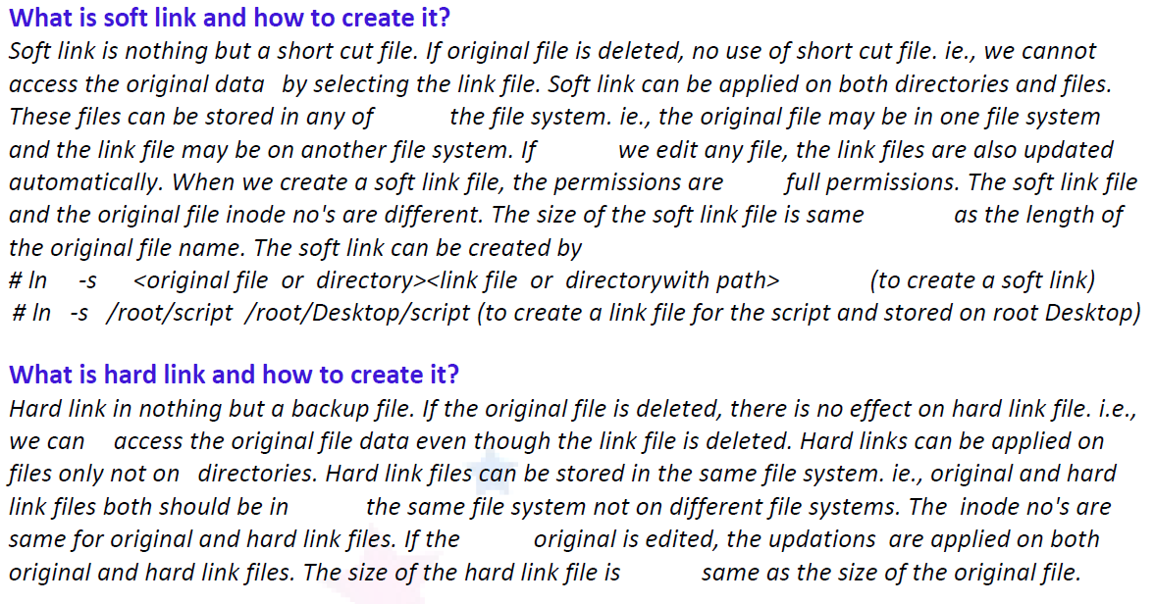

## **What is port forwarding in linux , how to do it ? real time example a. For ex:~ httpd1.0 and httpd1.1 These two httpd containers running on the same port called 80 If we try to access a anyone container with ip:port Conflict will occur cuz two containers are running same port For avoiding conflict we need to map the port with port map Docker run ~p 8000:80 ~d httpd1.0**

## **Nice command**

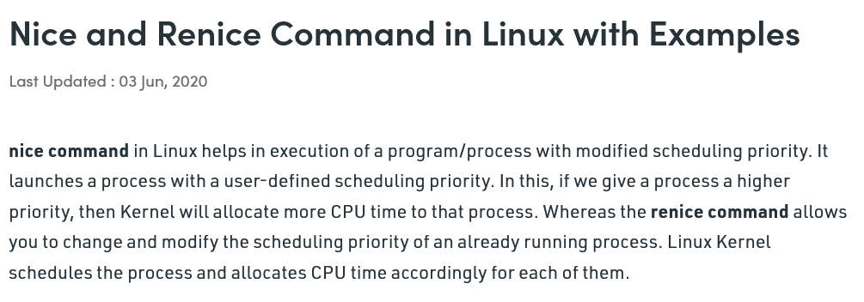

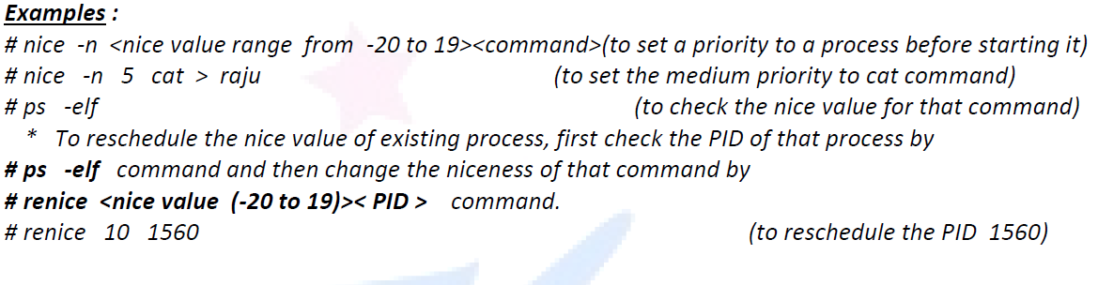

## **Diff command**

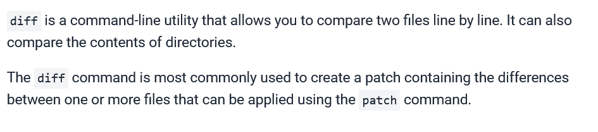

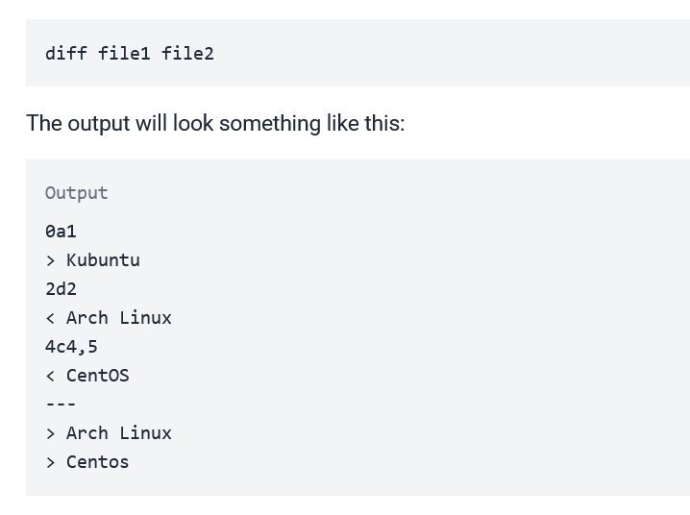

## **Cmp command**

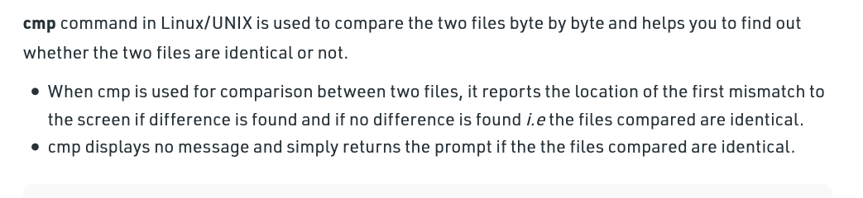

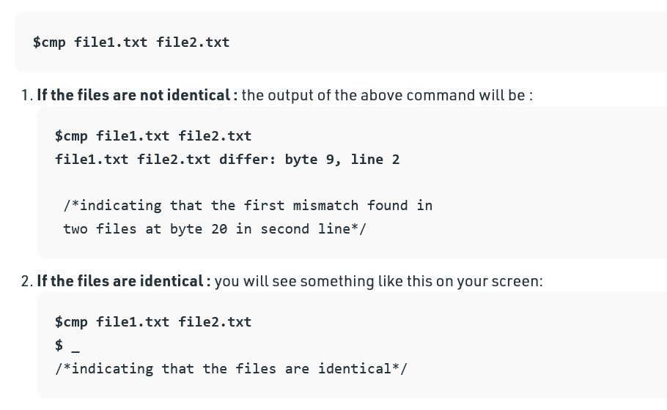

## **Sed command**

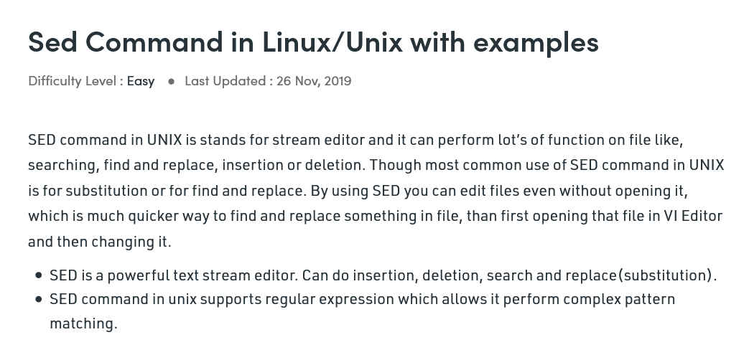

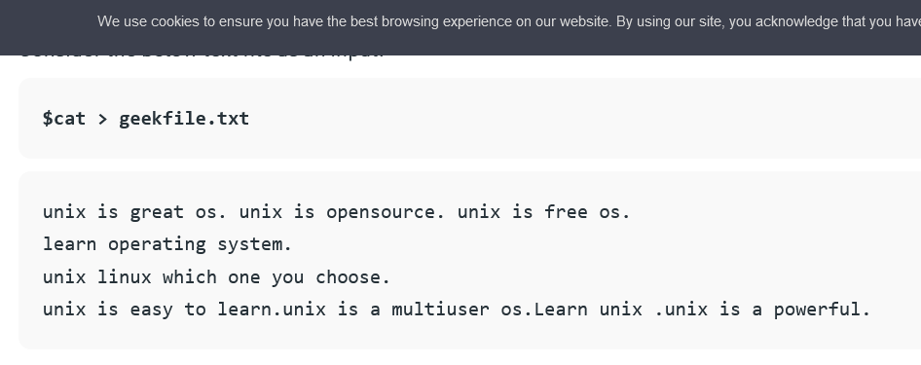

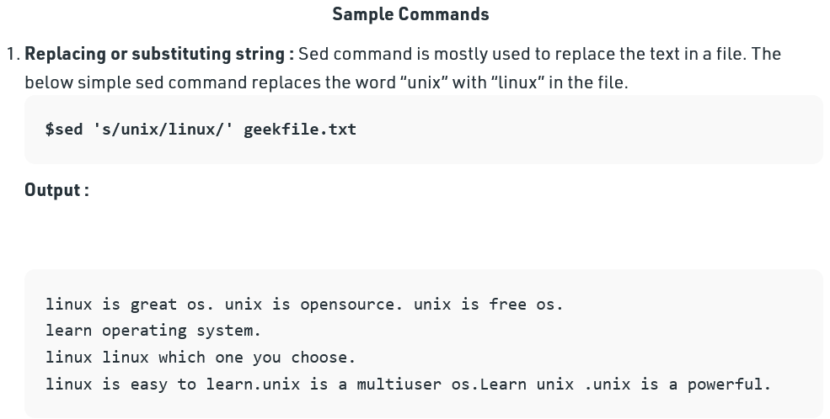

**Replacing all the occurrence of the pattern in a line :**The substitute flag /g (global replacement) specifies the sed command to replace all the occurrences of the string in the line.

**$sed 's/unix/linux/g' geekfile.txt**

For more info follow these[**https://www.geeksforgeeks.org/sed-command-in-linux-unix-with-examples/**](https://www.geeksforgeeks.org/sed-command-in-linux-unix-with-examples/)

## **Process id in linux**

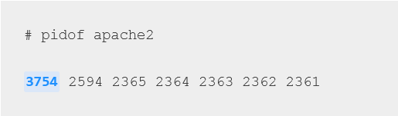

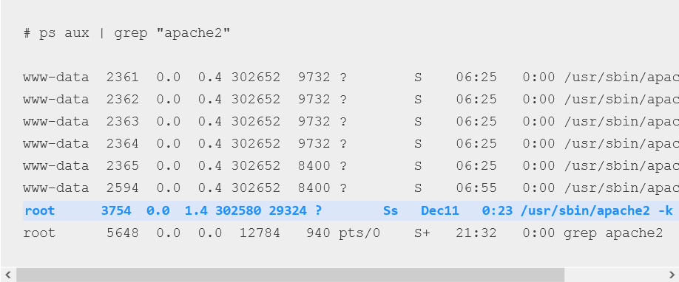

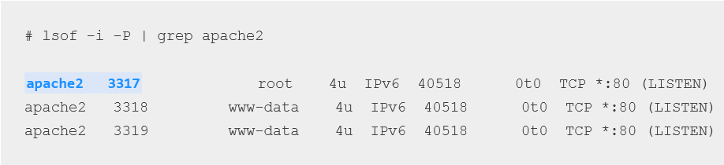

## **Explain the boot process of linux**

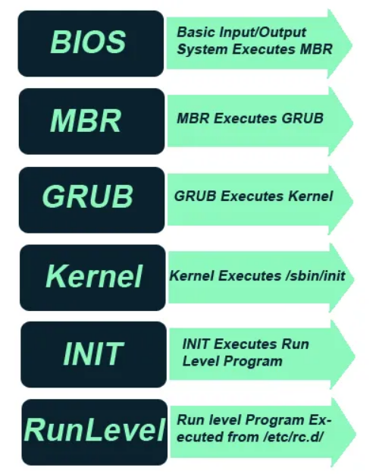

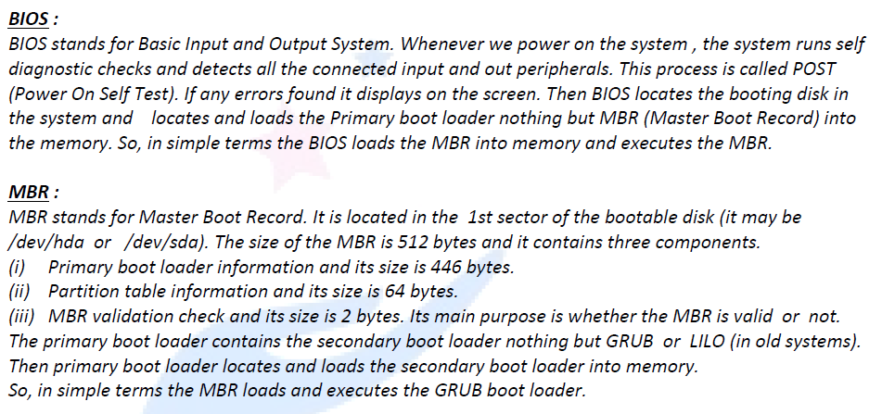

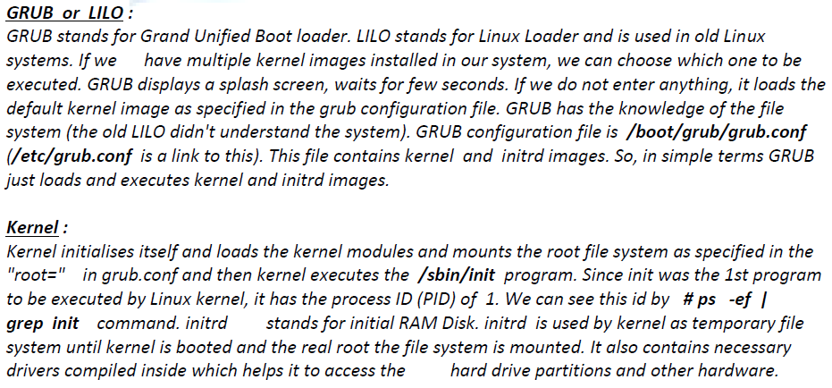

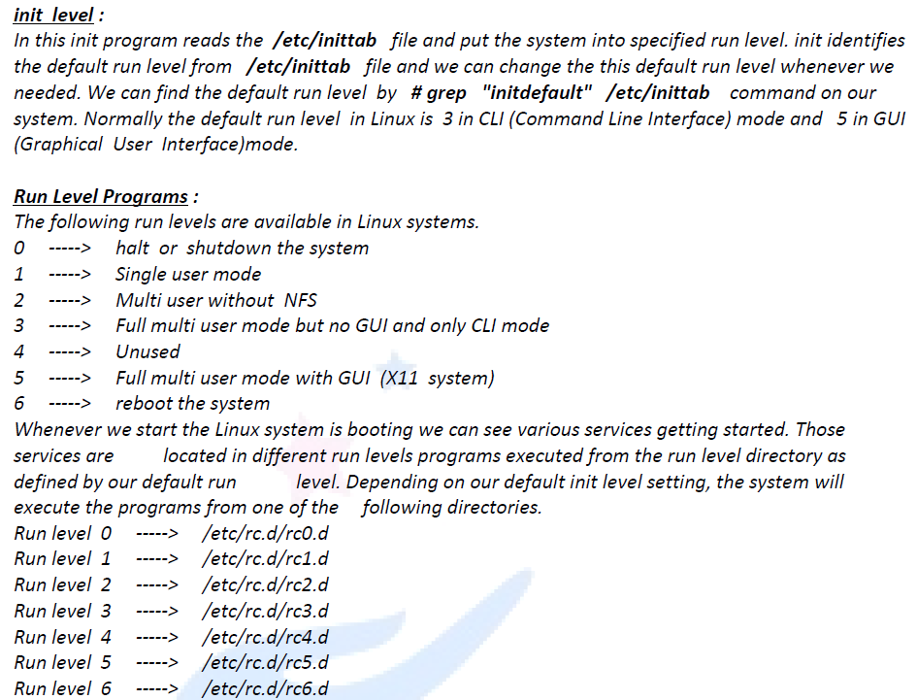

## **Explain what is zip file and unzip with its cmds**

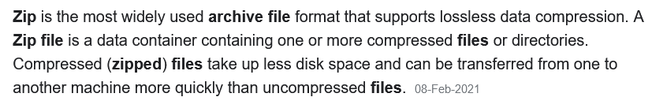

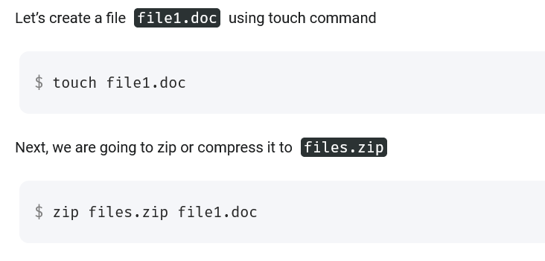

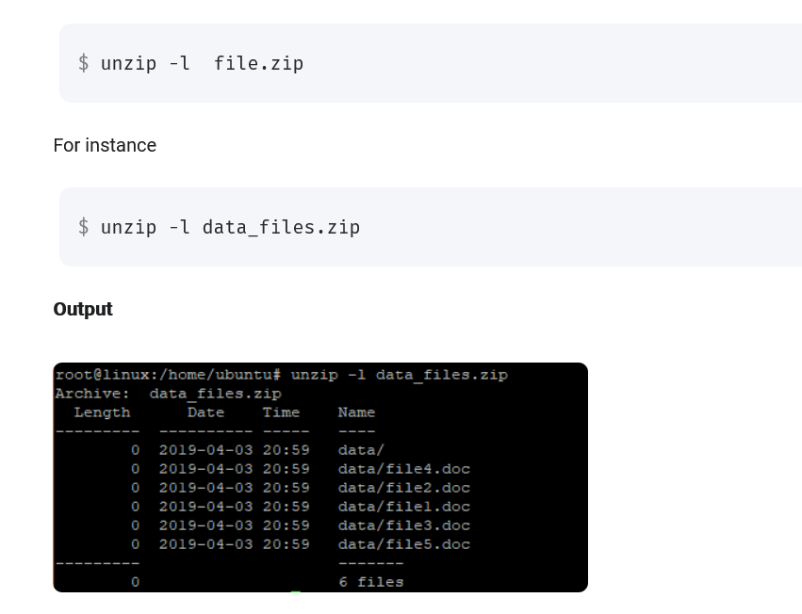

## **Do you about linux kernel ?**

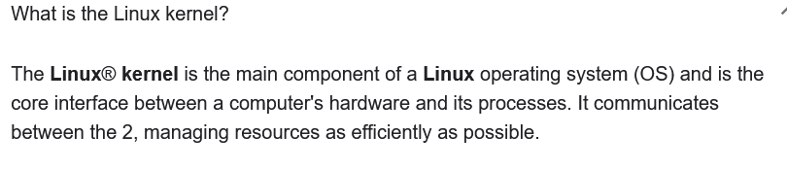

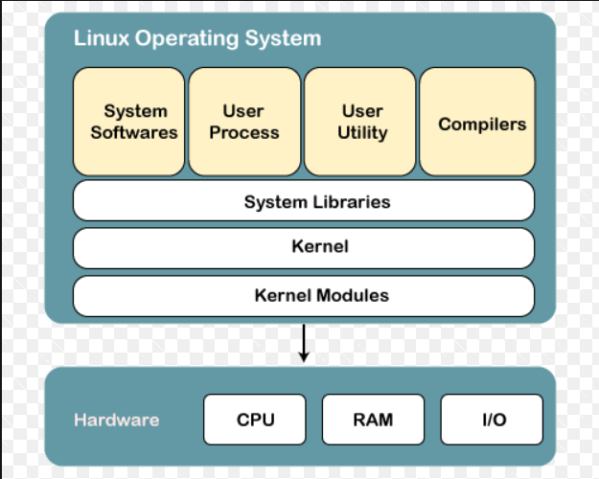

## **What is ACL?**

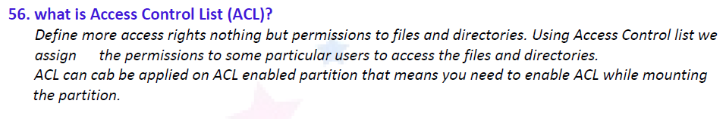

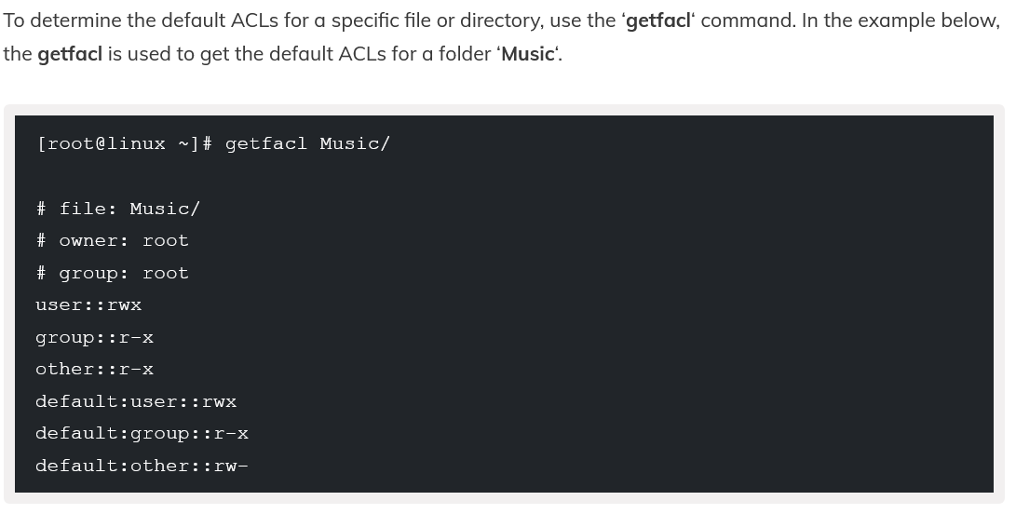

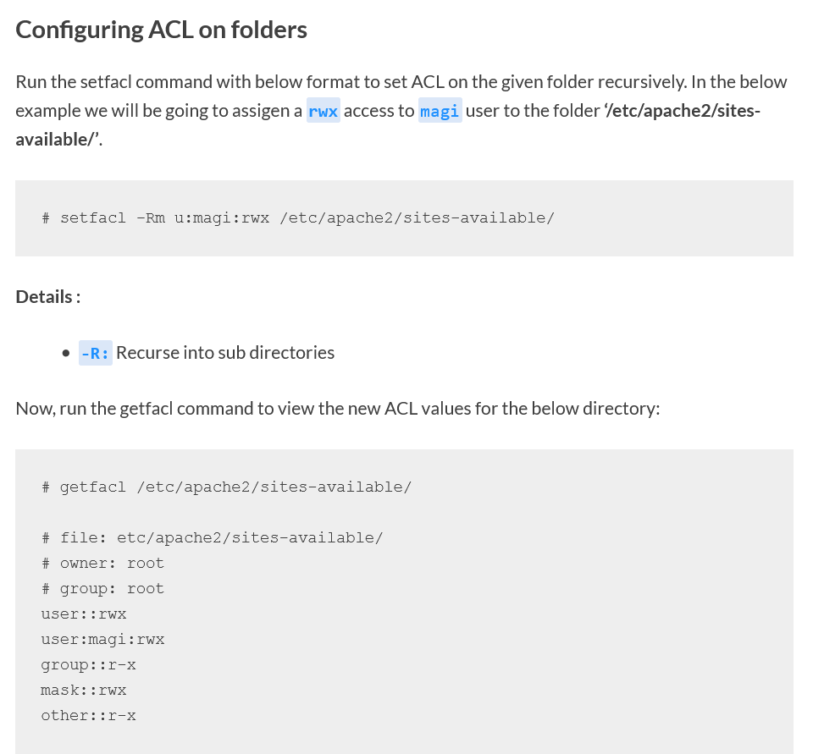

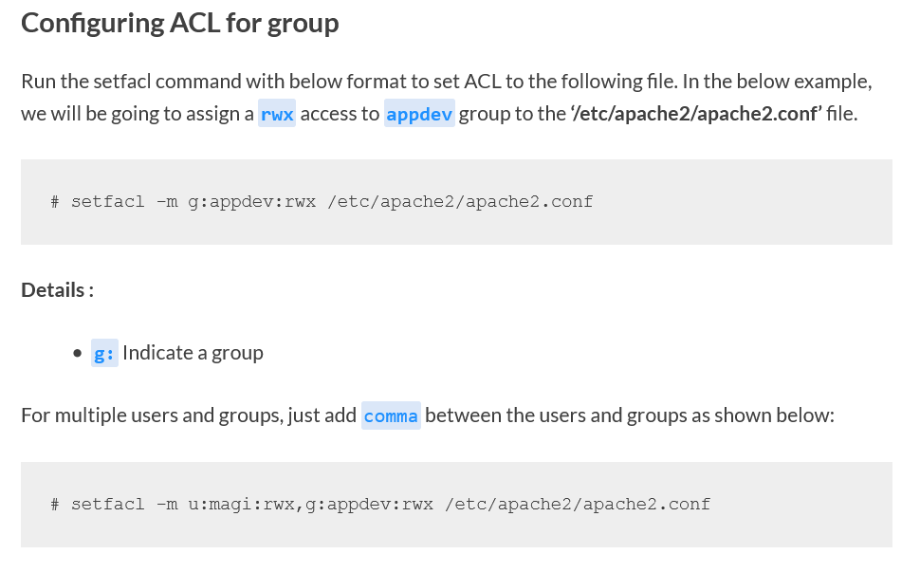

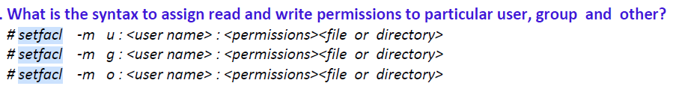

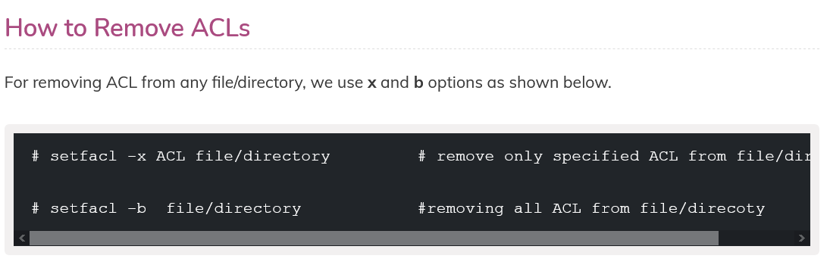

## **About linux file permissions and default umask value for permissions**

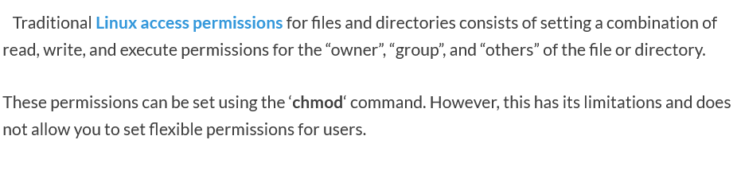

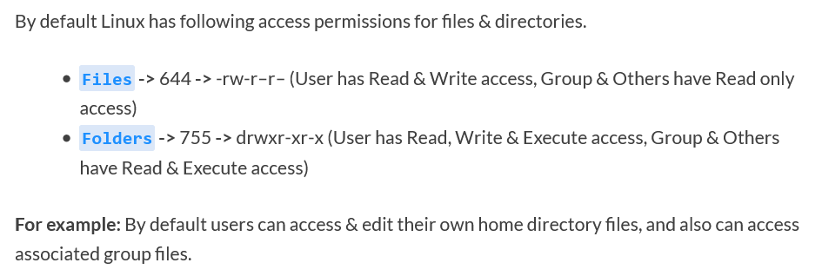

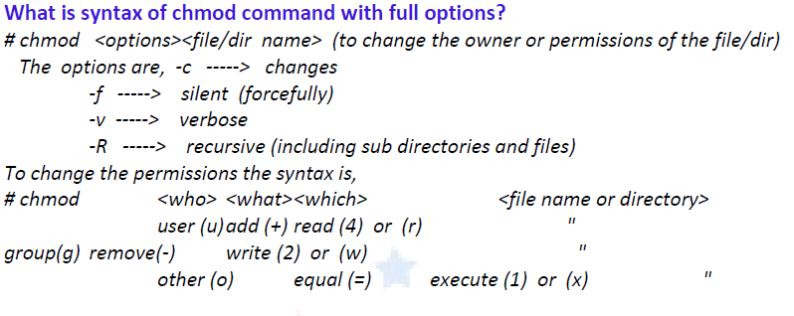

## **Can you turn linux server into proxy server?**

<https://www.hostinger.in/tutorials/how-to-set-up-nginx-reverse-proxy/>

<https://www.scaleway.com/en/docs/how-to-configure-nginx-reverse-proxy/>

<https://www.digitalocean.com/community/tutorials/how-to-configure-nginx-as-a-web-server-and-reverse-proxy-for-apache-on-one-ubuntu-18-04-server>

## **Diff betn home dir and working dir**

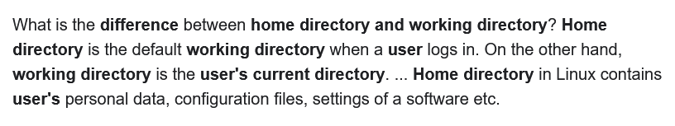

## **About webserver ( Apache in this case)**

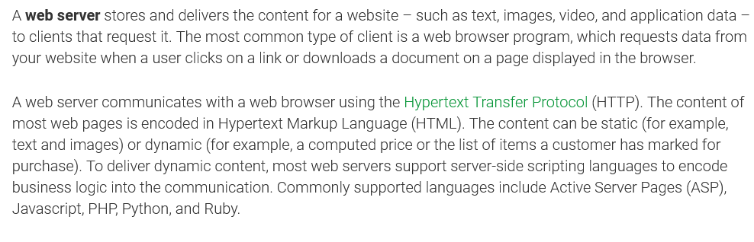

<https://www.digitalocean.com/community/tutorials/how-to-install-linux-apache-mysql-php-lamp-stack-ubuntu-18-04>

## **Can I in maintain 2 webservers in a single machine?**

Yes , u can have 2 tomcats or 2 apaches on 1 machine . You do this by making separtate directory/ port / ip addresses for 2 tocat instance

<https://dzone.com/articles/running-multiple-tomcat>

Second method : You can use nginx as reverse proxy to host multiple websites on 1 machine

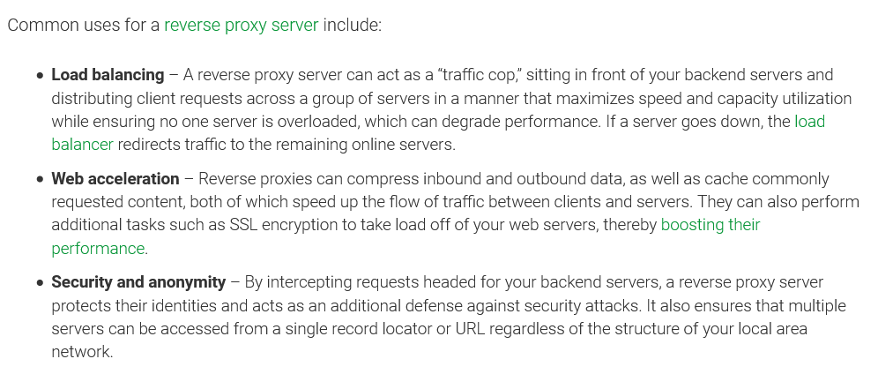

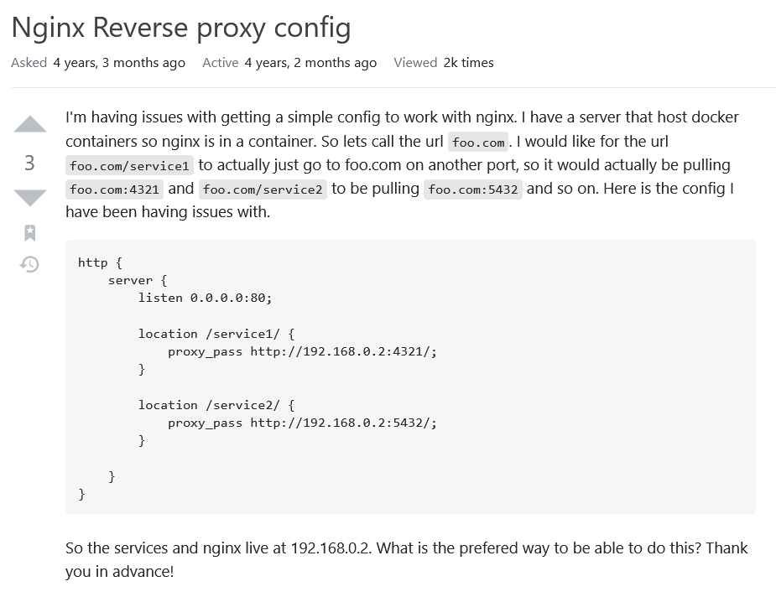

## **How will you check if the file is empty or not? ( ls -l if it is zero then file is empty)**

## **What are the signals and trap? Tell about the trap cmd. ( too see in kill cmd)**

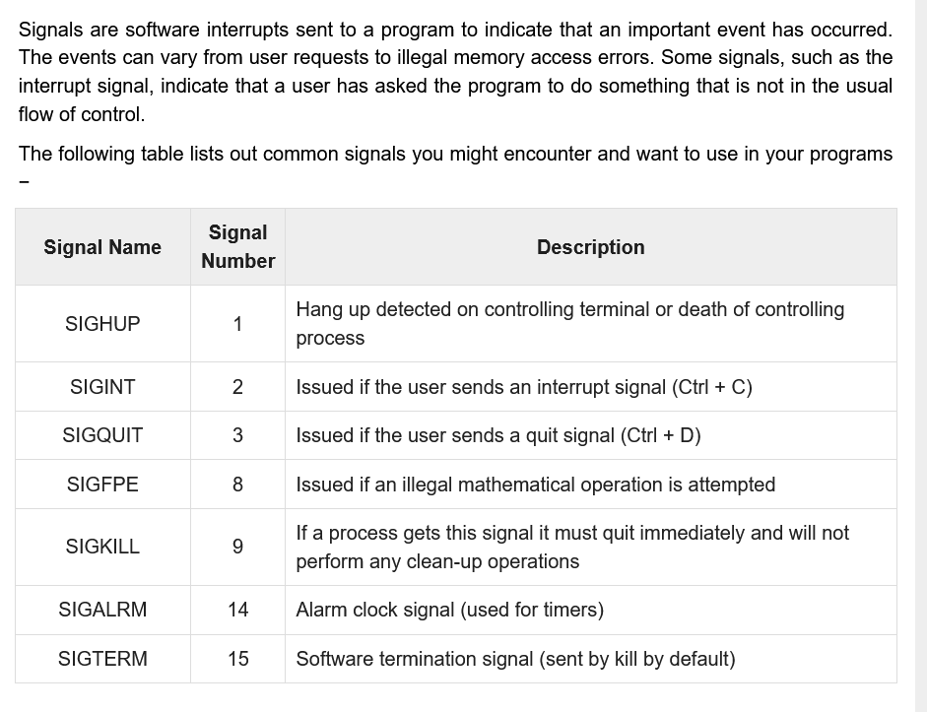

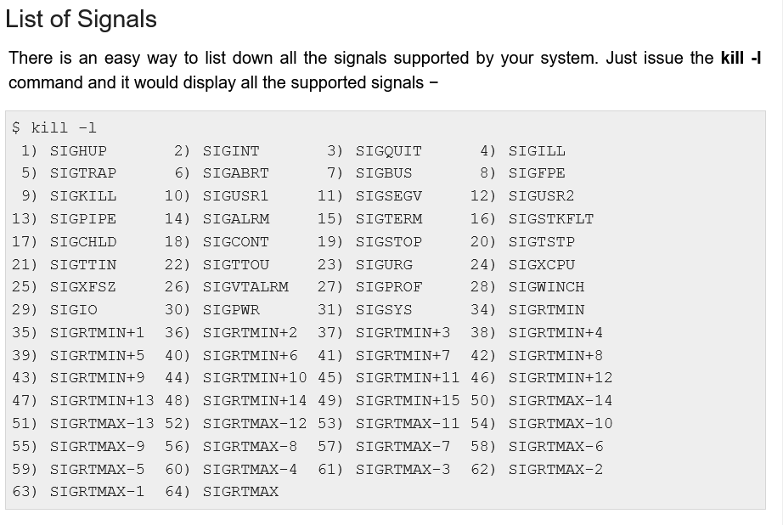

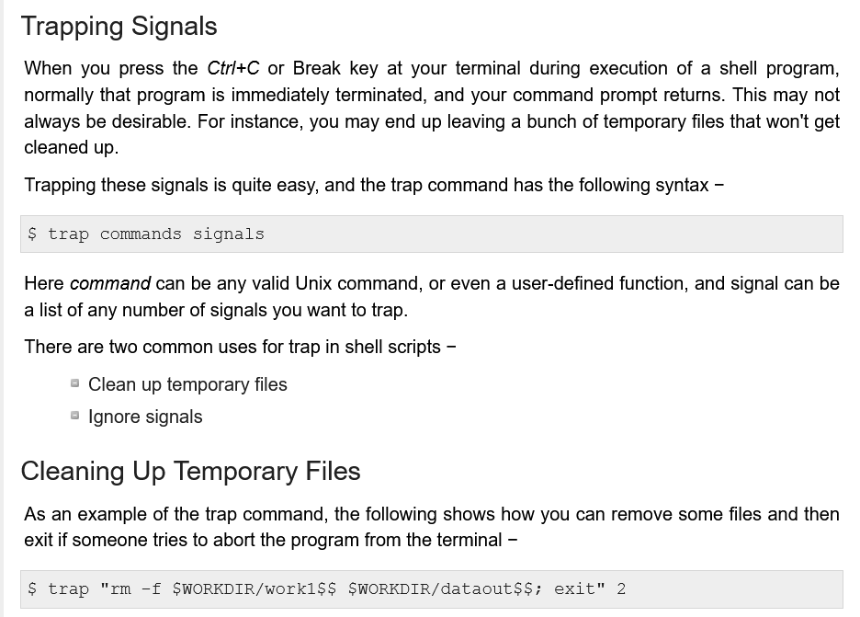

More more info go here <https://www.tutorialspoint.com/unix/unix-signals-traps.htm>

## **How do you call no. of lines in a file? (wc -l)**

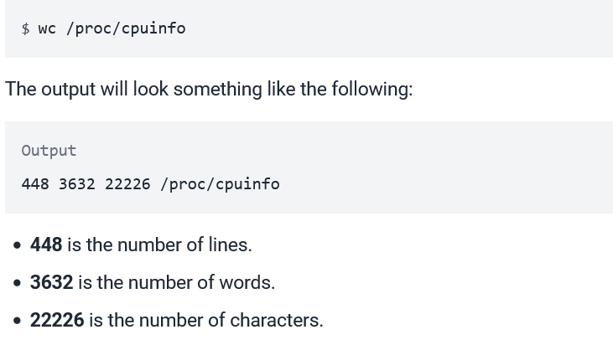

## **How can you maintain the security of a website on a Apache( httpd) server? ( SSL certificates)**

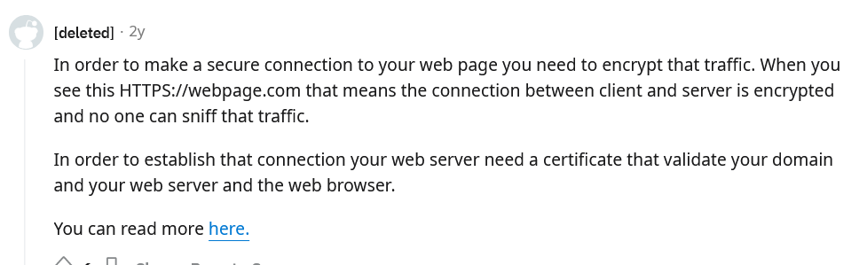

## **How to deploy war/var files on apache?**

Copy ur content into /var/www/html

## **How to find only duplicates( may be lines) in a text file? ( sort -n)**

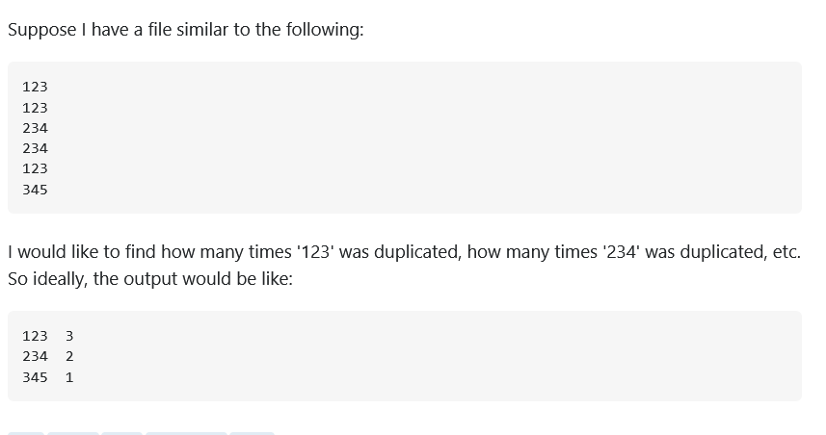

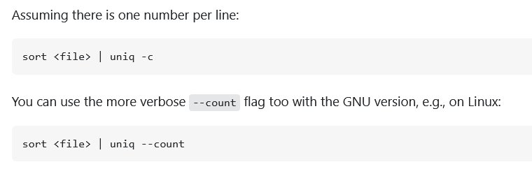

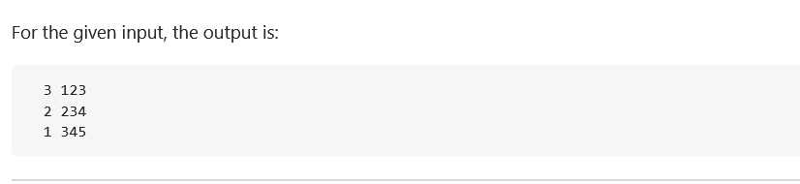

## **How to delete last 30 days data( may be logs)? ( find cmd)**

# find /path/to/ -name "*.log" -mtime +30

-exec rm -f {} \;

## **How to take backup in linux? ( can use a shell script**

Fore more info follow here <https://iq.opengenus.org/automated-backup-in-linux-using-shell-scripting-and-crontab-scheduler/>

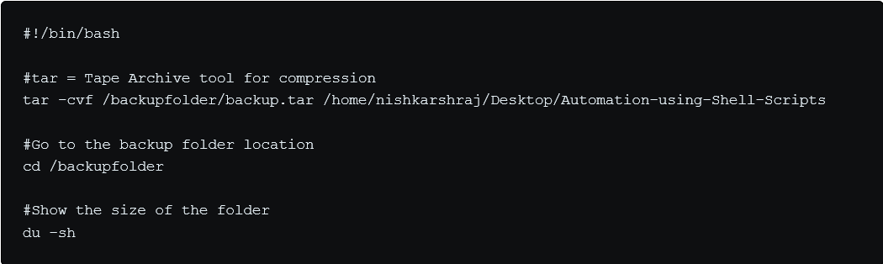

## **How to search for files ending with .log and delete it ( on top of that)? ( find and exec delete)**

# find /path/to/ -name "*.log"

# find /path/to/ -name "*.log" -exec rm -f {} \;

## **What is the use of ‘tee’ command?**

TEE COMMAND SAVES OUTPUT OF A COMMAND INTO A FILE

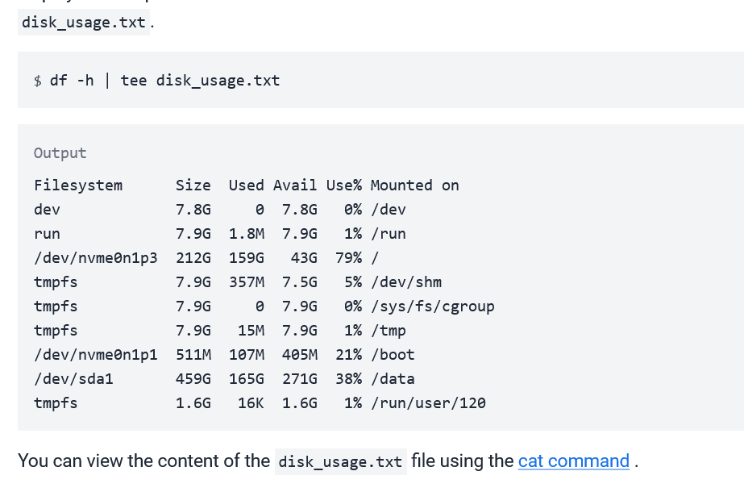

## **What does ‘>1’ means? ( may be for error files in logs and outputs context)**

## **How to check the execution status( cmd execution status) of any cmd? ( mkdir in this case)**

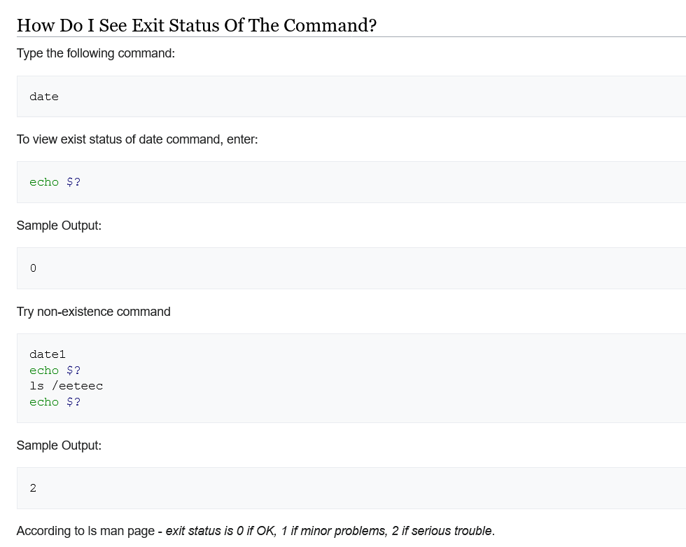

## **Sed and awk and adhoc ( stream editor and also related to vi editor)**

## **Cmd to delete and replace empty lines on sed**

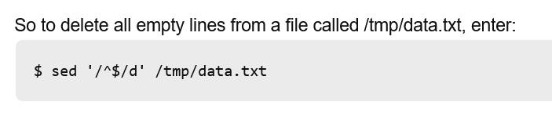

For more info refer here <https://stackoverflow.com/questions/16414410/delete-empty-lines-using-sed>

## **How to copy files from local windows machine to cloud based linux machine?**

Use scp command

## **How many severs are you having now for your current project and in your company? ( real time ques)**

Skip for later

## **How tomcat will deploy the jar/var files after jenkins build job in jenkins in the pipeline?** **How will you do it?**

Wriite those linux commands to deploy jar in tomcat in configure jenkins section

## **User management**

Refer here <https://www.geeksforgeeks.org/user-management-in-linux/>

1. Chmod -r … ( changing permissions of a dir)

For more info refer here <https://linuxize.com/post/chmod-command-in-linux/>

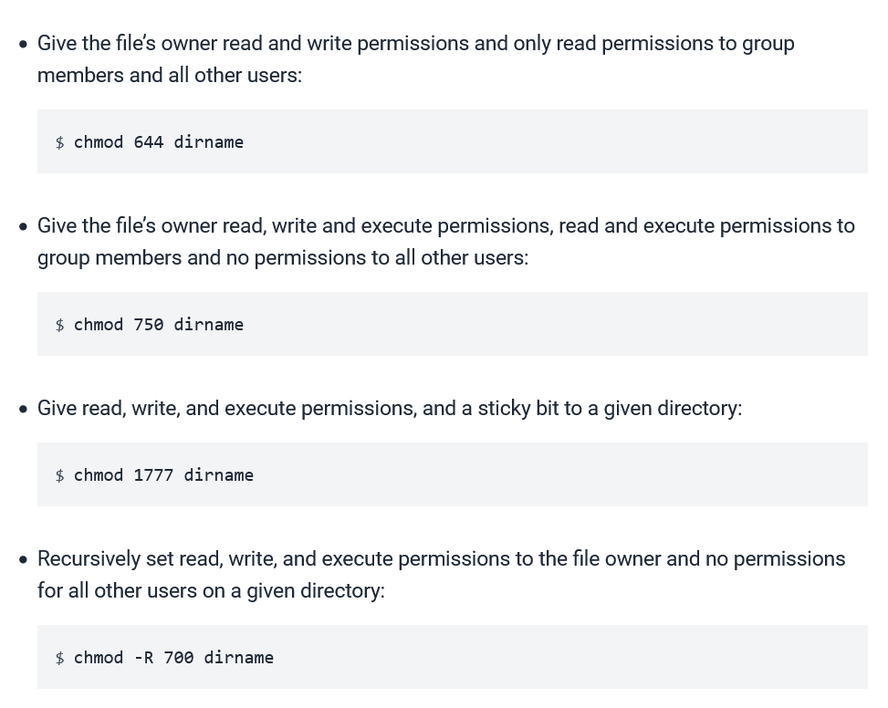

## **Finding particular port or something like that ( netstat -an | grep 80)**

$ netstat --help

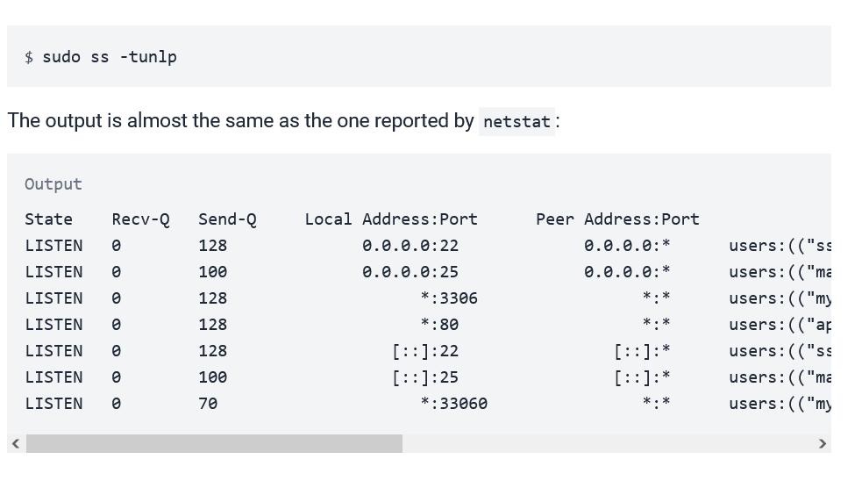

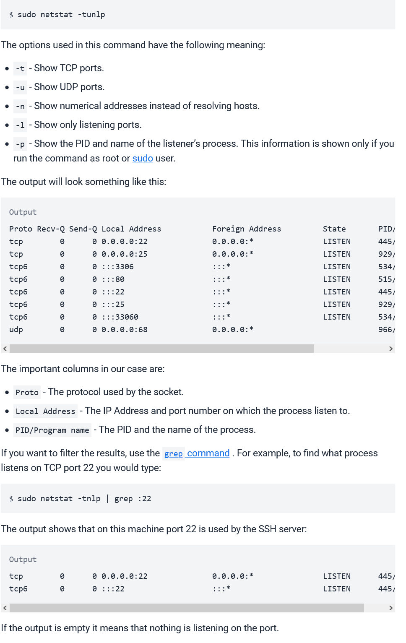

## **Cmd to see pid if a process is killed and system not functioning properly ( with port)**

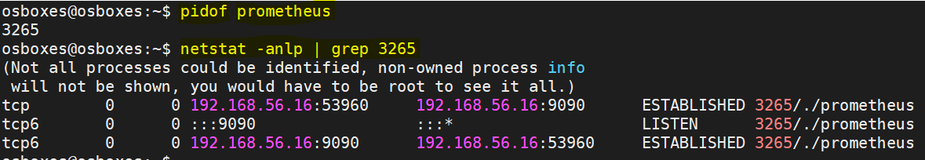

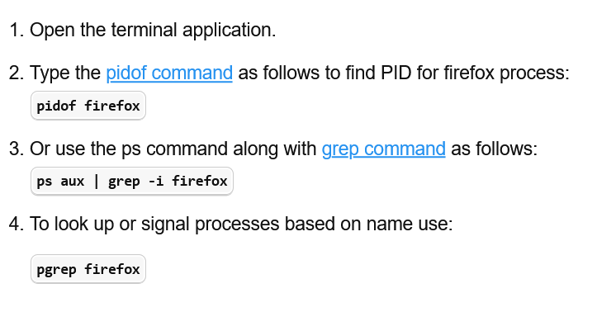

## **How to kill all processes without knowing pid? ( kill tree pid, ps3 pid)**

Use # pkcill command

# pkill firefox

## **What is hypervisor and kvm**

Basically hypervisior does virtualization

Kvm,vmware are diff types of hypervisiors

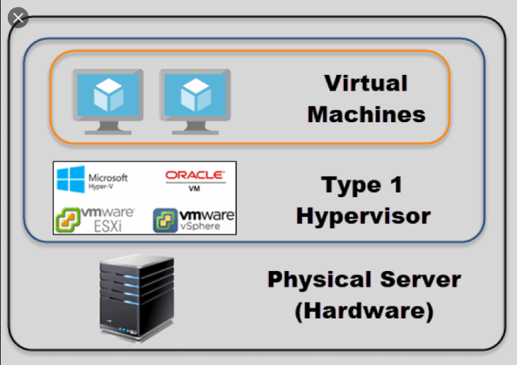

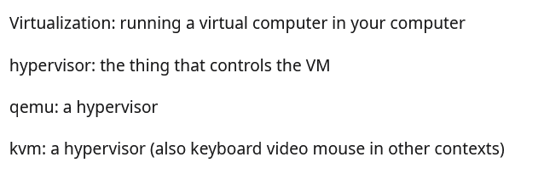

## **What is the difference between war and rar**

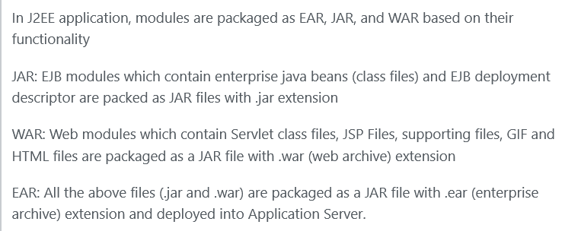

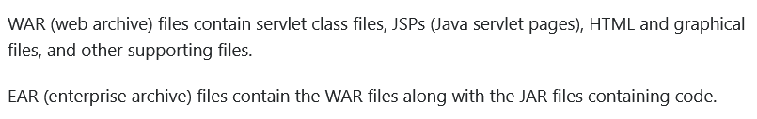

## **Does Tomcat supports EAR file?**

Nooooooooooooooooooooooooooooooooooooooooooooooooooooo

## **Can i run two web apps in same tomcat? If so, how ?**

1. IF 2 WEBAPPS NEED TO BE DEPLOYED ON SINGLE PORT

==============================================

FOR MORE INFO GO HERE <https://stackoverflow.com/questions/23569327/deploying-multiple-applications-to-tomcat/23610646>

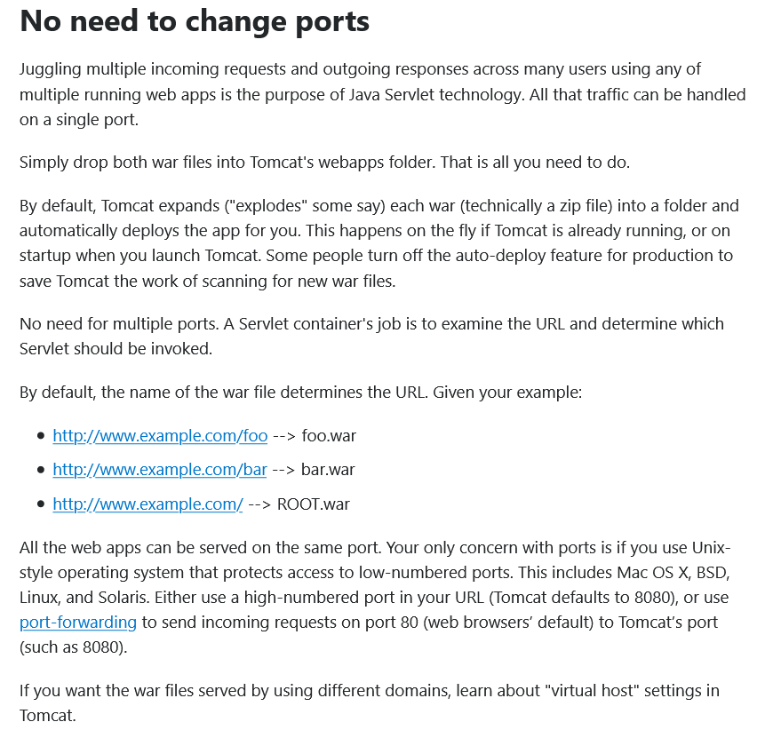

B ) IF 2 WEBAPPS NEED TO BE ON DIFF PORTS (DIRECTORY BASED VIRTUALHOSTING)

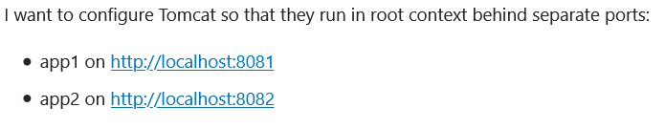

FOR MORE INFO <https://stackoverflow.com/questions/23569327/deploying-multiple-applications-to-tomcat/23610646>

<https://stackoverflow.com/questions/8823290/how-to-run-different-apps-on-single-tomcat-instance-behind-different-ports?noredirect=1&lq=1>

INSTEAD OF DROPPING UR WARS INTO WEBAPPS FOLDER , CREATE 2 FOLDER APP1 (WHICH WLL RUN ON PORT 8081) AND APP2 (WHICH WILL RUN ON 8082) INSIDE /HOME/TOMCAT/apache-tomcat-8.5.5/.

DROP UR WARS IN APP1 AND APP2 FOLDER

NOW EDIT SERVER.XML FILE INSIDE

/HOME/TOMCAT/apache-tomcat-8.5.5/CONF/SERVER.XML

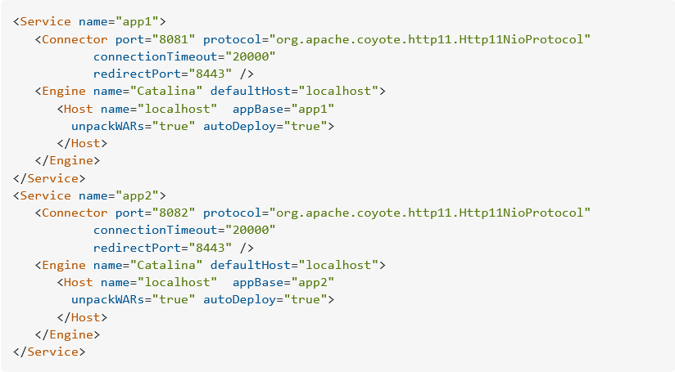

## **How to allocate extra memory for Tomcat server?**

Go to Catalina.sh in tomcat home directory

# cd ${TOMCAT_HOME}/bin/catalina.sh

Change ur memory here



## **Can we install two middleware Ex: Tomcat and Websphere in a single linux vm?**

## **OSI Model**

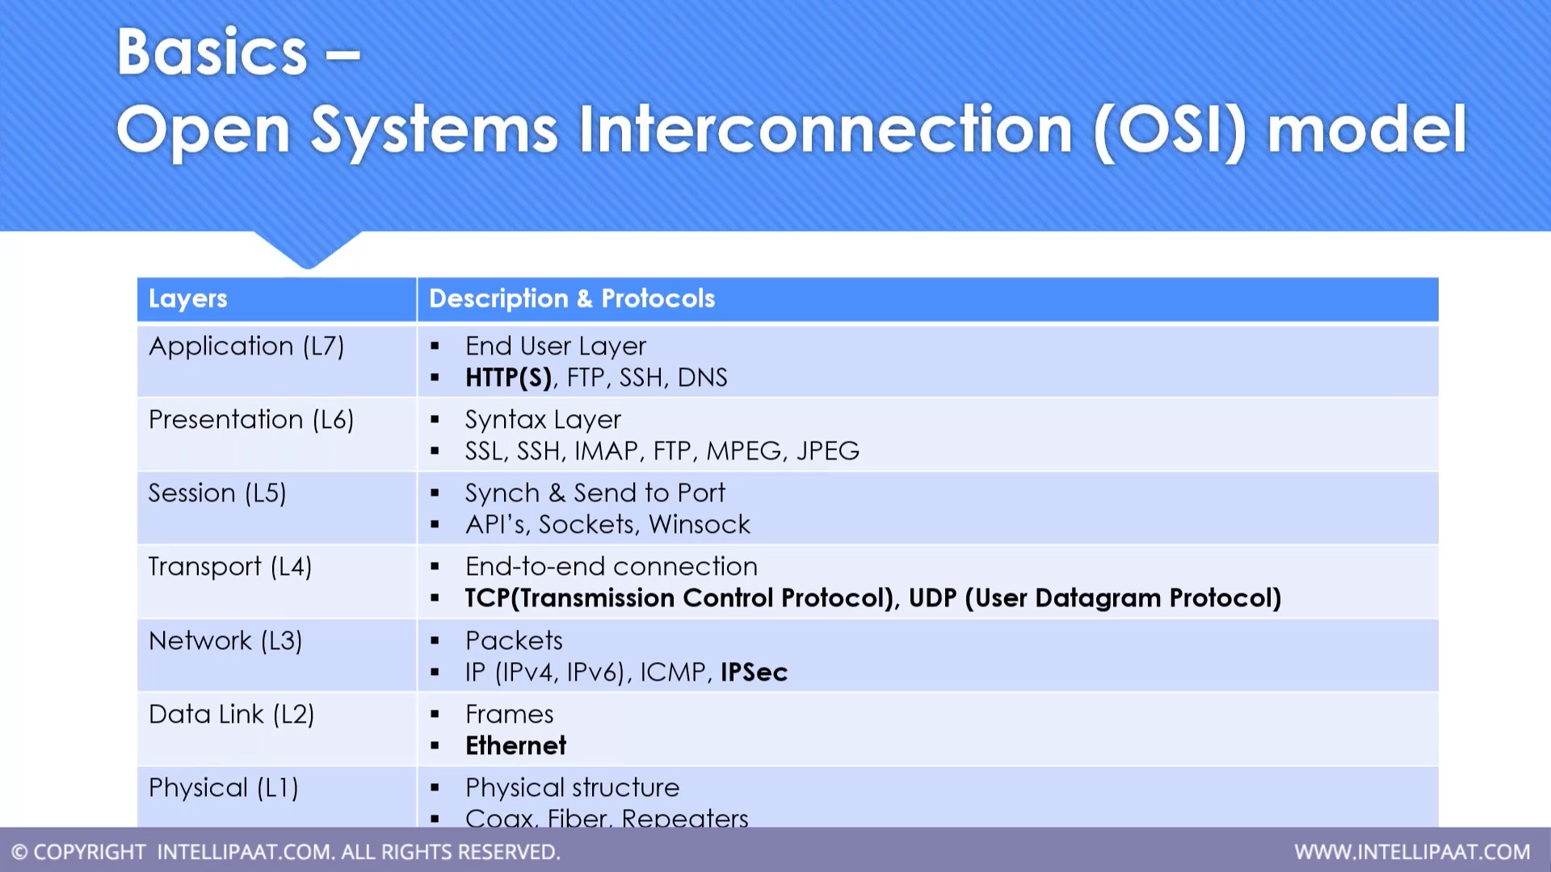

# Shell Scripting

## **Explain awk and sed commands**

**awk:**

Awk is mostly used for pattern scanning and processing.

awk is mostly used for data extraction and reporting.

awk command searches files for text containing a pattern. When a line or text matches, awk performs a specific action on that line/text.

The awk command provides a scripting language for text processing. With awk scripting language, you can make the following:

Define variables.

Use string and arithmetic operators.

Use control flow and loops.

Generate formatted reports.

**WHAT CAN WE DO WITH AWK ?**

**1. AWK Operations:**   
(a) Scans a file line by line   
(b) Splits each input line into fields   
(c) Compares input line/fields to pattern   
(d) Performs action(s) on matched lines

**2. Useful For:**   
(a) Transform data files   
(b) Produce formatted reports

**3. Programming Constructs:**   
(a) Format output lines   
(b) Arithmetic and string operations   
(c) Conditionals and loops

**sed:**

SED stands for stream editor

By using SED you can edit files even without opening it

SED is a powerful text stream editor. Can do insertion, deletion, search and replace(substitution).

SED command supports regular expression which allows it perform complex pattern matching.

The below simple sed command replaces the word “unix” with “linux” in the file.

$sed 's/unix/linux/' geekfile.txt

## **Diff between grep and awk**

When it comes to text processing in Linux, the three tools that come in pretty handy are grep, sed, and awk.

**grep** is only good for simple text matching and printing.

The grep command searches for lines matching a regex pattern and prints those matching lines to the standard output. It is useful when we need a quick way to find out whether a particular pattern exists or not in the given input.

**awk** has many built-in functions for string, arithmetic, and time manipulation but also allows the user to define his own functions just like any regular scripting language.

awk is mostly used for data extraction and reporting.

## **How to find a path of a shell script**

**For bash, sh, ksh:**

#!/bin/bash

# Absolute path to this script, e.g. /home/user/bin/foo.sh

SCRIPT=$(readlink -f "$0")

# Absolute path this script is in, thus /home/user/bin

SCRIPTPATH=$(dirname "$SCRIPT")

echo $SCRIPTPATH

**For tcsh, csh:**

#!/bin/tcsh

# Absolute path to this script, e.g. /home/user/bin/foo.csh

set SCRIPT=`readlink -f "$0"`

# Absolute path this script is in, thus /home/user/bin

set SCRIPTPATH=`dirname "$SCRIPT"`

echo $SCRIPTPATH

## **There are 2 vms, a shell script is in VM1 , we want that shell script to run on VM2 , ho to do it**

**ssh user@remotehost "bash -s" < local_script.sh**

-s makes bash read from standard input.

If you need to pass arguments to your script:

**ssh user@remotehost "bash -s" -- < local_script.sh "your_arg" "--aswitch" "avalue"**

Note the double dash -- (signifying the end of the command options) and the quotes around the arguments.

**Note:**

But you have to be sure that your script explicitly call exit or you will stay logged to the remote server after the script execution.

To be short, do not forget to put this at the end of local_script.sh:

**exit 0**

## **Operators in bash , diff between $@ and $* and $? And $#**

1. **echo $0**
2. **echo $?**
3. **echo $$**
4. **echo $@**
5. **echo $#**

**echo $0** simply shows you the name of the currently running process

**echo $$** returns PID of the current process.

**echo $?**will return the exit status of last command.

**$@** refers to all of a **shell script's command**-line arguments. $1 , $2 , etc.

**$#** is the number of positional parameters passed to the script.

## **In a folder there are 10 .txt files , u need to convert all of them to .html , how to write shell script**

#!/bin/bash

folderpath = `echo $1`

cd folderpath

fileslist = `ls`

for file in fileslist

do

mv "$file" "${file%.txt}.html"

done

## **Bash script to check disk space**

#!/bin/bash

df -h

## **Explain find command Have u developed shell script from scratch , give some examples**

Part I: Basic Find Commands for Finding Files with Names

Part II: Find Files Based on their Permissions

Part III: Search Files Based On Owners and Groups

Part IV: Find Files and Directories Based on Date and Time

Part V: Find Files and Directories Based on Size

Part VI: Find Multiple Filenames in Linux

**Part I – Basic Find Commands for Finding Files with Names**

**1. Find Files Using Name in Current Directory**

Find all the files whose name is tecmint.txt in a current working directory.

# find . -name tecmint.txt

./tecmint.txt

**2. Find Files Under Home Directory**

Find all the files under /home directory with name tecmint.txt.

# find /home -name tecmint.txt

/home/tecmint.txt

**3. Find Files Using Name and Ignoring Case**

Find all the files whose name is tecmint.txt and contains both capital and small letters in /home directory.

# find /home -iname tecmint.txt

./tecmint.txt

./Tecmint.txt

**4. Find Directories Using Name**

Find all directories whose name is Tecmint in / directory.

# find / -type d -name Tecmint

/Tecmint

**5. Find PHP Files Using Name**

Find all php files whose name is tecmint.php in a current working directory.

# find . -type f -name tecmint.php

./tecmint.php

**6. Find all PHP Files in Directory**

Find all php files in a directory.

# find . -type f -name "*.php"

./tecmint.php

./login.php

./index.php

**Part II – Find Files Based on their Permissions**

**7. Find Files With 777 Permissions**

Find all the files whose permissions are 777.

# find . -type f -perm 0777 -print

**8. Find Files Without 777 Permissions**

Find all the files without permission 777.

# find / -type f ! -perm 777

**9. Find SGID Files with 644 Permissions**

Find all the SGID bit files whose permissions set to 644.

# find / -perm 2644

**10. Find Sticky Bit Files with 551 Permissions**

Find all the Sticky Bit set files whose permission are 551.

# find / -perm 1551

**11. Find SUID Files**

Find all SUID set files.

# find / -perm /u=s

**12. Find SGID Files**

Find all SGID set files.

# find / -perm /g=s

**13. Find Read Only Files**

Find all Read Only files.

# find / -perm /u=r

**14. Find Executable Files**

Find all Executable files.

# find / -perm /a=x

**15. Find Files with 777 Permissions and Chmod to 644**

Find all 777 permission files and use chmod command to set permissions to 644.

# find / -type f -perm 0777 -print -exec chmod 644 {} \;

**16. Find Directories with 777 Permissions and Chmod to 755**

Find all 777 permission directories and use chmod command to set permissions to 755.

# find / -type d -perm 777 -print -exec chmod 755 {} \;

**17. Find and remove single File**

To find a single file called tecmint.txt and remove it.

# find . -type f -name "tecmint.txt" -exec rm -f {} \;

**18. Find and remove Multiple File**

To find and remove multiple files such as .mp3 or .txt, then use.

# find . -type f -name "*.txt" -exec rm -f {} \;

OR

# find . -type f -name "*.mp3" -exec rm -f {} \;

**19. Find all Empty Files**

To find all empty files under a certain path.

# find /tmp -type f -empty

**20. Find all Empty Directories**

To file all empty directories under a certain path.

# find /tmp -type d -empty

**21. File all Hidden Files**

To find all hidden files, use the below command.

# find /tmp -type f -name ".*"

**Part III – Search Files Based On Owners and Groups**

**22. Find Single File Based on User**

To find all or single file called tecmint.txt under / root directory of owner root.

# find / -user root -name tecmint.txt

**23. Find all Files Based on User**

To find all files that belong to user Tecmint under /home directory.

# find /home -user tecmint

**24. Find all Files Based on Group**

To find all files that belong to the group Developer under /home directory.

# find /home -group developer

**25. Find Particular Files of User**

To find all .txt files of user Tecmint under /home directory.

# find /home -user tecmint -iname "*.txt"

**Part IV – Find Files and Directories Based on Date and Time**

**26. Find Last 50 Days Modified Files**

To find all the files which are modified 50 days back.

# find / -mtime 50

**27. Find Last 50 Days Accessed Files**

To find all the files which are accessed 50 days back.

# find / -atime 50

**28. Find Last 50-100 Days Modified Files**

To find all the files which are modified more than 50 days back and less than 100 days.

# find / -mtime +50 –mtime -100

**29. Find Changed Files in Last 1 Hour**

To find all the files which are changed in the last 1 hour.

# find / -cmin -60

**30. Find Modified Files in Last 1 Hour**

To find all the files which are modified in the last 1 hour.

# find / -mmin -60

**31. Find Accessed Files in Last 1 Hour**

To find all the files which are accessed in the last 1 hour.

# find / -amin -60

**Part V – Find Files and Directories Based on Size**

**32. Find 50MB Files**

To find all 50MB files, use.

# find / -size 50M

**33. Find Size between 50MB – 100MB**

To find all the files which are greater than 50MB and less than 100MB.

# find / -size +50M -size -100M

**34. Find and Delete 100MB Files**

To find all 100MB files and delete them using one single command.

# find / -type f -size +100M -exec rm -f {} \;

**35. Find Specific Files and Delete**

Find all .mp3 files with more than 10MB and delete them using one single command.

# find / -type f -name *.mp3 -size +10M -exec rm {} \;

## **How to do looping in bash , diff between break and continue**

Simple counting:

#!/bin/bash

for i in {1..25}

do

sleep 1

echo $i

done

Create multiple files with different names

#!/bin/bash

for i in {1..10}

do

touch radha.$i

done

**'break'** is used for immediate termination of loop.

**'continue'** terminate the current iteration and resumes the control to the next iteration of the loop.

## **Single quote vs double quote in shell**

Single quotes:

Enclosing characters in single quotation marks (‘) holds onto the literal value of each character within the quotes.

No character in the single quote has special meaning.

Double quotes:

Double quotes are similar to single quotes except that it allows the shell to interpret dollar sign ($), backtick(`), backslash(\) and exclamation mark(!). The characters have special meaning when used with double quotes, and before display, they are evaluated. A double quote may be used within double quotes by preceding it with a backslash.

test=10

echo "$test"

echo 'test'

output:

10

Test

## **How to debug a bash script**

Start your bash script with **bash -x ./script.sh** or add in your script set -x to see debug output.

Adding -x to the script I'm running in Bash

**set -x**

Old good way of adding echo statements

**echo** "some text"

## **How do u check status of last command within a script (previous line execution status)**

**echo $?**will return the exit status of last command.

## **Types of variables in linux - system defined shell variables and user defined variables**

1) **System variables** - Created and maintained by Linux itself. This type of variable defined in CAPITAL LETTERS.

You can see system variables by giving command like $ set, Some of the important System

variables are

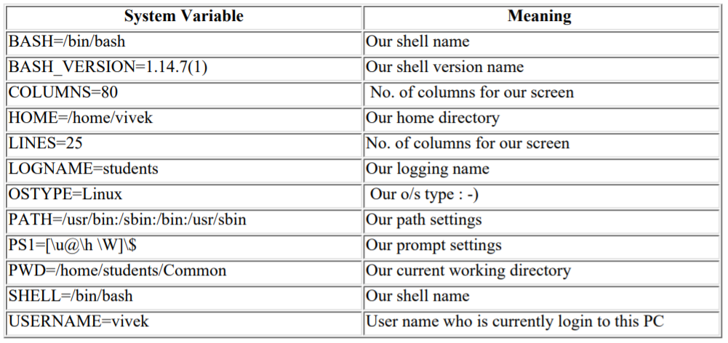

NOTE that Some of the above settings can be different in your PC. You can print any of the above

variables contain as follows

$ echo $USERNAME

$ echo $HOME

Caution: Do not modify System variable this can some time create problems.

2) **User defined variables (UDV)** - Created and maintained by user. This type of variable defined in lower LETTERS.

To define UDV use following syntax

Syntax: variablename=value

NOTE: Here 'value' is assigned to given 'variablename' and Value must be on right side = sign For

e.g.

$ no=10 # this is ok

$ 10=no # Error, NOT Ok, Value must be on right side of = sign.

To define variable called 'vech' having value Bus

$ vech=Bus

To define variable called n having value 10

$ n=10

## **Scp and awk command**

**SCP** (Secure Copy) is command line tool in Linux and Unix like systems which is used to transfer files and directories across the systems securely over the network. When we use scp command to copy files and directories from our local system to remote system then in the backend it makes ssh connection to remote system. In other words, we can say scp uses the same SSH security mechanism in the backend, it needs either password or keys for authentication.

# scp <options> <files_or_directories> user@target_host:/<folder>

**Awk** is a scripting language used for manipulating data and generating reports. The awk command programming language requires no compiling, and allows the user to use variables, numeric functions, string functions, and logical operators. ... Awk is mostly used for pattern scanning and processing.

## **If u want to execute 2 commands in background serially , what to do**

We can start multiple commands as a single job through three steps:

Combining the commands – We can use “;“, “&&“, or “||“ to concatenate our commands, depending on the requirement of conditional logic, for example: cmd1; cmd2 && cmd3 || cmd4

Grouping the commands – We can group the combined commands by “{ }” or “( )“, for example: ( cmd1; cmd2 && cmd3 || cmd4 )

Sending the command group to the background as a job – If we add the & operator after our command group, the shell will run the command group as a background job, for example: ( cmd1; cmd2 && cmd3 || cmd4 ) **&**

## **In shell script what does 2>&1 mean ?**

File descriptor 1 is the standard output (stdout).

File descriptor 2 is the standard error (stderr).

**2>&1 redirects stderr to stdout**.

## **How do u connect to any remote server in jenkins through shell script**

Create a ssh key pair in your jenkins server, log in with the jenkins user than is currently running the app server and execute ssh-keygen command:

$ su devops

$ ssh-keygen

Leave the options by default, a file /your_home/.ssh/id_rsa is generated, take care if you have a previous file, you will not be able to authenticate using the previous key anymore if you choose overwrite.

Copy the public key to remote server, using the command:

$ ssh-copy-id

If the command it’s not available you can do it manually with this:

$ cat ~/.ssh/id_rsa.pub | ssh username@remote_host "mkdir -p ~/.ssh && touch ~/.ssh/authorized_keys && chmod -R go= ~/.ssh && cat >> ~/.ssh/authorized_keys"

Then test your connection

$ ssh username@remote_host

## **How to insert a line inside a file in remote server ? (through shell command)**

echo "Append string to file" | ssh root@my.machine.remote 'cat >> ~/.ssh/authorized_keys'

## **What are shell and python scripting ? Have you worked on any of these?**

## **What are data types in python?**

Every value in Python has a datatype. Since everything is an object in Python programming, data types are actually classes and variables are instance (object) of these classes.

Python has five standard Data Types:

* Numbers
* String
* List
* Tuple
* Dictionary

## **Can you read a pyth scpt if given to you?**

## **Have you used any shell scripts for automation purpose or anything like that?**

## **What are the types of shells?**

SHELL is a program which provides the interface between the user and an operating system.

Types of Shell:

**C Shell (csh)**

**Bourne shell ( sh)**

**Korn shell ( ksh)**

**Bourne Again shell ( bash)**

C Shell – Denoted as csh

Command full-path name is /bin/csh,

Non-root user default prompt is hostname %,

Root user default prompt is hostname #.

Bourne Shell – Denoted as sh

Command full-path name is /bin/sh and /sbin/sh,

Non-root user default prompt is $,

Root user default prompt is #.

Korn Shell - Denoted as ksh

Command full-path name is /bin/ksh,

Non-root user default prompt is $,

Root user default prompt is #.

Bourne-Again Shell – Denoted as bash

It is compatible to the Bourne shell. It includes features from Korn and Bourne shell.

Command full-path name is /bin/bash,

Default prompt for a non-root user is bash-g.gg$

(g.ggindicates the shell version number like bash-3.50$),

Root user default prompt is bash-g.gg#.

## **Advantage of bash shell over others**

Nonportable shell features--*Interactive*.

|  |  |  |  |  |  |  |
| --- | --- | --- | --- | --- | --- | --- |
| **Feature** | sh | csh | ksh | tcsh | bash | zsh |
| Aliases | POSIX | X | X | X | X | X |
| Alias completion | - | - | - | X | X | X |
| Aliases take arguments | - | X | - | X | - | - |
| Automatically list choices for ambiguous completions | - | - | - | X | X | X |
| cd path searches | POSIX | X | X | X | X | X |
| Command aliases | POSIX | X | X | X | X | X |
| Command editing (emacs) | POSIX | - | X | X | X | X |
| Command editing (vi) | POSIX | - | X | X | X | X |
| Command completion | - | X | - | X | X | X |
| Built-in command completion | - | - | - | X | X | X |
| Command documentation being typed | - | - | - | X | - | - |
| Command history | POSIX | X | X | X | X | X |
| Command history appending | POSIX | - | X | - | X | - |
| Co-process support | POSIX | - | X | - | - | X |
| History substitution | - | X | - | X | X | X |
| History expansion | - | - | - | X | X | X |
| Filename completion | POSIX | X | X | X | X | X |
| Filename expansion | POSIX | - | X | X | - | X |
| Function completion | - | - | - | - | X | X |
| Hostname completion | - | - | - | - | X | X |
| Incremental history searching | - | - | - | X | X | X |
| Job control (bg, fg, ...) | POSIX | X | X | X | X | X |
| Log in/out watching | - | - | - | X | - | X |
| Multi-prompt commands in history buffer | POSIX | - | X | - | X | X |
| notify shell built-in | POSIX | X | - | X | X | - |
| One key completion | - | X | - | X | X | X |
| Programmable completion | - | - | - | X | - | X |
| pushd, popd commands and/or other directory stack commands | - | X | - | X | X | X |
| Recursive command-line scans | POSIX | X | - | X | X | - |
| Spelling correction for user ids, commands and filenames | - | - | - | X | - | X |
| Substring selectors :*x* | - | X | - | X | X | X |
| Variable completion | - | - | - | X | X | X |
| Variable expansion | - | - | - | X | X | X |
| Variable editing | - | - | - | - | - | X |
| *(...) wildcards | POSIX | - | X | - | - | X |
| $(...) command expression | POSIX | - | X | - | X | X |
| {...} wildcards | - | X | - | X | X | X |

Nonportable shell features--*Programming*.

|  |  |  |  |  |  |  |
| --- | --- | --- | --- | --- | --- | --- |
| **Feature** | **sh** | **csh** | **ksh** | **tcsh** | **bash** | **zsh** |
| Arithmetic expressions | POSIX | X | X | X | X | X |
| Array variables | POSIX | X | X | X | X | X |
| Assignment id=string | X | - | X | - | X | X |
| case statement | X | - | X | - | X | X |
| clobber option | POSIX | X | X | X | X | X |
| echo -n option | - | X | - | X | X | X |
| for statement | X | - | X | - | X | X |
| export command | X | - | X | - | X | X |
| foreach statement | - | X | - | X | - | X |
| getopts built-in command | POSIX | - | X | - | X | X |
| glob command | - | X | - | X | - | - |
| Hash table problems, rehash and unhash commands | - | X | - | X | - | - |
| let command | POSIX | - | X | - | X | X |
| limit, unlimit commands | - | X | - | X | - | X |
| nice shell built-in | - | X | - | X | - | - |
| nohup shell built-in | - | X | - | X | - | - |
| onintr command | - | X | - | X | - | - |
| print command | POSIX | - | X | - | X | X |
| Redirection from iterative statements | X | - | X | - | X | X |
| RANDOM shell variable | POSIX | - | X | - | X | X |
| repeat shell built-in | - | X | - | X | - | X |
| select statement | POSIX | - | X | - | X | X |
| setenv, unsetenv commands | - | X | - | X | - | - |
| SHELL variable specifies command to execute scripts | - | X | - | X | - | - |
| switch statement | - | X | - | X | - | - |
| until statement | X | - | X | - | X | X |
| set -*x* | X | - | X | - | X | X |
| set *optionname* | - | X | - | X | X | X |
| Shell functions | X | - | X | - | X | X |
| trap command | X | - | X | - | X | X |
| typeset command | POSIX | - | X | - | X | X |
| ulimit command | X | - | X | - | X | X |
| Undefined variable is an error | - | X | - | X | - | - |
| ! special character | - | X | - | X | X | X |
| @ command | - | X | - | X | - | - |
| >& redirection | - | X | - | X | X | X |

## **Switches of bash shell**

In shell scripting switch case is represented using keywords case and esac which will do multilevel branching and checking in a better way than multiple if-else conditions. Switch case will need an expression which it needs to evaluate and need to perform multiple operations based on the outcome of the expression.

This script is to demonstrate the usage of the case statement.

$ cat signal.sh

#!/bin/bash

if [ $# -lt 2 ]

then

echo "Usage : $0 Signalnumber PID"

exit

fi

case "$1" in

1) echo "Sending SIGHUP signal"

kill -SIGHUP $2

;;

2) echo "Sending SIGINT signal"

kill -SIGINT $2

;;

3) echo "Sending SIGQUIT signal"

kill -SIGQUIT $2

;;

9) echo "Sending SIGKILL signal"

kill -SIGKILL $2

;;

*) echo "Signal number $1 is not processed"

;;

esac

In the above example:

$1 and $2 are the signal number and process id respectively.

Using kill command, it sends the corresponding signal to the given process id.

It executes the sleep command for a number of seconds.

The optional last comparison *) is a default case and that matches anything.

Usage of the above shell script: Find out the process id of the sleep command and send kill signal to that process id to kill the process.

## **How will you read a file in a shell?**

**Reading File Using 'cat fileName'**

#!/bin/bash

value=`cat read_file.txt`

echo "$value"

**Reading File Using '$(<fileName>)**

#!/bin/bash

value=$(<read_file.txt)

echo "$value"

**Reading File Content from Command-line**

$ while read line; do Command; done < input.file

$ while read line; do echo $line; done < input.file

**Reading File Content Using Script**

#!/bin/bash

file='read_file.txt'

i=1

while read line; do

#Reading each line

echo "Line No. $i : $line"

i=$((i+1))

done < $file

**Passing filename from Command line and reading the File**

#!/bin/bash

file=$1

while read line; do

#Readind each line in sequence

echo $line

done <read_file.txt

## **What will be the output for ‘$$’ and ‘$?’**

echo $? will return the exit status of last command.

echo $$ returns PID of the current process.

## **How will you check if the file is empty or not?**

The **-s** option to the test builtin check to see if FILE exists and has a size greater than zero. It returns true and false values to indicate that file is empty or has some data.

#!/bin/bash

_file="$1"

[ $# -eq 0 ] && { echo "Usage: $0 filename"; exit 1; }

[ ! -f "$_file" ] && { echo "Error: $0 file not found."; exit 2; }

if [ **-s** "$_file" ]

then

echo "$_file has some data."

# do something as file has data

else

echo "$_file is empty."

# do something as file is empty

fi

## **How will you check the shell script is right or not?**

**Enabling Syntax Checking Debugging Mode in Shell Scripts**

Coming back to our topic of emphasis, The -n activates syntax checking mode. It instructs the shell to basically read all the commands, however doesn’t execute them, it (shell) only examines the syntax used.

Sample Script:

#!/bin/bash

#convert

for image in *.png; do

convert "$image" "${image%.png}.jpg"

echo "image $image converted to ${image%.png}.jpg"

done

exit 0

In case there are errors in your shell script, the shell will output the errors on the terminal, otherwise, it displays nothing.

**The syntax for activating syntax checking is as follows:**

**$ bash -n script.sh**

Because the syntax in the script is correct, the command above will not display any output. Therefore, let us try to remove the done word that closes the for loop and see if it shows an error:

$ bash -n script.sh

**script.sh: line 11: syntax error: unexpected end of file**

## **How will you read an array input?**

#!/bin/bash

# To declare static Array

arr=(1 2 3 4 5)

# loops iterate through a set of values until the list (arr) is exhausted

for i in "${arr[@]}"

do

# access each element

# as $i

echo $i

done

## **How will you do debugging in shell scripting?**

Bash shell offers debugging options which can be turn on or off using the set command:

**set -x** : Display commands and their arguments as they are executed.

**set -v** : Display shell input lines as they are read.

**$bash** -vx <script.sh>

## **Diff betn shell and command module**

In most of the use cases, both shell and command modules perform the same job. However, there are few main differences between these two modules.

**Variable and Operations support**

While using the Command module, the commands will not be executed through a shell. Consequently, variables like $HOME are not available, and operations like <, >, | and & will not work in this case. If you want to use these variables and operations, you need to use a shell module.

**Command execution**

In the Shell module, commands are executed through a shell or by default in the remote node ‘/bin/sh’. As we have mentioned above, in the command module, commands execution is not processed through the shell. The location can be changed with an executable option. Piping and redirection features are therefore available in the shell module.

**Security**

If you want to run a command predictably and securely then, it is recommended to use the command module instead of the shell. The command module will not be affected by the user’s environment, so; it is more secure than the shell module.

**Conclusion**

Although both modules are useful, you should first check whether a more specific Ansible module is available for the given task. It is best practice to use modules instead of executing the raw command because modules fulfill all standards, including exception handling. If you find there is no module available, it is more secure to use the command modules because tasks will not be affected through the user environment setup. Use the shell modules if you need some specific variable features and operations.

## **How to kill the process or script? ( kill -9 <pid>) What does the numbers mean in ‘kill -9’ <pid>?**

**What Processes Can You Kill in Linux?**

Before killing or terminating a process, you need to consider permissions.

A root user can kill all processes. You can either add sudo before a command to run it as root, or obtain a root shell with su.

**Step 1: View Running Linux Processes**

To view a list of all currently running processes, use the command:

# **top**

**Step 2: Locate the Process to Kill**

Before you can kill a process, you need to find it. There are multiple ways you can search for a process in Linux.

Locate a Process with ps Command

# **ps -aux**

-a. View processes of all users rather than just the current user.

-u. Provide detailed information about each of the processes

-x. Include processes that are controlled not by users but by daemons.

Finding the PID with pgrep or pidof

# **pgrep <options> <pattern>**

Here are the options that can be used with this command:

-l. List both the process names and the PIDs.

-n. Return the process that is newest.

-o. Return the process that is oldest.

-u. Only find processes that belong to a specific user.

-x. Only find processes that exactly match the given pattern.

pgrep -u root displays all processes owned by root.

The pidof command is used to find the ID of a process, provided that you know the name of the process.

**pidof <options> <program>**

A few options can be included, such as:

-c. Only return PIDs within a single root directory.

-o. Omit certain PIDs (include the processes to omit after the flag).

-s. Only return a single PID.

-x. Also returns PIDs of shells that are running scripts.

**Step 3: Use Kill Command Options to Terminate a Process**

kill Command: If you know a process ID, you can kill it with the command:

kill -9 Linux Command

kill -9 is a useful command when you need to shut down an unresponsive service. Run it similarly as a regular kill command:

# **kill -9 <processID>**

Or

# **kill -SIGKILL <processID>**

## **What does ‘>1’ means? ( may be for error files in logs and outputs context)**

A file descriptor is a number that refers to an already open file. The standard ones are 0 for standard input, 1 for standard output or 2 for standard error.

0 for standard input

1 for standard output

2 for standard error

2> /dev/null means to redirect standard error to /dev/null . /dev/null is a special device that discards everything that is written to it.

## **How to check the execution status( cmd execution status) of any cmd? ( mkdir in this case)**

**$?** will return the exit status of last command

## **What is $0**

**$0** simply shows you the name of the currently running process

## **How to get present working dir in shell scripting?**

Below is a snippet that will print the PWD and the installed directory:

#!/bin/bash

echo "Script executed from: ${PWD}"

BASEDIR=$(dirname $0)

echo "Script location: ${BASEDIR}"

## **How to check whether particular port is already in use or not?**

That should give you pid & name of the process that holds port 80

**# sudo netstat -anp | grep ':80 '**

It will return TRUE if the port is already in use, or FALSE is it (i.e, available not listening currently).

**# nc -z IP PORT**

# nc -z 127.0.0.1 80

## **Comma delimited in shell (reiterate through all the values)**

I have this file with 20k+ IPs inside:

104.20.15.220,104.20.61.219,104.20.62.219,104.20.73.221,104.20.74.221,104.20.14.220

104.20.15.220,104.20.73.221,104.20.74.221,104.25.195.107,104.25.196.107,104.20.14.220

91.215.154.209

...

The question is how to split in into single IPs on each string:

104.20.15.220

104.20.61.219

replace a comma with a new line with below command

**awk 'gsub(/,/,"\n")' file**

They all return:

104.20.15.220

104.20.61.219

104.20.62.219

104.20.73.221

...

## **Orc/ok/oc in shell scripting ( check it)**

## **What is shebang in shell scripting?**

The single statement works fine as long as you use Bash or a shell compatible with the commands used in the script. **If no shell is specified in the script, the default shell will be used to execute the script commands.**

The next task is to ensure that the script will run using the Bash shell, even if another shell is the default. This is accomplished with the shebang line. Shebang is the geeky way to describe the #! characters that explicitly specify which shell to use when running the script. In this case, that is Bash, but it could be any other shell. If the specified shell is not installed, the script will not run.

Add the shebang line as the first line of the script, so now it looks like this:

**#!/usr/bin/bash**

echo "Hello world!"

## **How to replace a particular value in a text file or any file in shell?**

Find and replace text within a file using sed command

The procedure to change the text in files under Linux/Unix using sed:

**Use Stream EDitor (sed) as follows:**

**$ sed -i 's/old-text/new-text/g' input.txt**

The s is the substitute command of sed for find and replace

It tells sed to find all occurrences of ‘old-text’ and replace with ‘new-text’ in a file named input.txt

Verify that file has been updated:

$ more input.txt

Example:

$ cat hello.txt

The is a test file created by nixCrft for demo purpose.

foo is good.

Foo is nice.

I love FOO.

**$ sed -i 's/foo/bar/g' hello.txt**

$ cat hello.txt

The is a test file created by nixCrft for demo purpose.

bar is good.

bar is nice.

I love bar.

Note: s - substitute, g - global or all occurences

## **How can I access the jenkins specific env. variables in my workspace variables in any jenkins scripts or execute shell?**

All the environment variable can be used by surrounding with ${}

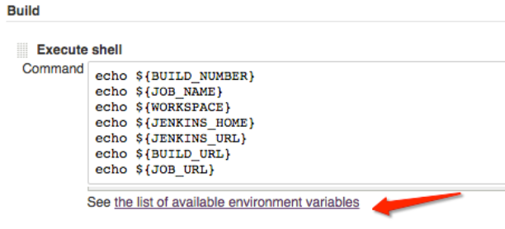

## **How to use bash script in ansible?**

Ansible Shell module to execute a Single Command.

Ansible Shell – Execute a Command with Pipe and Redirection.

Execute a Shell Script with Ansible Shell command.

Run a Shell command in a specific directory.

Run a Shell Command only if the file present or not present.

touch test.sh

#!/bin/bash

echo "Hello World"

**Playbook:**

- name: Transfer and execute a script.

hosts: server

user: test_user

sudo: yes

tasks:

- name: Transfer the script

copy: src=test.sh dest=/home/test_user mode=0777

- name: Execute the script in local

local_action: command sudo sh /home/test_user/test.sh

- name: Execute the script in remote

command: sh /home/test_user/test.sh

## **Shell script for moving the backup file ( backup copy) will move tp central linux system server ( nfs mount point) and run it daily.**

**Backup script**

**Step 1 - archive the content**

Note: make sure the destination folder exists first. If not create it using the following command:

# mkdir /backup

# tar -cvpzf /backup/backupfilename.tar.gz /data/directory

# tar -cvpzf /backup/admfactory.com.tar.gz /var/www/html

Tar command explained

tar = Tape archive

c = Create

v = Verbose mode will print all files that are archived.

p = Preserving files and directory permissions.

z = This will tell tar that to compress the files.

f = It allows tar to get the file name.

**Step 2 - create backup script**

Now let's add tar command in a bash script to make this backup process automatic. Also it good to add some dynamic value in the name to make sure there is no overwriting of backup files. e.g.

# vi /backup.sh

Paste the following script and change your details.

#!/bin/bash

TIME=`date +%b-%d-%y` # This Command will read the date.

FILENAME=backup-admfactory-$TIME.tar.gz # The filename including the date.

SRCDIR=/var/www/html # Source backup folder.

DESDIR=/backup # Destination of backup file.

**tar -cpzf $DESDIR/$FILENAME $SRCDIR**

Note: I removed the v parameter for tar command line as is not needed.

Automation

In Linux, we can easily use the cron jobs in order to schedule task.

The cron jobs line has 6 parts see below explanation:

Minutes Hours Day of Month Month Day of Week Command

0 to 59 0 to 23 1 to 31 1 to 12 0 to 6 Shell Command

Open crontab editor utility:

# crontab -e

Note: the edit rules are similar with vi editor.

Paste the following text in the editor:

# M H DOM M DOW CMND

00 04 * * * /bin/bash /backup.sh

This will run the script every day at 04:00:00.

## **To print a specific line from a file ( xml or anything). ( awk , rsync cmd )**

Syntax in Bash Script

1. awk :

**awk '{if(NR==LINE_NUMBER) print $0}' file.txt**

1. sed :

sed -n LINE_NUMBERp file.txt

1. head :

head -n LINE_NUMBER file.txt | tail -n + LINE_NUMBER

Here LINE_NUMBER is, which line number you want to print

Examples:

Print a line from single file

To print 4th line from the file then we will run following commands. The output of following lines will be “articles”.

1. awk :

awk '{if(NR==4) print $0}' file.txt

1. sed :

sed -n 4p file.txt

1. head :

head -n 4 file.txt | tail -n + 4

## **How to copy files from local windows machine to cloud based Linux machine?**

$ scp [Options] [Source] [Destination]

$ scp /path/of/your/local/file.ext username@remote-server-IP:path/of/remote/file.ext -i key.pem

## **A shell script named test.sh can accept 4 parameters i.e, a,b,c,d. the parameters wont be supplied in order always and number of parameters might also vary( only 2 parameters user might supply sometimes), how to identify position of letter c?**

#!/bin/bash

point=$1 #initially points to first parameter

i="0"

while [$i -le $#] # $# is the number of positional parameters passed to the script

do

i=$[$i+1]

point=$i #increment count to point to next positional parameter

if [ $i -eq "c" ]

then

echo "position of letter c was in ${i} position"

fi

done

## **write a script which accepts file or folder, if its folder delete it else print "this is a file"?**

#!/bin/bash

if [ -d $1 ]

then

echo "Folder $1 exists and deleting the folder ."

rm -r $1

else

echo "this is a file."

Fi

## **Logic for checking whether supplied string for a script is palindrome or not? what are all the commands you will use?**

#!/bin/bash

read -p "Enter a string: " string

if [[ $(rev <<< "$string") == "$string" ]]; then

echo Palindrome

fi

## **command to get number of lines in a file?**

wc -l <filename>

## **In a file I have ip addresses , I want list unique ip addresses with number of times its present in file?**

**Counting IP Addresses in a Log File**

**How can I find unique ip addresses in a log file?**

We can use the uniq command to remove duplicate ip addresses, but uniq needs a sorted input. We can do that with the sort command, like so:

**grep -o "[0-9]\+\.[0-9]\+\.[0-9]\+\.[0-9]\+" httpd.log | sort | uniq**

**Show me the number of times each IP shows up in the log**

Now we can use the -c flag for uniq to display counts:

**grep -o "[0-9]\+\.[0-9]\+\.[0-9]\+\.[0-9]\+" httpd.log | sort | uniq -c**

This will output something like:

7 10.0.0.30

1 10.0.0.80

3 10.0.0.70

The ip counts are not in order, so we can pass our results through sort again, this time with the -n flag to use a numeric sort.

**grep -o "[0-9]\+\.[0-9]\+\.[0-9]\+\.[0-9]\+" httpd.log | sort | uniq -c | sort –n**

The above will put them in order from least to greatest, you can pipe the result to tail if you only want to see the top N IP addresses!

Pretty handy right? It works great for counting or finding ip addresses in nginx, apache or any kind of log files with ip addresses.

Try the below also:

grep -E -o "([0-9]{1,3}[\.]){3}[0-9]{1,3}" logfile | sort | uniq -c | sort –nr

## **What is exit status in UNIX?**

Each Linux or Unix shell command returns a status when it terminates normally or abnormally. For example, if backup.sh script is unsuccessful, and it returns a code which tells the shell script to send an e-mail to sysadmin.

What is an exit code in bash shell?

Every Linux or Unix command executed by the shell script or user has an exit status. Exit status is an integer number. **0 exit status means the command was successful without any errors**. **A non-zero (1-255 values) exit status means command was a failure.**

How to find out the exit code of a command

You need to use a particular shell variable called $? to get the exit status of the previously executed command. To print $? variable use the echo command or printf command:

A sample shell script to get the exit code of a command

#!/bin/bash

#

# Sample shell script to demo exit code usage #

#

set -e

## find ip in the file ##

grep -q 192.168.2.254 /etc/resolv.conf

## Did we found IP address? Use exit status of the grep command ##

if [ **$?** -eq 0 ]

then

echo "Success: I found IP address in file."

exit 0

else

echo "Failure: I did not found IP address in file. Script failed" >&2

exit 1

fi

| Exit Codes With Special Meanings | |
| --- | --- |
| **Exit status** | **Description** |
| 1 | Catchall for general errors |
| 2 | Misuse of shell builtins (according to Bash documentation) |
| 126 | Command invoked cannot execute |
| 127 | Command not found |
| 128 | Invalid argument to exit command |
| 128+n | Fatal error signal “n” |
| 130 | Bash script terminated by Control-C |
| 255* | Exit status out of range |

## **Lets say I have shell script name magic.sh when I execute. It gives “This is from magic.sh”, so now if I change file name to magic-test.sh I should get “This is from magic-test.sh” basically as name of file chages my output should also change?**

#!/bin/bash

if [ $0 -eq "magic.sh" ]

then

echo "This is from magic.sh"

else

echo "This is from magic-test.sh"

fi

## **Command to find empty files in a given directory?**

find . -name '*.*' -size 0

## **Commands you will use it for configuring ssh connectivity between 2 machines and what files will be present in .ssh folder?**

**Step One—Create the RSA Key Pair**

$ ssh-keygen -t rsa

**Step Two—Store the Keys and Passphrase**

Enter file in which to save the key (/home/demo/.ssh/id_rsa):

**Step Three—Copy the Public Key**

$ ssh-copy-id demo@198.51.100.0

**what files will be present in .ssh folder**

**Public and Private Keys**

identity

identity.pub

id_dsa

id_dsa.pub

**Other Important Files**

authorized_keys

known_hosts

config

## **How to schedule a shell script in unix machines?**

<minute> <hours> <day_of_month> <month> <day_of_week> <command_to_run>

minute: 0 to 59

hours: 0 to 23

day of the month: 1 to 31

month: 1 to 12

day of the week: 0 (Sunday) to 6 (Saturday)

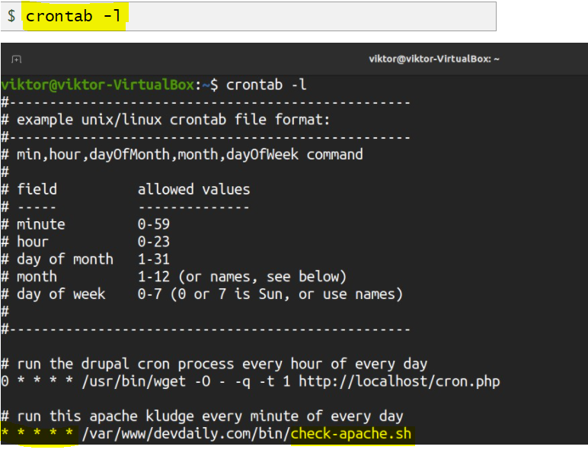

## **Command to get load average ?**

Linux load averages are "system load averages" that show the running thread (task) demand on the system as an average number of running plus waiting threads. This measures demand, which can be greater than what the system is currently processing. Most tools show three averages, for 1, 5, and 15 minutes:

$ **uptime**

16:48:24 up 4:11, 1 user, load average: 25.25, 23.40, 23.46

top - 16:48:42 up 4:12, 1 user, load average: 25.25, 23.14, 23.37

$ **cat /proc/loadavg**

25.72 23.19 23.35 42/3411 43603

**Some interpretations:**

If the averages are 0.0, then your system is idle.

If the 1 minute average is higher than the 5 or 15 minute averages, then load is increasing.

If the 1 minute average is lower than the 5 or 15 minute averages, then load is decreasing.

If they are higher than your CPU count, then you might have a performance problem (it depends).

As a set of three, you can tell if load is increasing or decreasing, which is useful.

# GIT

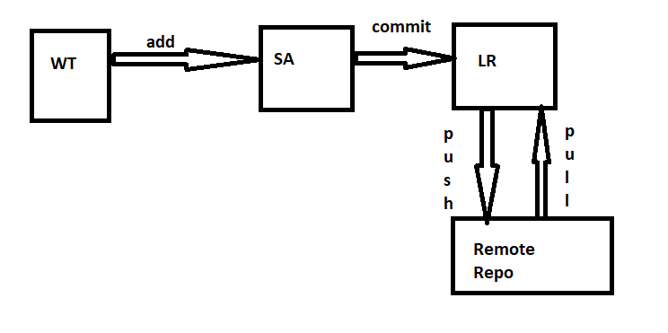

## **Diff between reset and revert in git**

git revert is used to undo a previous commit.

git revert is for undoing committed changes

git reset is used to undo changes in your working directory that haven't been comitted yet.

git reset HEAD is for undoing uncommitted changes.

## **Git pull vs git fetch**

If you do a **git fetch** it will just fetch all the changes in the remote repository (Github) and move the origin/master pointer to HEAD. Meanwhile your local branch master will keep pointing to where it has.

If you do a **git pull**, it will do basically fetch (as explained previously) and merge any new changes to your master branch and move the pointer to HEAD.

So, **git pull=git fetch + merge.**

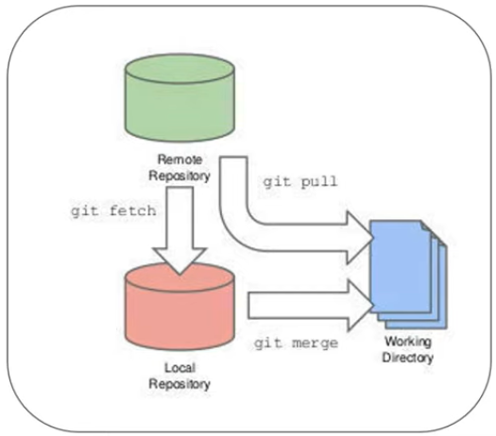

## **I did wrong commit and i want to go back to previous, what to do**

Undo a local commit

**git reset HEAD <file-name>** (revert the changes from staging area) Note- After reset, it places the file in working area.

**git reset HEAD~** (revert the last commit from local repo)

**git checkout -- <file-name>** (discard the changes from the staging area)

Undo a public commit

**git revert HEAD** (Your changes will now be reverted and ready for you to commit and push)

## **Explain Git stash**

GIT Stash is used to save your uncommit Changes so that you can work on something else and revert them from your Working Directory.

**git stash** (send the uncommited files to stash area)

**git stash apply** (bring back the uncommited files from stash area)

**git stash list** (List the stash)

**git stash drop** (removes the stash)

## **How can i merge 2 branch**

git checkout master (Change the active branch back to master)

**git merge develop** (merge the "develop" branch into master)

git push origin master

## **Explain git cherrypick**

git cherry-pick is a command that picks a particular commit by reference and appended to the current working HEAD.

Cherry picking is the act of picking a commit from a branch and applying it to another.

git cherry-pick can be useful for undoing changes and restoring lost commits.

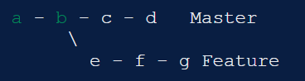

git checkout master

git cherry-pick f

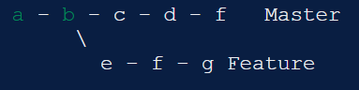

## **Revert a commit that has been pushed to github**

**git revert {commit_id}**

**git revert HEAD -m 1**

In the above code line. "Last argument represents"

1 - reverts one commits.

2 - reverts last two commits.

n - reverts last n commits.

Git revert creates a new commit that reverts the changes made by another commit.

## **How to squash last 10 commits to 1 single commit**

Squash commits into one with Git

A nice way to group some changes together, especially before sharing them with others.

Step-1: Choose your starting commit

The first thing to do is to invoke git to start an interactive rebase session:

**git rebase --interactive HEAD~10** (where 10 is the number of commits you want to join)

Step-2: picking and squashing

At this point your editor of choice will pop up, showing the list of commits you want to merge.

Note that it might be confusing at first, since they are displayed in a reverse order, where the older commit is on top.

You mark a commit as squashable by changing the word pick into squash next to it.

Save the file and close the editor.

Step-3: Create the new commit

You have just told Git to combine all seven commits into the first commit in the list.

It's now time to give it a name: your editor pops up again with a default message, made of the names of all the commits you have squashed.

## **What is staging area in git**

There are three places in Git where file changes can reside, and these are working directory, staging area, and the repository.

Staging is a step before the commit process in git.

**git add <filename>** (move the changes from working area to staging area)

## **Diff between git clone and git checkout**

git clone is to fetch your repositories from the remote git server.

git checkout used to switch between versions of code already on the local system.

E.g., you are currently on master branch and you want to switch into develop branch.

## **How to change branch in git**

git checkout <branch-name>

## **Benefits of git over svn**

Git is distributed.

No more single point of failure.

It’s available offline.

It’s faster to commit. Because you commit to the central repository more often in SVN, network traffic slows everyone down.

Whereas with Git, you're working mostly on your local repository and only committing to the central repository every so often.

## **Diff between git and github**

Git is a version control system that lets you manage and keep track of your source code history.

GitHub is a cloud-based hosting service that lets you manage Git repositories.

If you have open-source projects that use Git, then GitHub is designed to help you better manage them.

## **Diff between git pull and git update and git fetch**

git fetch is the command that tells your local git to retrieve the latest meta-data info from the original (yet doesn't do any file transferring. It's more like just checking to see if there are any changes available).

git pull brings (copy) changes from the remote repository to local repository.

Update is not a git command

## **How to resolve merge conflicts**

Merge "develop" branch into "master" branch.

Steps-

git checkout master

git merge develop -m "merging develop with master"

How to Resolve Merge Conflicts in Git?

1. The easiest way to resolve a conflicted file is to open it and make any necessary changes. If the conflict is related to code file then contact the developer.
2. After editing the file, we can use the git add a command to stage the new merged content.
3. The final step is to create a new commit with the help of the git commit command.
4. Git will create a new merge commit to finalize the merge.

## **How to find list of files changed after a particular commit**

git log --oneline --decorate --graph --all

Changes since last commit:

**git diff** will show you any uncommitted changes since the last commit.

## **How did u use git web hooks in ur project**

A webhook is a mechanism to automatically trigger the build of a Jenkins project upon a commit pushed in a Git repository.

In order for builds to be triggered automatically by PUSH and PULL REQUEST events, a Jenkins Web Hook needs to be added to each GitHub repository. You need admin permissions on that repository.

Jenkins automatically create a build if it detects changes to a GitHub repository. This can be a very useful improvement to continuous integration setup with Jenkins because this method is only telling Jenkins to attempt a new build when a change is detected rather than polling on an interval, which can be a very inefficient.

## **How to configure email while setting up git**

git config --global user.name myusername

git config --global user.email myemail

git config --global github.user myusername

git config --global github.token mytoken

## **What is merging and raising a pr request**

Pull/Merge requests are created if you are working in a feature branch and wants to merge your change in main branch (eg. Master branch).

Raising and managing Pull Request or **PR** (as its called in Github and Bitbucket ) or Merge Request or **MR** (as its called in Gitlab) is probably the most regular part of a Developer’s day to day workflow, when working in a team.

## **How did u manage tagging in ur git**

How will you identify specific release versions of your code?. Tagged with git, tags.

Tags are ref's that point to specific points in Git history.

Tagging is generally used to capture a point in history that is used for a marked version release (i.e. v1.0.1).

Commands :

git tag <tag_name>

git tag –-list

git tag --delete <tag_name>

git tag -a v1.0 (Annotated tag)

git tag show v1.0

git log --oneline --decorate --graph --all

git diff <tag-1> <tag-2>

git tag -a beta1.0 <commit-id-1> (This is how we tag a Specific Commit in GIT)

git tag -a beta1.0 -f <commit-id-2> (Update Tags in GIT. Now tag "beta1.0" point to commit-id-2)

git log --oneline --decorate --graph --all (Now we can see tag has been moved to commit-id-2)

## **Diff ben distributed VCS and centralized VCS**

**Centralized VCSs** keep the history of changes on a central server from which everyone requests the latest version of the work and pushes the latest changes to. ...

On the other hand, on a **Distributed VCS**, everyone has a local copy of the entire work's history.

## **Explain git flow model**

Git Flow is a branching model that places meaning on different branches. Each feature is developed in its own branch, and merged into a standard 'develop' branch. To perform a release, the 'develop' branch is merged into master. ... At any time you can checkout any other feature branch to easily move between tasks.

The Gitflow Workflow defines a strict branching model designed around the project release. This provides a robust framework for managing larger projects.

The overall flow of Gitflow is:

1. A develop branch is created from master
2. A release branch is created from develop
3. Feature branches are created from develop
4. When a feature is complete it is merged into the develop branch
5. When the release branch is done it is merged into develop and master
6. If an issue in master is detected a hotfix branch is created from master
7. Once the hotfix is complete it is merged to both develop and master

## **Diff betn continuos delivery and continuos deployment**

**Continuous Delivery**

Continuous Delivery is a software development practice where you build software in such a way that the software can be released to the production at any time.

You achieve Continuous Delivery by continuously integrating the products built by the development team, running automated tests on those built products to detect problems, and then push those files into production-like environments to ensure that the software works in production.

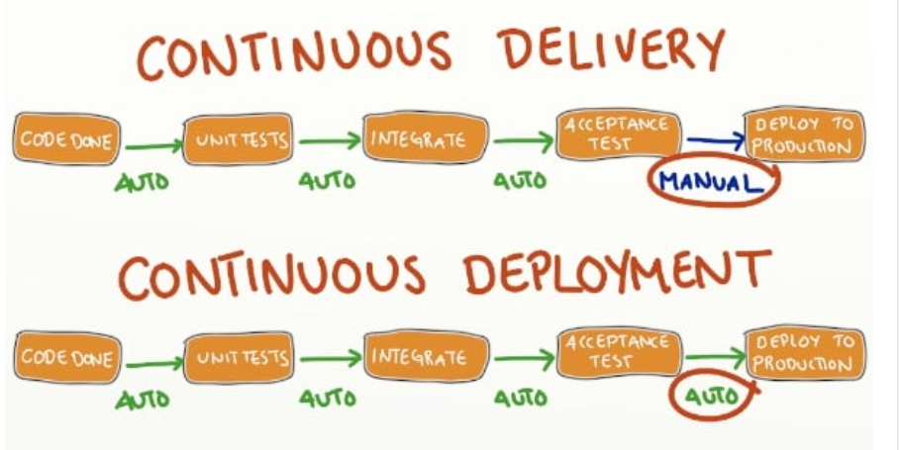

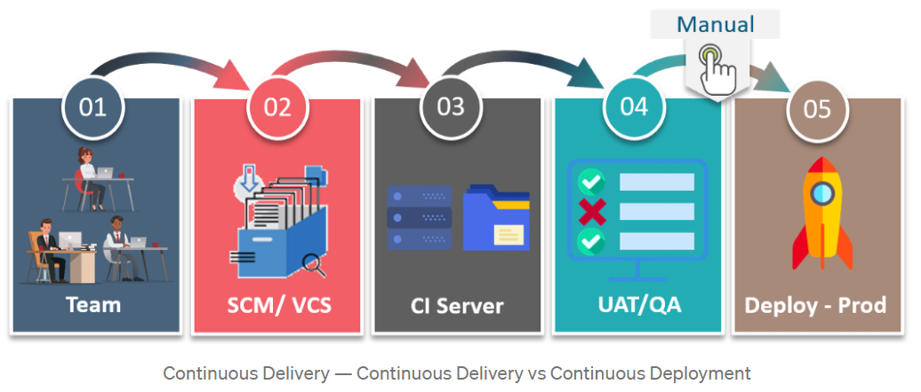

**Continuous Deployment**

Continuous deployment means that every change that you make, goes through the pipeline, and if it passes all the tests, it automatically gets deployed into production. So, with this approach, the quality of the software release completely depends on the quality of the test suite as everything is automated.

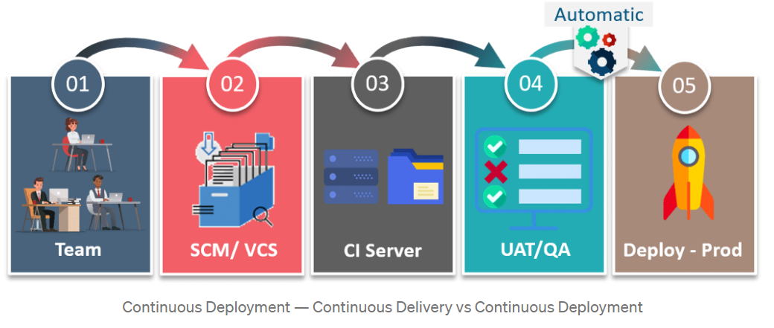

Using Continuous Deployment, there’s no release approval required. So, the code moves automatically from the developer site to the production site, which is not the case with continuous delivery.

It is always recommended that we should not use, Continuous Deployment as we need to consider many factors before releasing the software like marketing the product before it’s out to the world, but we must do Continuous Delivery so that we have the capability to deliver the software to any given environment at any given time.

## **Different phases of continuous integration**

Continuous integration is a DevOps software development practice where developers regularly merge their code changes into a central repository, after which automated builds and tests are run.

Stage 1 – Build/Assembly

Stage 2 – Unit Test

Stage 3 – Code Quality Analysis

Stage 4 – Integration Test

Stage 5 – Acceptance/End-to-End Tests

Stage 6 – Store Versioned Binary Artifact

## **Tell your branching strategy.**

## **What is git stash and unstash? Why they are used?**

git stash temporarily shelves (or stashes) changes you've made to your working copy so you can work on something else, and then come back and re-apply them later on.

GIT Stash is used to save your uncommit Changes so that you can work on something else and revert them from your Working Directory.

git stash (send the uncommited files to stash area)

git stash apply (bring back the uncommited files from stash area)

git stash list (List the stash)

git stash drop (removes the stash)

## **Diff betn git apply,git pop and git unstash**

git stash apply //apply the changes without removing stored files from stash area.

git stash pop // apply the changes as well as remove stored files from stash area.

git stash apply (bring back the uncommited files from stash area)

git stash list (List the stash)

git stash drop (removes the stash)

-Stash with Message

git stash save “message text”

-Find changes done in specific stash

git stash show stash@{Index}

-Apply Specific stash

git stash apply stash@{index}

-Drop specifc stash

git stash drop stash@{index}

-Clear all Stashes

git stash clear

-Stash all files

git stash -a

## **Git rebase**

Rebasing is the process of moving or combining a sequence of commits to a new base commit. Rebasing is most useful and easily visualized in the context of a feature branching workflow. The general process can be visualized as the following:

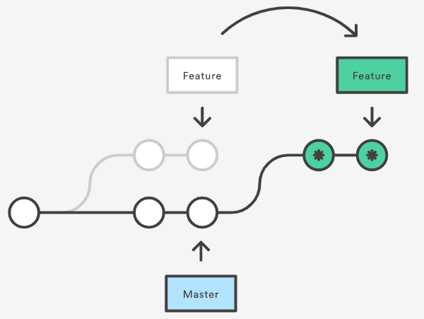

The primary reason for rebasing is to maintain a linear project history. For example, consider a situation where the master branch has progressed since you started working on a feature branch. You want to get the latest updates to the master branch in your feature branch, but you want to keep your branch's history clean so it appears as if you've been working off the latest master branch. This gives the later benefit of a clean merge of your feature branch back into the master branch.

Rebase

-------

Switch to feature branch- git checkout develop

Apply rebase to master- git rebase master

Merge conflict in rebase

------------------------

Abort the rebase- git rebase --abort

git checkout master

-update file1 and commit in master

git checkout develop

-update file1 and commit in develop

git rebase master

-Now merge conflict during rebase happens.

-Resolve the conflicts in file1 and commit

git rebase --continue

Rebase remote repository

--------------------------

-Update some file directly in remote repo.

git status

-It shows upto date.

git fetch

git status

git pull --rebase origin master

git log --oneline --decorate --graph --all

-This is how , we can rebase the local repo with remote repo.

git push origin master

-Cleanup after rebase

git checkout master

git merge develop

git branch -d develop

git status

## **Explain git process**

## **Reverting in git when wrong commit or anything happens in the whole process**

git revert {commit_id}

## **Git remote –b**

Git remote repository is the one of the server

To fetch the data from your remote projects: $ git fetch <remote>

List your existing remotes: $ git remote -v

## **How many developers are there in QA and dev team?**

8 Developers to 2 QA

## **Git caps ( merge,conflict)**

Conflicts generally arise when two people have changed the same lines in a file, or if one developer deleted a file while another developer was modifying it.

How to Resolve Merge Conflicts in Git?

The easiest way to resolve a conflicted file is to open it and make any necessary changes.

After editing the file, we can use the git add a command to stage the new merged content.

The final step is to create a new commit with the help of the git commit command.

Git will create a new merge commit to finalize the merge.

Merging- Happy Path in GIT

List local Branches: git branch

Create & CheckOut Branch

Verify Difference between Branches

Merge one Branch to Another Branch- git merge <Source>

Ex- Merge "develop" branch into "master" branch.

Steps-

git checkout master

git merge develop -m "merging develop with master"

**Note**: If conflicts has happened in code file then work with developer to resolve the conflicts.

## **What to do if 100 or more conflicts happen during merging?**

Work with developers to resolve the conflicts.

## **What to do if you wanna override the dev branch code in the master branch while merging having more conflicts? ( consult with developer and see if u can do it manually)**

## **Who is maintaining repository github?**

## **How to add hookscripts? ( github reference)**

Hook scripts allow you to customize Git’s internal behavior and trigger customizable actions at key points in the development life cycle. They are programs that run automatically every time a particular event occurs in a Git repository, such as a push or merge. As a system admin, you can add one hook script and then enable (i.e.: configure) it for the entire system, all the repositories in selected projects, or individual repositories.

In addition:

* you can use pre-commit hook scripts to reject pushes
* hook scripts can echo information to the user’s terminal to tell them why their commit was rejected or give other information

## **How to revert some checkin already pushed to the remote repo? (using Git commit id)**

git revert <commit-id>

## **Rebasing in git**

Rebase command integrates changes from one branch into another. It is an alternative to the better known "merge" command. Most visibly, rebase differs from merge by rewriting the commit history in order to produce a straight, linear succession of commits.

git checkout develop (Switch to feature branch)

git rebase master (Apply rebase to master)

## **Tell me about developer work flow in git**

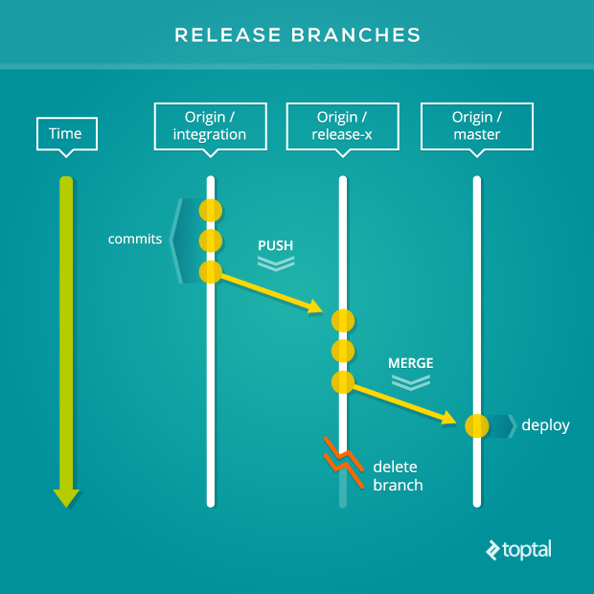

## **Diff betn reset and revert**

**git revert**: Undoes a change part of a commit to the local/origin repo by creating a new commit.

command: git revert <id>

**git reset**: Git reset will delete/undo changes which are committed in local repo. It undo changes by 3 ways, –soft, –mixed, –hard. Where mixed is the default value.

Working Dir (coding ) -> Staging Area(Index) -> local Repo (git push)

git reset –soft/mixed/hard –HEAD~N -> mixed is default

git reset --soft HEAD~N # will move file/changes from local commit to staging area

git reset --mixed HEAD~N #will move file/changes from local commit to working directory

git reset --hard HEAD~N #will delete file /changes from working directory

## **Have you done any deployment automation?**

Automated deployment is a form of deployment where the defined steps for shipping code from a development environment to staging/production environment is a one-step procedure and fully or partially automated.

Benefits of Automated deployment

Deployments become much less error-prone and much more repeatable

You can release more frequently

## **Why we need git ? what makes it diff and unique from other tools like SVN?**

Git is a free and open-source distributed version control system

Git is a distributed version control system - which just means that when you do a git clone (+url of your repository) what you are actually getting is a complete copy of your entire history of that project.

Git is a distributed version control system, whereas SVN is a centralized version control system.

Features of Git

Distributed System

**Compatibility**: Git is compatible with all the Operating Systems that are being used these days.

**Non-linear Development**: Git allows users from all over the world to perform operations on a project remotely.

**Branching**: Git allows its users to work on a line that runs parallel to the main project files. These lines are called branches.

**Lightweight**: Git stores all the data from the central repository on to the local repository while cloning is done.

**Speed**: Since Git stores all the data related to a project in the local repository by the process of cloning, it is very much efficient to fetch data from the local repository instead of doing the same from the remote repository. Git is very fast and scalable compared to other version control systems which results in the handling of large projects efficiently.

**Open-Source**: Unlike other Version Control Systems which provide paid functionalities like the repository space, privacy of codes, accuracy, and speed, etc. Git is all open-source software that provides these functionalities in free and even in a better way than others.

**Reliable**: Providing a central repository that is being cloned each time a User performs the Pull operation, the data of the central repository is always being backed up in every collaborator’s local repository. Hence, in the event of crashing of the central server, the data will never be lost as it can be gained back easily by any of the developer’s local machine. Once the Central Server is all repaired, the data can be regained by any of the multiple collaborators.

**Secure**: Git keeps a record of all the commits done by each of the collaborators on the local copy of the developer. A log file is maintained and is pushed to the central repository each time the push operation is performed. So, if a problem arises then it can be easily tracked and handled by the developer.

Git uses SHA1 to store all the records in the form of objects in the Hash.

**Economical**: Git is released under the General Public’s License(GPL) and hence it is available for free.

## **Cloning specific branch in git**

git clone <repo-url> --branch=<branch-name>

## **What kind of work have you done in git?**

Creating branches for release as requested by Dev team.

Baselining the code ie-Merging the branches into the master after the production release.

Resolving merge conflicts by co-ordinating with developers.

Maintaining the repositories

## **What is sub-module in git and why we need it?**

Git submodules allow you to keep a git repository as a subdirectory of another git repository.

Git submodules are simply a reference to another repository at a particular snapshot in time.

Git submodules enable a Git repository to incorporate and track version history of external code.

In order to add a Git submodule, use the “git submodule add” command and specify the URL of the Git remote repository to be included as a submodule.

This lets you clone another repository into your project and keep your commits separate. Why is that useful? because it lets you use another project from within the project you're working on.

## **How to delete a particular file from a group of files from staging area to local? ( after git add it went to staging area after cloning from repo to local)**

git rm <filename>

git commit -m "deleted a file using git rm command"

**Deleting files in OS level (vs) Deleting using git rm command**

OS level deletion is reflected in working area.

<git rm> deletion is reflected in staging area.

**Delete multiple files from git**

git rm -rf <folder-name>

git status

git commit -m "recursive delete"

## **What is CI/CD?**

CICD is the combined practices of continuous integration and either continuous delivery or continuous deployment.

CI/CD bridges the gaps between development and operation activities and teams by enforcing automation in building, testing and deployment of applications.

Continuous integration(CI) is the practice of automating the integration of code changes from multiple contributors into a single software project. It’s a primary DevOps best practice, allowing developers to frequently merge code changes into a central repository where builds and tests then run.

Continious Delivery(CD) is focused on keeping the code ready to deploy at any given time, Continuous Delivery is a natural follow-up to CI.

Continuous Deployment(CD), unlike the previous version of CD, this one focuses on putting all the changes straight into production.

## **How to revert back the wrong commit?**

git reset HEAD <file-name> (revert the changes from staging area) Note- After reset, it places the file in working area.

git reset HEAD~ (revert the last commit from local repo)

git checkout -- <file-name> (discard the changes from the staging area)

git reset --soft <commit-id> (Revert the application to a particular commit id.)

git reset --soft: After the target commit ID all the files or changes will move to staging area.

git reset: After the target commit ID all the files or changes will move to working area.

git reset --hard: No data will be left for recover.It will completely reset your project to that commit id. We will loose all the changes after that commit id.

## **How can you merge 2 branches?**

git branch (List local Branches)

git merge <Source> (Merge one Branch to Another Branch)

Ex- Merge "develop" branch into "master" branch.

Steps-

git checkout master

git merge develop -m "merging develop with master"

## **Cherrypicking**

Cherry picking is the act of picking a commit from a branch and applying it to another. git cherry-pick can be useful for undoing changes. For example, say a commit is accidently made to the wrong branch. You can switch to the correct branch and cherry-pick the commit to where it should belong.

Cherry-picking in Git stands for applying some commit from one branch into another branch. In case you made a mistake and committed a change into the wrong branch, but do not want to merge the whole branch. You can revert the commit and apply it on another branch.

you don't want to merge a whole branch into another branch. You only need to pick one or two specific commits. To pick some changes into your main project branch from other branches is called cherry-picking.

**Scenerio1: Accidently make a commit in a wrong branch.**

Copy the particular commit id that you want to make on the master branch. Now switch to master branch and cherry-pick it there.

$ git checkout master

$ git cherry-pick <commit id>

**Scenario2: Made the changes proposes by another team member.**

Another use of cherry-picking is to make the changes proposed by another team member. Suppose one of my team members made any changes in the main project and suggests it for the main project. You can cheery-pick it after review.

**Usage of cherry-pick**

* It is a handy tool for team collaboration.
* It is necessary in case of bug fixing because bugs are fixed and tested in the development branch with their commits.
* It is mostly used in undoing changes and restoring lost commits.
* You can avoid useless conflicts by using git cherry-pick instead of other options.
* It is a useful tool when a full branch merge is not possible due to incompatible versions in the various branches.
* The git cherry-pick is used to access the changes introduced to a sub-branch, without changing the branch.

## **Have you done any automated unit testing or code review tool?**

## **How to push to developers when the build fails?**

A build would be marked as failed if:

* any of the tests failed ("fail first" mode)
* there is a static code analysis error or warning
* coverage dropped lower than N% (in our case it's 90%)

Setup mail notification to the team

## **How to generate webhooks?**

## **Basic cmds in git for java projects .**

GIT Configuration

$ git config --global user.name "Java Code Geeks"

$ git config --global user.email "your.email@domain.com"

$ git config --list

$ git config --unset user.name

Initialising a GIT repository

$ cd /path-to-your-project/

$ git init

.gitignore file

echo *.class >> .gitignore

Adding files to the index of local repository & committing them

$ git add *

$ git commit

Connecting remote repository to local repository and branching

$ git remote add origin https://github.com/datsabk/GITTutorial.git

$ git remote -v (lists out various branches of the project that exist in the remote repository. It should be noted that it shows only the branches which are pushed to the remote repository.)

git checkout -b newbranchname (switch to a new branch)

$ git remote remove origin (disconnect the local repository from the remote repository.)

Push and pull the code to and from the remote repository

$ git push -all origin

$ git push origin newbranch

$ git pull branch-name

$ git diff

Clone a specific remote repository

$ git clone remote-repository-url

Merge a branch/changes from a branch to current repository

$ git checkout master

$ git merge branch-name

Reset the branch and overwrite the committed files

$ git reset --hard HEAD (resets the committed files of the branch to the previous HEAD revision.)

$ git reset --soft HEAD^ (^ sign indicates the previous commit state)

Logging information for GIT

$ git log

$ git log --oneline --decorate --graph –all

## **Integrating jenkins and git( webhooks and case of independent jobs)**

## **Let's say i have maven repo cloned on to my local, did some changes and i have build the code now target folder will be generated. So now when i do git operations like git add, git commit or any other git operations target folder should not be considered, how would you achieve the same?**

Add the target/* into “.gitignore” file

## **How to clone specific branch in git?**

$ git clone <remote-repo-url> --branch=<branch-name>

## **Lets say your organization has github and bitbucket to store code, you have cloned a repo onto your local and changed directory name. after some days one of your team members asks you to share clone link, how would you provide the same?**

Push the code into remote and share the repo-url.

## **I have shell script to delete particular dependency ( repo is maven project ). before running the script i need to clone repo to my local, here point to note i should only clone master branch and only last commit ( last commit has all the code ) how would you do this?**

$ git clone <remote-repo-url> --branch=master

## **Lets say you have changed 5 files a,b,c,d and e in a repo and you did git add ., now all the files are in staging area, now i decided not to commit file d. how would delete it from staging area?**

git checkout -- d (discard the changes from the staging area)

## **Let’s say you’re working on new feature in some branch, now your manager says stop working on that and change few other things on old code. Here after changing the old code, I need to work on new code, so I need to place my new changes some place How would handle this scenario?**

**GIT Stashing**

GIT Stash is used to save your uncommit Changes so that you can work on something else and revert them from your Working Directory.

git stash (send the uncommited files to stash area)

git stash apply (bring back the uncommited files from stash area)

git stash list (List the stash)

git stash drop (removes the stash)

## **What is a conflict in git?**

A conflict arises when two separate branches have made edits to the same line in a file, or when a file has been deleted in one branch but edited in the other. Conflicts will most likely happen when working in a team environment.

## **command to list all branches in a repo?**

List All Branches

1. To see local branches, run this command: **git branch**
2. To see remote branches, run this command: **git branch -r**
3. To see all local and remote branches, run this command: **git branch –a**

## **What is git reset ? Types of reset ?**

The git reset command is used for undoing changes.

**git reset --soft**: After the target commit ID all the files or changes will move to staging area.

**git reset**: After the target commit ID all the files or changes will move to working area.

**git reset --hard**: No data will be left for recover.It will completely reset your project to that commit id. We will loose all the changes after that commit id.

After git reset hard, if we want to recover the lost commits

git reflog (This will list down all the previous commit ids from the cache)

git checkout <particular commit id>

## **How to delete local branch and remote branch in git ?**

git branch -d <branch-name> (delete the remote branch)

git branch -D <branch-name> (delete the local branch)

## **Difference between git diff and git status ?**

**git status** command will only let you know, what are in staging area, it will show you whether there is some file which is untracked etc.

**git diff** command will show you the exact difference, or say if you added some lines to a file, it will show you those lines which are modified.

## **What are hooks in git?**

Git hooks are scripts that run automatically every time a particular event occurs in a Git repository. They let you customize Git's internal behavior and trigger customizable actions at key points in the development life cycle.

The hooks are all stored in the hooks subdirectory of the Git directory. In most projects, that's . git/hooks .

## **Explain Branching and Master in GIT**

A **branch** in Git is simply a lightweight movable pointer to one of these commits. The default branch name in Git is master . As you start making commits, you're given a master branch that points to the last commit you made. Every time you commit, the master branch pointer moves forward automatically.

**master**: the name of the default branch that git creates for you when first creating a repo. In most cases, "master" means "the main branch". Most shops have everyone pushing to master, and master is considered the definitive view of the repo. ... origin: the default name that git gives to your main remote repo.

Git stores a branch as a reference to a commit. In this sense, a branch represents the tip of a series of commits—it's not a container for commits.

## **Master branch is mandatory for all GIT repositories ?**

master is just the name of a branch, there's nothing magic about it except it's created by default when a new repository is created.

Most Git repositories use master as the main (and default) branch - if you initialize a new Git repo via git init, it will have master checked out by default.

However, if you clone a repository, the default branch you have is whatever the remote's HEAD points to (HEAD is actually a symbolic ref that points to a branch name). So if the repository you cloned had a HEAD pointed to, say, foo, then your clone will just have a foo branch.

The remote you cloned from might still have a master branch (you could check with git ls-remote origin master), but you wouldn't have created a local version of that branch by default, because git clone only checks out the remote's HEAD.

## **Can i choose not to have a GIT master ?**

In Git, "master" is a naming convention for a branch. After cloning (downloading) a project from a remote server, the resulting local repository has a single local branch: the so-called "master" branch. This means that "master" can be seen as a repository's "default" branch.

If you create a new repository from the Github web GUI, you sometimes get the name 'main' instead of 'master'. By using the command git status from your terminal you'd see which location you are. In some cases, you'd see origin/main.

## **How do I stop a branch from committing to master?**

Use git hook

1. Go to your repository.
2. Create file .git/hooks/pre-commit with following content:

#!/bin/sh

branch="$(git rev-parse --abbrev-ref HEAD)"

if [ "$branch" = "master" ]; then

echo "You can't commit directly to master branch"

exit 1

fi.

1. Make it executable (not required on Windows): $ chmod +x .git/hooks/pre-commit.

## **You just managing/using GIT or you are responsible for core set up of GIT?**

I am not managing the git but I have the knowledge of setting up GIT.

## **Which is the location where global credentials are provided for GIT so that Jenkins can pick them?**

Setup Jenkins Credentials for Git

To add a credential, click on “Add” next to “Credentials” -> Select “Jenkins Credential Provider”, this will display the following add credentials screen. Domain:

By default “Global credentials (unrestricted)” is selected. Other option is: “Username and password”. Use default.

## **Can we override GIT credentials at a Jenkins job level?**

Source Code Management -> Git -> Credentials

Credentials: By default, this will be “None”. There will an “Add” button next to it. From here, you can specify the credentials that are required for the Git URL specified above.

## **You have two different repositories one in GIT and one in SVN. You have to take the code from both the repositories, then do a compilation and create a single build. Can this be achieved ?**

In Pipeline script, we can write 2 stages one for pulling the code from GIT and another for Pulling code from SVN and build.

Pull code from SVN to Jenkins?

Now create a Jenkins build job. Select New Item, give the build project a name such as svn-tomcat-demo, select Maven project, and click OK. Under source code management, select Subversion and enter your SVN repository URL and credential. Please download the sample code and check the code into your SVN server.

## **Is it possible to provide both GIT and SVN repository in a single jenkins job?**

Checkout from one of the SCMs using Jenkins, and from the other using the command line in "Execute Shell" or "Execute Batch Command".

However, this will not build on changes for the second SCM.

## **Can we use multiple GIT repos in a single jenkins job?**

I think we can in pipeline script but I have not used this feature.

## **How do i troubleshoot conflict while merging two branches?**

Merge conflict

**(1) Keep Calm**

Above all, you need to realize that you cannot break anything: Git always allows you to go back to the state before the conflict occurred. With a simple "git merge --abort", you can always undo the merge and start over again. This makes it almost impossible to severely screw things up.

**2)How do I Know I Have a Conflict?**

When calling "git status", you'll see a special Unmerged paths category.

All of the items in this category are in a conflict state and need to be dealt with:

$ git status

**3)Understand When & Why a Conflict Happens**

Conflicts occur when the same file was changed in contradictory ways. Most modifications don't fall into this category: if two people just work on the same file, Git can most likely figure things out on its own.

The most common situation when it cannot do this is when the exact same lines were edited in that file. In that case, Git has no way of knowing what's correct - you'll have to look at the changes and decide how you want the file to finally look.

**(4) A Conflict is Just an Annotation**

It helps to realize that a conflict is nothing magical. In the concerned file, Git simply marks the areas that were edited in contradictory ways:

This helps you understand which edits were made - and even on which branches.

**(5) Solving Means Choosing & Editing**

Your job now is to condition the file to its desired state. There are a couple of ways to do this:

(a) You can simply open the file in an editor, search for the conflict markers (see above image) and make any necessary modifications. When you're done, the file needs to look exactly as you want it to look.

(b) Alternatively, you can tell Git that you'll simply go with one of the edited versions, called "ours" or "theirs".

**(6) Wrap Up**

When you've successfully solved all conflicts, you need to do two more things:

(1) Mark each conflicted file as solved. A simple "git add <filepath>" does this for you.

(2) Commit the resolution just as you would commit any other change with the "git commit" command.

# MAVEN

## **Explain maven**

Maven is a powerful project management tool that is based on POM (project object model).

It is used for projects build, dependency and documentation.

It simplifies the build process like ANT. ... maven make the day-to-day work of Java developers easier and generally help with the comprehension of any Java-based project.

## **What is central and remote repository ln maven**

A **maven repository** is a directory of packaged JAR file with pom.xml file. Maven searches for dependencies in the repositories. There are 3 types of maven repository:

1. Local Repository
2. Remote Repository
3. Central Repository

Maven searches for the dependencies in the following order:

**Local repository** then **Remote repository** then  **Central repository**.

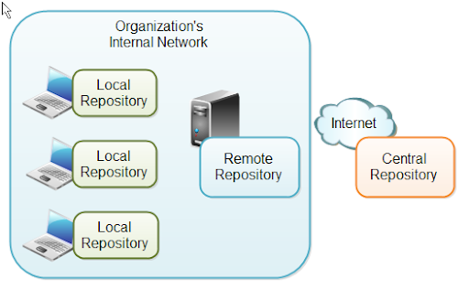

If dependency is not found in these repositories, maven stops processing and throws an error.

**Maven Local Repository**

Maven **local repository** is located in your local system. It is created by the maven when you run any maven command.

By default, maven local repository is %USER_HOME%/.m2 directory. For example: **C:\Users\SSS IT\.m2**.

Triggers in SQL (Hindi)

**Update location of Local Repository**

We can change the location of maven local repository by changing the **settings.xml** file. It is located in **MAVEN_HOME/conf/settings.xml**, for example: **E:\apache-maven-3.1.1\conf\settings.xml**.

Let's see the default code of settings.xml file.

*settings.xml*

...

**<settings** xmlns="http://maven.apache.org/SETTINGS/1.0.0"

   xmlns:xsi="http://www.w3.org/2001/XMLSchema-instance"

   xsi:schemaLocation="http://maven.apache.org/SETTINGS/1.0.0 http://maven.apache.org/xsd/settings-1.0.0.xsd"**>**

  <!-- localRepository

   | The path to the local repository maven will use to store artifacts.

   |

   | Default: ${user.home}/.m2/repository

**<localRepository>**/path/to/local/repo**</localRepository>**

  --**>**

...

**Maven Central Repository**

Maven **central repository** is located on the web. It has been created by the apache maven community itself.

The path of central repository is: <http://repo1.maven.org/maven2/>.

The central repository contains a lot of common libraries that can be viewed by this url <http://search.maven.org/#browse>.

**Maven Remote Repository**

Maven **remote repository** is located on the web. Most of libraries can be missing from the central repository such as JBoss library etc, so we need to define remote repository in pom.xml file.

Let's see the code to add the jUnit library in pom.xml file.

*pom.xml*

**<project** xmlns="http://maven.apache.org/POM/4.0.0"

xmlns:xsi="http://www.w3.org/2001/XMLSchema-instance"

  xsi:schemaLocation="http://maven.apache.org/POM/4.0.0

http://maven.apache.org/xsd/maven-4.0.0.xsd"**>**

**<modelVersion>**4.0.0**</modelVersion>**

**<groupId>**com.javatpoint.application1**</groupId>**

**<artifactId>**my-application1**</artifactId>**

**<version>**1.0**</version>**

**<packaging>**jar**</packaging>**

**<name>**Maven Quick Start Archetype**</name>**

**<url>**http://maven.apache.org**</url>**

**<dependencies>**

**<dependency>**

**<groupId>**junit**</groupId>**

**<artifactId>**junit**</artifactId>**

**<version>**4.8.2**</version>**

**<scope>**test**</scope>**

**</dependency>**

**</dependencies>**

**</project>**

You can search any repository from Maven official website **mvnrepository.com**.

## **Explain maven lifecycle**

Maven is based around the central concept of a build lifecycle. ... There are three built-in build lifecycles: **default**, **clean** and **site**.

The default lifecycle handles your project deployment,

the clean lifecycle handles project cleaning,

while the site lifecycle handles the creation of your project's site documentation.

A Maven phase represents a stage in the Maven build lifecycle.

**validate**: check if all information necessary for the build is available.

**compile**: compile the source code.

**test-compile**: compile the test source code.

**test**: run unit tests.

**package**: package compiled source code into the distributable format (jar, war, …)

**What is Build Lifecycle?**

A Build Lifecycle is a well-defined sequence of phases, which define the order in which the goals are to be executed. Here phase represents a stage in life cycle. As an example, a typical Maven Build Lifecycle consists of the following sequence of phases.

|  |  |  |
| --- | --- | --- |
| Phase | Handles | Description |
| prepare-resources | resource copying | Resource copying can be customized in this phase. |
| validate | Validating the information | Validates if the project is correct and if all necessary information is available. |
| compile | compilation | Source code compilation is done in this phase. |
| Test | Testing | Tests the compiled source code suitable for testing framework. |
| package | packaging | This phase creates the JAR/WAR package as mentioned in the packaging in POM.xml. |
| install | installation | This phase installs the package in local/remote maven repository. |
| Deploy | Deploying | Copies the final package to the remote repository. |

## **Explain maven install, deploy and package**

**mvn package** – take the compiled code and package it in its distributable format, such as a JAR, WAR

**mvn install** – install the package JAR or WAR file into the local repository, for use as a dependency in other projects locally.

**mvn deploy** - put the JAR or WAR file of your project into remote repository e.g. maven central or your company's nexus repository for sharing with other projects.

## **How to change the default directory structure in maven?**

**Changing default structure in maven for war**

My project folder structure is different from that of Maven. Can I still use Maven?

If yes .. I want to use webContent folder instead of webapp .. how can i do that?

i already changed java folder to javaSource using

You can have whatever structure you want and still use maven. Just define directory with your web resources.

<project>

...

<build>

<plugins>

<plugin>

<groupId>org.apache.maven.plugins</groupId>

<artifactId>maven-war-plugin</artifactId>

<version>2.1.1</version>

<configuration>

<webResources>

<resource>

<!-- this is relative to the pom.xml directory -->

<directory>resource2</directory>

</resource>

</webResources>

</configuration>

</plugin>

</plugins>

</build>

...

</project>

Have a look at the war plugin usage page: http://maven.apache.org/plugins/maven-war-plugin/war-mojo.html

In your case, you'll need to set the warSourceDirectory (in a <configuration> tag in the war-<plugin> section) like:

<plugin>

<groupId>org.apache.maven.plugins</groupId>

<artifactId>maven-war-plugin</artifactId>

<version>2.6</version>

<configuration>

<warSourceDirectory>${project.basedir}/WebContent</warSourceDirectory>

</configuration>

</plugin>

## **What is the goal of maven?**

Maven is based around the central concept of a Build Life Cycles. Inside each Build Life Cycles there are Build Phases, and inside each Build Phases there are Build Goals.

When executing a build phase we execute all build goals within that build phase.

Build goals are assigned to one or more build phases.

We can also execute a build goal directly.

**Maven defines 4 items of a build process:**

1. **Lifecycle**

Three built-in lifecycles (aka build lifecycles): default, clean, site. (Lifecycle Reference)

1. **Phase**

Each lifecycle is made up of phases, e.g. for the default lifecycle: compile, test, package, install, etc.

1. **Plugin**

An artifact that provides one or more goals.

Based on packaging type (jar, war, etc.) plugins' goals are bound to phases by default. (Built-in Lifecycle Bindings)

1. **Goal**

The task (action) that is executed. A plugin can have one or more goals.

One or more goals need to be specified when configuring a plugin in a POM. Additionally, in case a plugin does not have a default phase defined, the specified goal(s) can be bound to a phase.

Maven can be invoked with:

a phase (e.g clean, package)

<plugin-prefix>:<goal> (e.g. dependency:copy-dependencies)

<plugin-group-id>:<plugin-artifact-id>[:<plugin-version>]:<goal> (e.g. org.apache.maven.plugins:maven-compiler-plugin:3.7.0:compile)

with one or more combinations of any or all, e.g.:

mvn clean dependency:copy-dependencies package

## **Explain the lifecycles of maven. Also see the plugins of maven.**

**Maven Plugins**

The **maven plugins** are central part of maven framework, it is used to perform specific goal.

According to Apache Maven, there are 2 types of maven plugins.

1. Build Plugins
2. Reporting Plugins

**Build Plugins**

These plugins are executed at the time of build. These plugins should be declared inside the **<build>** element.

**Reporting Plugins**

These plugins are executed at the time of site generation. These plugins should be declared inside the **<reporting>** element.

**Maven Core Plugins**

A list of maven core plugins are given below:

|  |  |
| --- | --- |
| **Plugin** | **Description** |
| clean | clean up after build. |
| compiler | compiles java source code. |
| deploy | deploys the artifact to the remote repository. |
| failsafe | runs the JUnit integration tests in an isolated classloader. |
| install | installs the built artifact into the local repository. |
| resources | copies the resources to the output directory for including in the JAR. |
| site | generates a site for the current project. |
| surefire | runs the JUnit unit tests in an isolated classloader. |
| verifier | verifies the existence of certain conditions. It is useful for integration tests. |

List of Maven Plugins

To see the list of maven plugins, you may visit apache maven official website <http://repo.maven.apache.org/maven2/org/apache/maven/plugins/>.

## **Does maven generate any plugin? (like sonar -sonar)**

## **When I issue mvn install what all things happen in background?**

It will run all goals of all configured plugins associated with any phase of the default lifecycle up to the "install" phase:

A Build Lifecycle is a well-defined sequence of phases, which define the order in which the goals are to be executed. Here phase represents a stage in life cycle. As an example, a typical **Maven Build Lifecycle** consists of the following sequence of phases.

|  |  |  |
| --- | --- | --- |
| **Phase** | **Handles** | **Description** |
| prepare-resources | resource copying | Resource copying can be customized in this phase. |
| validate | Validating the information | Validates if the project is correct and if all necessary information is available. |
| compile | compilation | Source code compilation is done in this phase. |
| Test | Testing | Tests the compiled source code suitable for testing framework. |
| package | packaging | This phase creates the JAR/WAR package as mentioned in the packaging in POM.xml. |
| install | installation | This phase installs the package in local/remote maven repository. |
| Deploy | Deploying | Copies the final package to the remote repository. |

## **What are the settings you need to do before mvn deploy? ( reference may be to pom.xml)**

Have a closer look at the **pom.xml** and observe the below list of important tags used:

|  |  |
| --- | --- |
| **Tag Element** | **Description** |
| scm | Configures the scm (in this cases SVN is used) of the project |
| repositories | Storage location of the WAR/EAR/JAR file after the successful build |
| plugin | maven-release-plugin to automate the process |

## **Why maven takes much time in 1st execution than subsequent executions like 2nd,3rd,4th …. etc executions?**

In the 1st execution, maven downloads all the dependencies from central/remote repository

to local .m2 folder.

## **What is multi-module project in maven? What are the configurations you need to do in parent and child project? What is dependency management?**

Maven's Multi-Module Project

A multi-module project is built from an aggregator POM that manages a group of submodules. In most cases, the aggregator is located in the project's root directory and must have packaging of type pom.

Parent POM

Now, the submodules are regular Maven projects, and they can be built separately or through the aggregator POM.

Submodules or subprojects are regular Maven projects that inherit from parent POM.

declare our submodules explicitly in parent POM.

## **What is transitive dependency?**

Maven helps to import project dependent JARS from central repositories if specified in the pom.xml

For example, project A depends on project B and project B depends on project C

A –> B

B –> C

Now whenever maven looks for the dependency of project A, then it downloads the direct dependency as specified i.e.; project B and also project C as project B depends on this –> that’s transitive dependency

Let us look at it in detail

Sample pom.xml for Maven Transitive dependencies example

pom.xml

<project...>

<modelVersion>4.0.0</modelVersion>

<groupId>in.bench.resources</groupId>

<artifactId>MavenTransitiveDependencies</artifactId>

<version>0.0.1-SNAPSHOT</version>

<name>MavenTransitiveDependencies</name>

<description>Apache Maven (3.2.3): Transitive dependencies explanation</description>

<!-- spring-core dependencies -->

<dependencies>

<dependency>

<groupId>org.springframework</groupId>

<artifactId>spring-core</artifactId>

<version>4.1.2.RELEASE</version>

</dependency>

</dependencies>

</project>

In the above sample pom.xml, we have explicitly declared “spring-core-4.1.2.RELEASE” as dependencies to our “MavenTransitiveDependencies” project

But this “spring-core-4.1.2.RELEASE” dependency, in turn dependent on “common-logging-1.1.3” JAR

Maven manages this transitive dependency and downloads from central repository, if not available in the local repository

You can check this using maven command “mvn dependency:tree”

## **Describe ANT or Maven scripts**

Difference between Ant and Maven

|  |  |
| --- | --- |
| **Ant** | **Maven** |
| It is a tool box. | It is a framework. |
| It is mainly a build tool. | It is mainly a project management tool. |
| The **ant** scripts are not reusable. | The **maven** plugins are reusable. |
| It is less preferred than **Maven**. | It is more preferred than **Ant**. |

Ant is a Java-based build tool created as part of the Apache open-source project. You can think of it as a Java version of make. Ant scripts have a structure and are written in XML. Similar to make, Ant targets can depend on other targets. ... This editor is automatically associated with files named build.

Maven is a powerful project management tool that is based on POM (project object model). It is used for projects build, dependency and documentation. It simplifies the build process like ANT. ... maven make the day-to-day work of Java developers easier and generally help with the comprehension of any Java-based project.

## **What are maven goals?**

Goals are executed in phases which help determine the order goals get executed in. ... If you specify a goal when you execute Maven then it will run that goal and only that goal. In other words, if you specify the jar:jar goal it will only run the jar:jar goal to package your code into a jar.

**Maven Goal**

1. compiler:compile – the compile goal from the compiler plugin is bound to the compile phase.
2. compiler:testCompile is bound to the test-compile phase.
3. surefire:test is bound to test phase.
4. install:install is bound to install phase.
5. jar:jar and war:war is bound to package phase.

## **What is a maven archtype?**

What is Archetype? In short, Archetype is a Maven project templating toolkit. An archetype is defined as an original pattern or model from which all other things of the same kind are made. The name fits as we are trying to provide a system that provides a consistent means of generating Maven projects.

maven-archetype-quickstart is an archetype which generates a sample Maven project: project. |-- pom. xml.

The Archetype Plugin allows the user to create a Maven project from an existing template called an archetype. It also allows the user to create an archetype from an existing project.

## **Diff betn freestyle job and maven job**

A Free-Style project is a project that can incorporate almost any type of build.

While a maven project you can only build maven projects, the Free-Style project is the more "generic" form of a project.

You can execute shell/dos scripts, invoke ant, and a lot more.Majority of the plugins are written to use the free-style project.

The maven module is limited in that it can't invoke a shell script, or anything else just the maven targets.

## **What are the three lifecycles in maven?**

There are three built-in build lifecycles: **default**, **clean** and **site**. The default lifecycle handles your project deployment, the clean lifecycle handles project cleaning, while the site lifecycle handles the creation of your project's site documentation.

Maven Lifecycle:

Below is a representation of the default Maven lifecycle and its 8 steps:

1. Validate
2. Compile
3. Test
4. Package
5. Integration test
6. Verify
7. Install
8. Deploy.

## **What are things you need to set, if you want download dependency from private repository ?**

**Add your repository to your Maven project**

In the <distributionManagement/> section of your pom.xml, we’ll need to tell Maven to deploy to our newly created private Maven repository, as demonstrated below.

Note that the id is set to packagecloud-examplecorp, which is what we used in our .jenkins.settings.xml file.

<**distributionManagement**>

<**repository**>

<id>packagecloud-examplecorp</id>

<url>packagecloud+https://packagecloud.io/exampleCorp/core</url>

</**repository**>

<snapshotRepository>

<id>packagecloud-examplecorp</id>

<url>packagecloud+https://packagecloud.io/exampleCorp/core</url>

</snapshotRepository>

</distributionManagement>

## **What are the issues you faced while working on maven projects?**

**#1. Desired Maven archetype or artifact does not exist**

[ERROR] Failed to execute goal org.apache.maven.plugins:maven-archetype-plugin:2.2:generate (default-cli) on project standalone-pom: The desired archetype does not exist (org.apache.maven.archetypes:maven-archetype-quickstart:RELEASE) -> [Help 1]

Q. Where can you find the maven plugins and archetypes?

A. ~/.m2/repository/org/apache/maven/plugins and ~/.m2/repository/org/apache/maven/plugins/archetypes.

To fix it: delete the “archetypes” folder and rerun the mvn command. Same course of action for any other artifacts that are missing.

c:\Temp\Java\projects>mvn archetype:generate -DgroupId=com.mytutorial -DartifactId=simpleBatch

You can force the update of the artifact that is already present in your local repository from the remote repository with “-U” flag.

c:\Temp\Java\projects>mvn -U archetype:generate -DgroupId=com.mytutorial -DartifactId=simpleBatch

**#2. The Maven project you are trying to create, already exist in the current folder**

[ERROR] Failed to execute goal org.apache.maven.plugins:maven-archetype-plugin:2.2:generate (defaundalone-pom: Directory simpleBatch already exists – please run from a clean directory -> [Help 1]

To fix it: Delete the project (i.e. folder) that is already present.

**#3. Maven does not automatically download a particular artifact from a repository**

To fix it: In this case, you can manually download the jar file, and then install it to your local repository using the following command.

mvn install:install-file -Dfile=<path-to-file> -DgroupId=<group-id> \

-DartifactId=<artifact-id> -Dversion=<version> -Dpackaging=<packaging>

Example:

mvn install:install-file -DgroupId=javax.transaction \

-DartifactId=jta -Dpackaging=jar -Dversion=1.0.1B

-Dfile=c:\Temp\my-commonservices-1.5.5-SNAPSHOT-tests.jar -DgeneratePom=true \

**#4.Limited visibility into the dependencies (i.e. transitive dependencies)**

You have no control over, and limited visibility into, the dependencies specified by your dependencies (i.e. transitive dependencies). Builds will break because different copies of Maven will download different artifacts at different times. Your local build can break again in the future when the dependencies of your dependencies accidentally release new, non-backwards compatible changes without remembering to bump their version number. You can use the following commands and tools to check the dependency tree, and exclude certain artifact versions in the pom.xml file.

mvn dependency:tree

mvn dependency:analyze

## **Command to skip the test cases in maven**

**To skip running the tests for a particular project, set the skipTests property to true.**

<project>

[...]

<build>

<plugins>

<plugin>

<groupId>org.apache.maven.plugins</groupId>

<artifactId>maven-surefire-plugin</artifactId>

<version>3.0.0-M5</version>

<configuration>

**<skipTests>true</skipTests>**

</configuration>

</plugin>

</plugins>

</build>

[...]

</project>

**You can also skip the tests via the command line by executing the following command:**

mvn install -DskipTests

**If you absolutely must, you can also use the maven.test.skip property to skip compiling the tests**. maven.test.skip is honored by Surefire, Failsafe and the Compiler Plugin.

mvn install -Dmaven.test.skip=true

## **.m2 is local repository for maven, now I don’t want to use .m2 folder as my local repository I want to use some other folder as my local, is it possible in maven? If yes, how would you do that?**

Maven local repository location & how to change it?

Maven is build and dependency management tool. It downloads required project dependencies to our local system and include them to project compilation or run-time as defined.

**1. Maven’s default local repository location**

By default maven’s local repository exist on ‘${user.home}/.m2/repository’. In different operating systems, these path are resolved to –

Windows 7: C:/Documents and Settings/<username>/.m2/repository

Windows 10: C:/Users/<username>/.m2/repository

Linux: /home/<username>/.m2/repository

Mac: /Users/<username>/.m2/repository

We can change local repository location to some other location of our choice.

**2. Change maven local repository location**

Maven is distributed as archive folder. Generally, developers download the maven and extract it their workstation.

After you have downloaded the maven, follow given simple steps to change maven local repository location to some other path.

Navigate to path {M2_HOME}\conf\ where M2_HOME is maven installation folder.

Open file settings.xml in edit mode in some text editor.

Fine the tag <localRepository>

Update the desired path in value of this tag. Save the file.

setting.xml

<settings xmlns="http://maven.apache.org/SETTINGS/1.0.0"

xmlns:xsi="http://www.w3.org/2001/XMLSchema-instance"

xsi:schemaLocation="http://maven.apache.org/SETTINGS/1.0.0 http://maven.apache.org/xsd/settings-1.0.0.xsd">

<!-- localRepository

| The path to the local repository maven will use to store artifacts.

|

| Default: ${user.home}/.m2/repository -->

**<localRepository>E:/devsetup/M2</localRepository>**

...

</settings>

**mvn install -Dmaven.repo.local=/alternate/repo/location**

## **maven follows convention over configuration that means it assumes code should be there under src/main/java, test cases under src/tests and many more.Here my requirement is I don’t want to follow that conventions I need to use different folder structure is that possible in maven?**

Yes. Refer Q-5

## **mvn help:effective-pom -Doutput=pom_eff.xml**

## **What are dependency and plugin in maven? Give one example for each?**

Both plugins and dependencies are Jar files.

But the difference between them is, most of the work in maven is done using plugins; whereas dependency is just a Jar file which will be added to the classpath while executing the tasks.

For example, you use a compiler-plugin to compile the java files. You can't use compiler-plugin as a dependency since that will only add the plugin to the classpath, and will not trigger any compilation. The Jar files to be added to the classpath while compiling the file, will be specified as a dependency.

Same goes with your scenario. You have to use spring-plugin to execute some spring executables [ I'm not sure what spring-plugins are used for. I'm just taking a guess here ]. But you need dependencies to execute those executables. And Junit is tagged under dependency since it is used by surefire-plugin for executing unit-tests.

So, we can say, plugin is a Jar file which executes the task, and dependency is a Jar which provides the class files to execute the task.

## **In Which tag we will mention output artifact type( like jar, war or any other)?**

## **What is the architecture of Maven or How Maven works?**

## **What is the role of setting.xml and pom.xml maven in Maven?**

**settings.xml** contains system and/or user configuration,

**pom.xml** contains project information. All build configuration ends up in the pom.

## **pom.xml is not provided for a workspace. Can we take basic config from somewhere and create the build ?**

No.

## **GroupId and ArtefactId ?**

**groupId** uniquely identifies your project across all projects. A group ID should follow [Java's package name rules](https://docs.oracle.com/javase/specs/jls/se6/html/packages.html#7.7). This means it starts with a reversed domain name you control. For example,

org.apache.maven, org.apache.commons

**artifactId** is the name of the jar without version. If you created it, then you can choose whatever name you want with lowercase letters and no strange symbols. If it's a third party jar, you have to take the name of the jar as it's distributed.

eg. maven, commons-math

# Jenkins

## **What is continuous integration continuous delivery and continuous deployment**

<https://www.atlassian.com/continuous-delivery/principles/continuous-integration-vs-delivery-vs-deployment>

Continuous Integration is merging all code from all developers to one central branch of the repo many times a day trying to avoid conflicts in the code in the future. The concept here is to have multiple devs on a project to keep the main branch of the repo to the most current form of the source code, so each dev can check out or pull from the latest code to avoid conflicts.

“Continuous Delivery is a small build cycle with short sprints…”

Where the aim is to keep the code in a deployable state at any given time. This means that on top of automated testing, you have an automated release process and you can deploy your application any time by clicking a button.

This does not mean the code or project is 100% complete, but the feature sets that are available are vetted, tested, debugged and ready to deploy, although you may not deploy at that moment.

The focus and key here is to keep the code base at a deployable state.

With Continuous Deployment, every change that is made is automatically deployed to production. This approach works well in enterprise environments where you plan to use the user as the actual tester and it can be quicker to release.

Continuous Delivery does not mean that you push the code to production every so often, that's continuous deployment. Continuous Delivery means you build your installation package(s) on a regular basis, and it is capable of being deployed whenever necessary, not that it actually is deployed (although it could be, in which case it's both Continuous Deployment and Delivery).

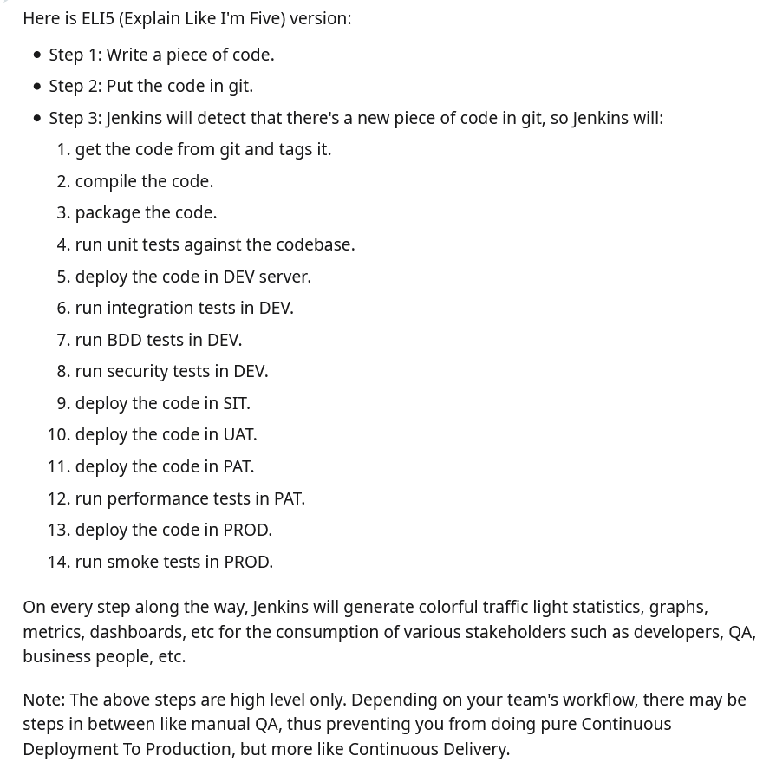

## **Explain git workflow for developers (also explain the 3 git stages**

<https://nvie.com/posts/a-successful-git-branching-model/>

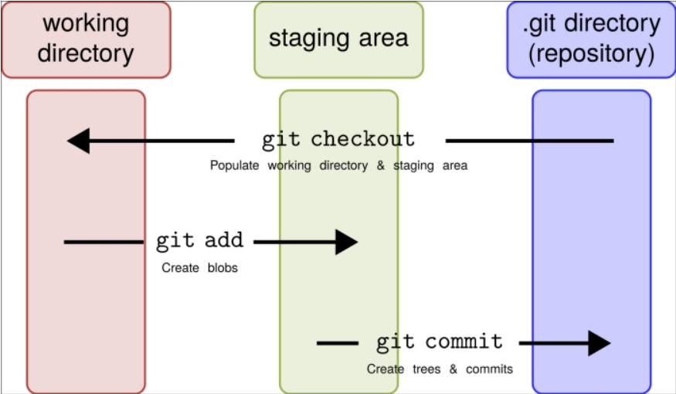

Feature branch = individual developers branch

Develop branch =all induvial feature branches merge here

Release branch = used for all sorts of testing , basically it’s a pre prod release

Hotfix branch = Hotfix branches are very much like release branches in that they are also meant to prepare for a new production release, albeit unplanned. They arise from the necessity to act immediately upon an undesired state of a live production version. When a critical bug in a production version must be resolved immediately

Master branch = production environment , don’t mess around

Steps-

Develop branch is created from master branch

Hotfix branch is created from master branch

Feature branch is created from develop branch

Merge hotfix branches into develop and master branch as part of incorporating bug fixes

Merge feature branches into develop branch

Merge develop branch into release branch for any release

Merge release into master after successful release

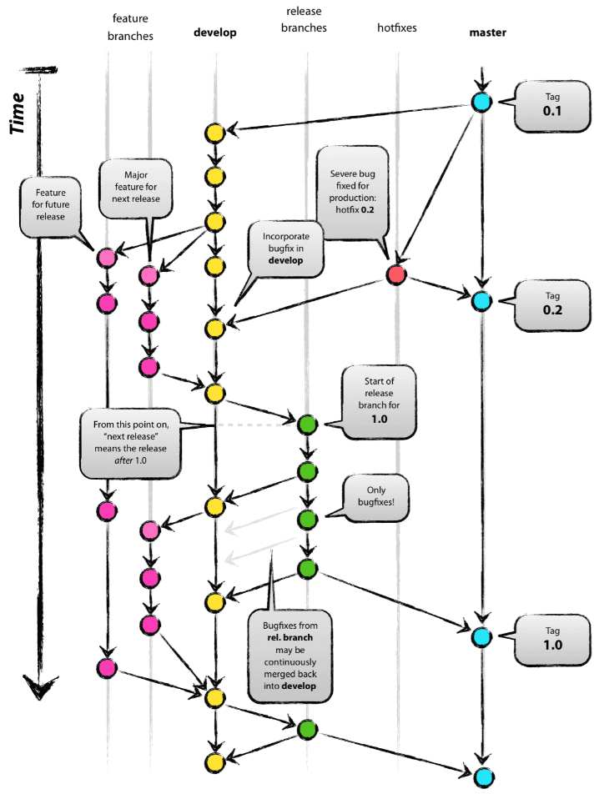

## **How to create a job in jenkins using groovy and jenkinsfile**

For more info follow here <https://medium.com/appgambit/build-pipeline-with-jenkins-c13bf788a3f0>

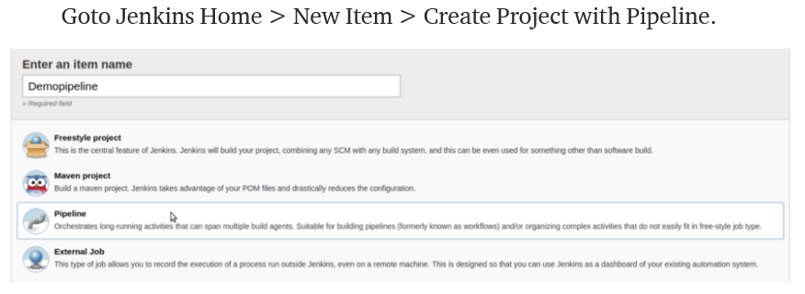

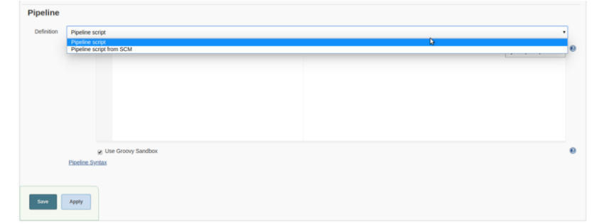

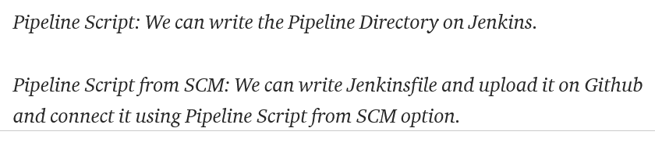

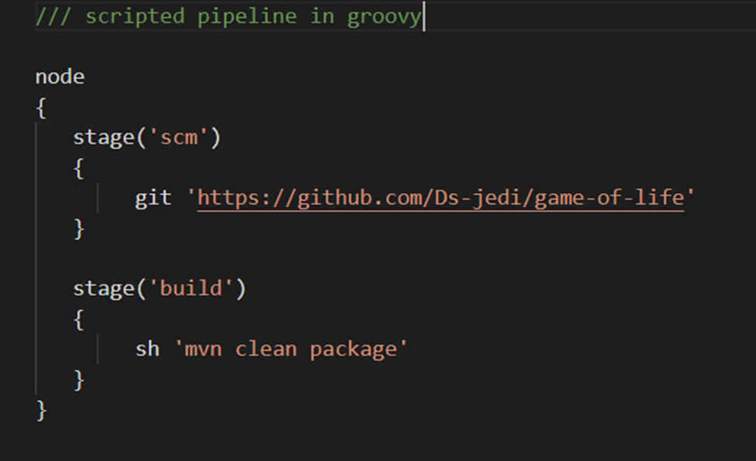

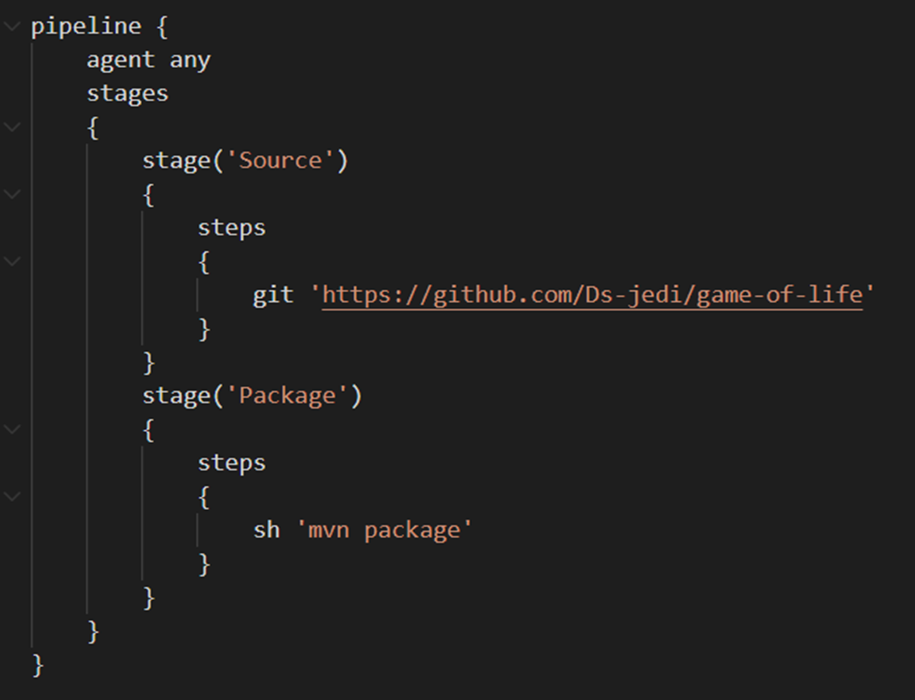

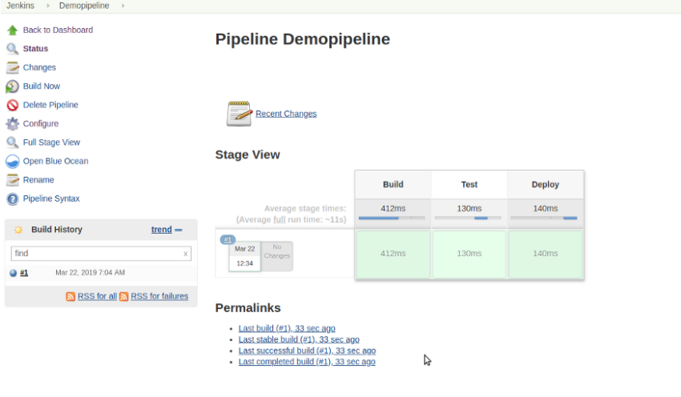

## **Explain Seed jobs in jenkins**

To run the Job DSL script, we must first incorporate it into a seed job.

The seed job is a normal Jenkins job that runs the Job DSL script; in turn, the script contains instructions that create additional jobs.

In short, the seed job is a job that creates more jobs. In this step, you will construct a Job DSL script and incorporate it into a seed job.

## **Explain ur branching strategy**

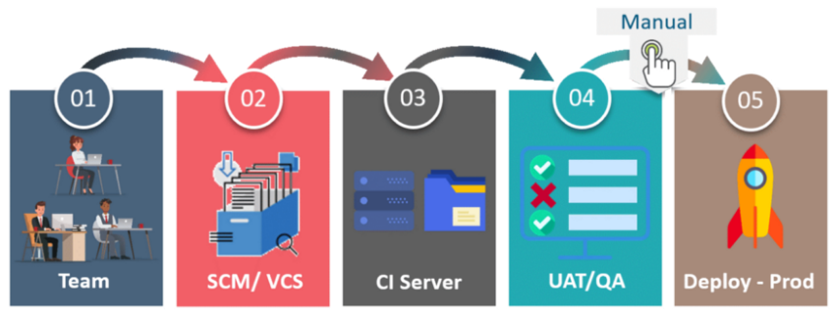

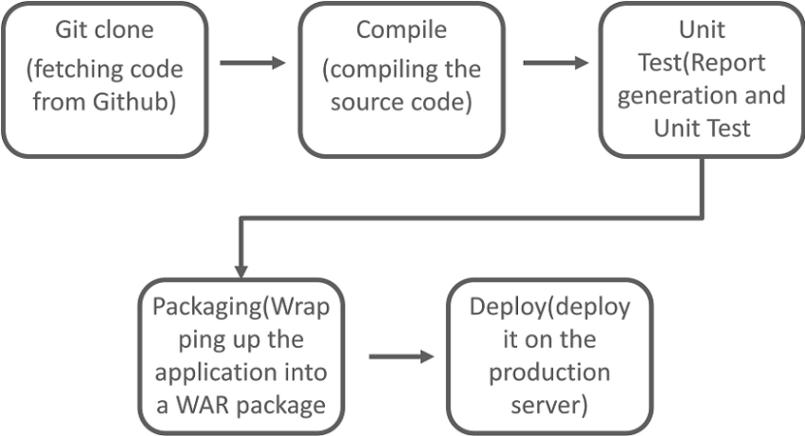

## **If u have 5 environments and how do u manage those 5 env**

## **In jenkins which plugins u use explain any 5 of them**

Sonarcube, HP Fortify Scan

Nexus, Artifactory

Email extension

Thin backup

Blueocean

Job DSL plugin

## **How do u manage all those plugins**

## **How to use sonarcube and explain basic components**

## **Why we use sonarcube**

## **Explain code coverage and line coverage**

## **What is ur coding standards that u have set up in sonarcube**

## **How to configure sonarcube with jenkins ,**

Go to manage jenkins give url of sonarcube server and port no and other stuff

## **What parameters are passed in jenkins job to configure Sonarqube in jenkins?**

## **Where u use git plugin in jenkins ?**

GIT plugin is already installed in jenkins

If not installed install it

For more info follow here <https://plugins.jenkins.io/git/>

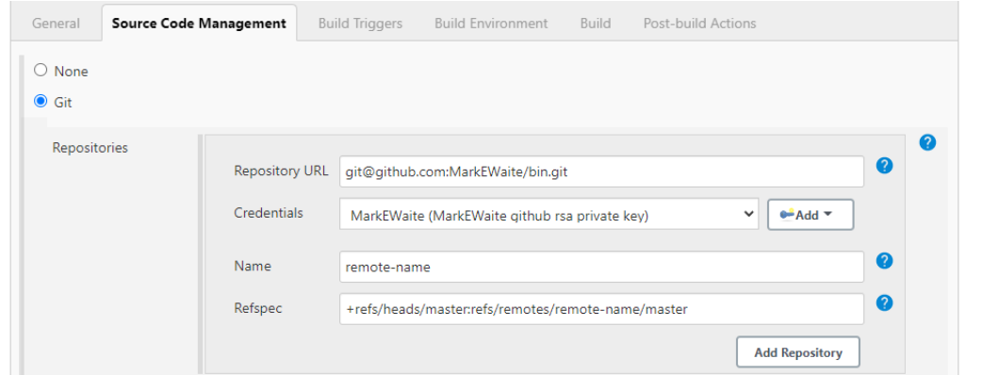

## **I want to build a job remotely in jenkins . Explain remote trigger and jenkins api token**

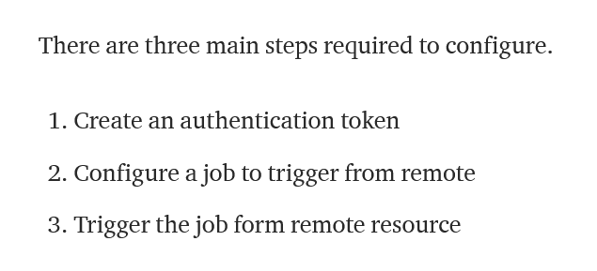

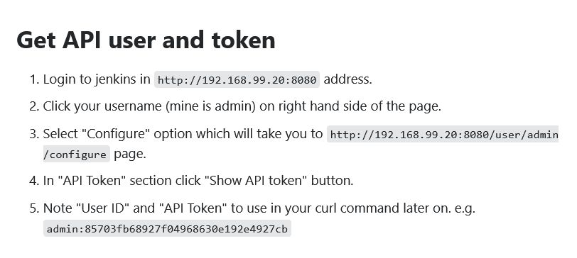

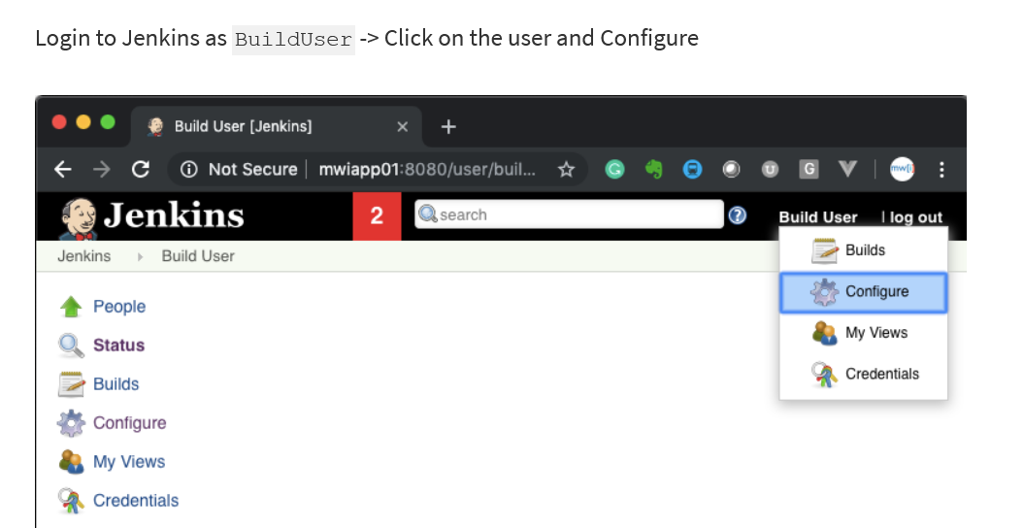

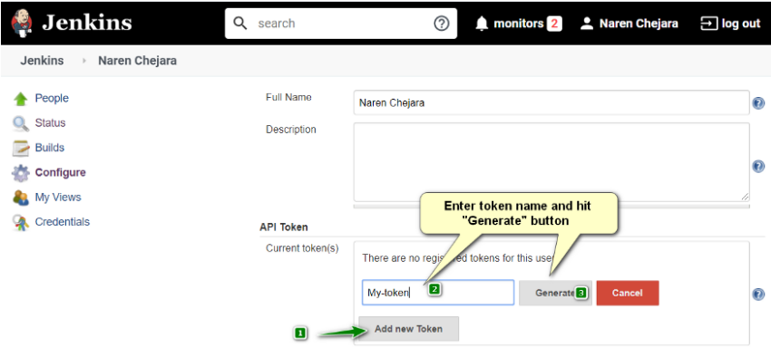

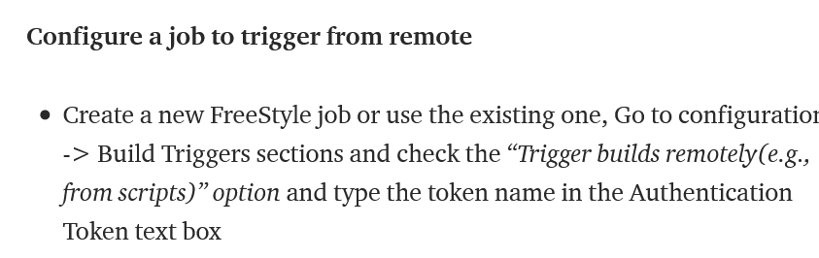

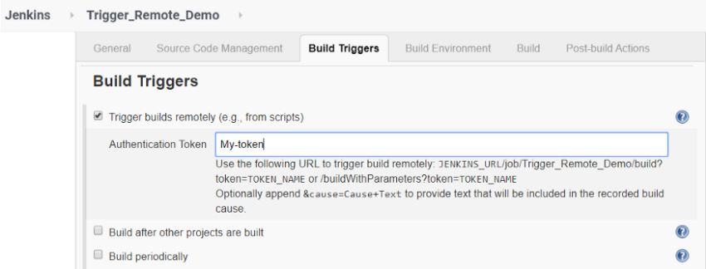

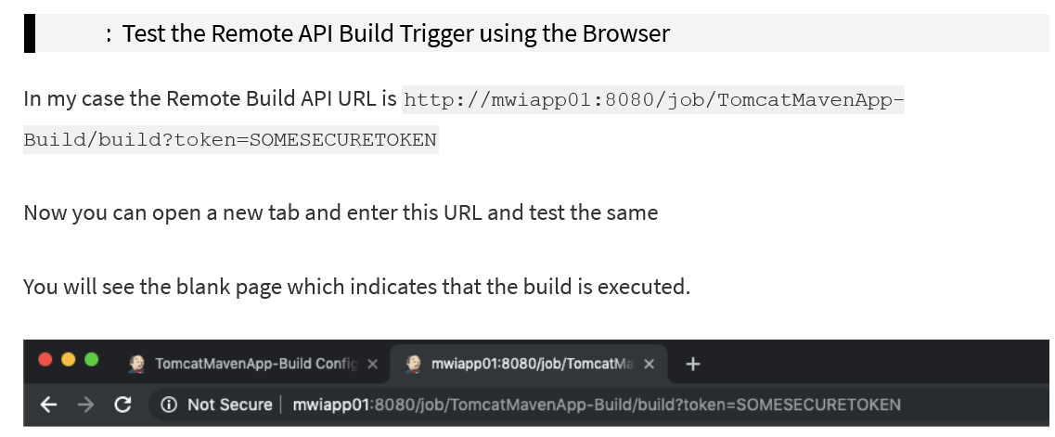

OR CURL IT

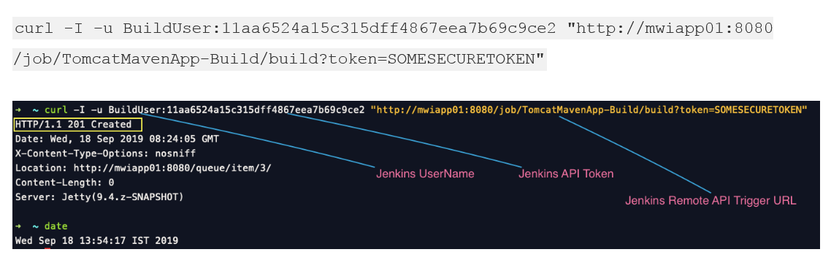

For more info follow here

<https://www.middlewareinventory.com/blog/jenkins-remote-build-trigger-url/>

<https://narenchejara.medium.com/trigger-jenkins-job-remotely-using-jenkins-api-20973618a493>

## **When we configure jenkins , we need to pass some parameters in your job , what are those**

## **Where u use artifactory plugin**

## **Did u use artifactory and nexus plugin in ur pom file so that it automatically deploys those artifacts to artifactory server**

## **Did u configure master slave in jenkins how to run a job on a specific slave how to do node labeling**

## **How many aws servers do u have ?**

## **Explain cicd in your organization**

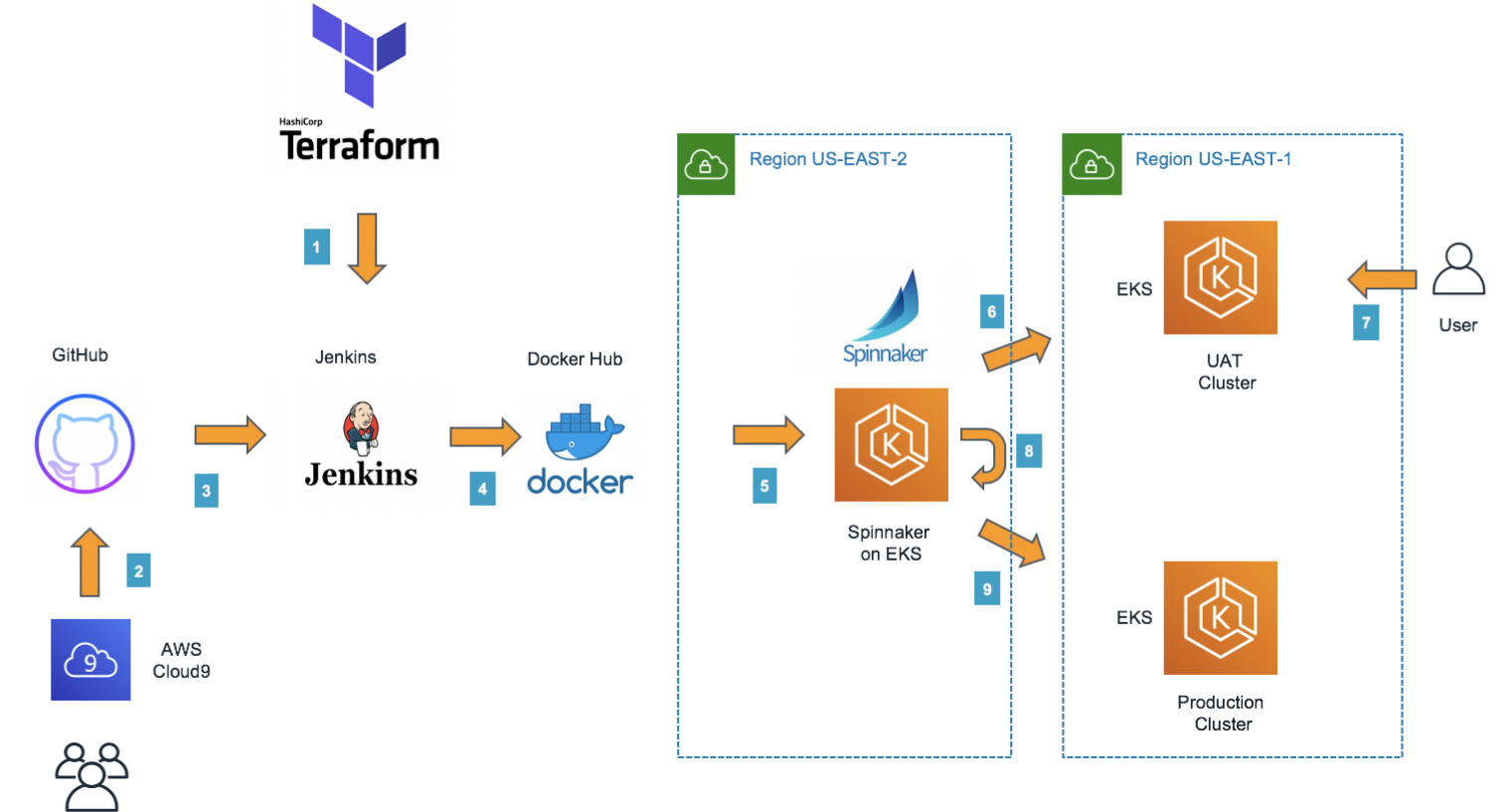

## **Explain structure of jenkins pipeline**

A jenkins pipeline automates the process of software delivery. It builds code, runs tests, and helps you to safely deploy a new version of the software. It involves from the integration and testing phase to delivery and deployment. These connected practices are referred as CI/CD pipeline.

<https://www.jenkins.io/doc/book/pipeline/jenkinsfile/>

<https://www.jenkins.io/doc/book/pipeline/jenkinsfile/>

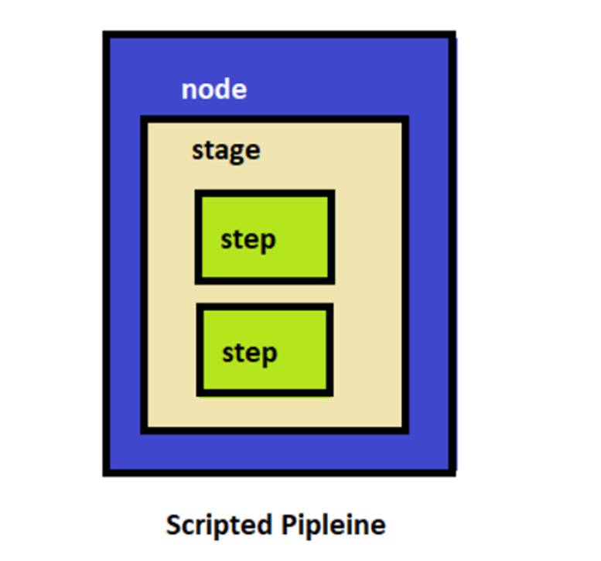

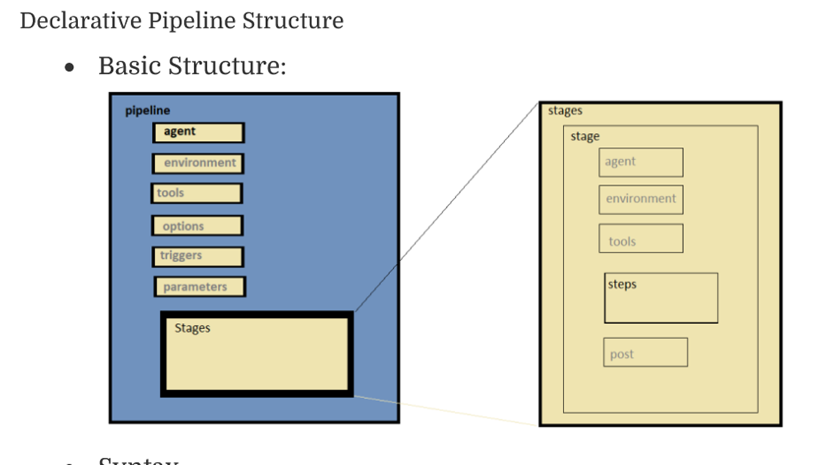

## **How to deploy container using ansible in Jenkins**

<https://github.com/yankils/Simple-DevOps-Project/blob/master/Jenkins_Jobs/Deploy_on_Container_using_Ansible.MD>

1. Install Jenkins one 1 ec2 and docker&ansible on other EC2
2. Connect Jenkins to ansible/docker machine via publish over ssh plugin
3. Make sure that dockerfile is on ansible/docker machine

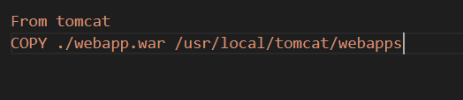

1. WRITE UR PLAYBOOK

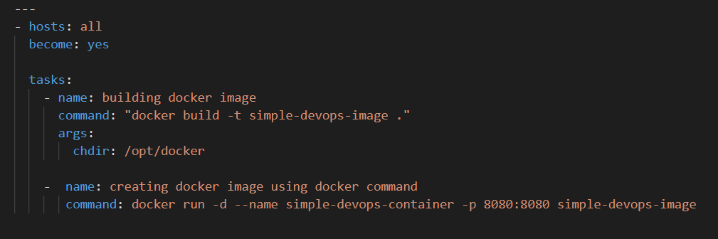

1. Go to Jenkins , configure job, add game of life git repo and this to post build action

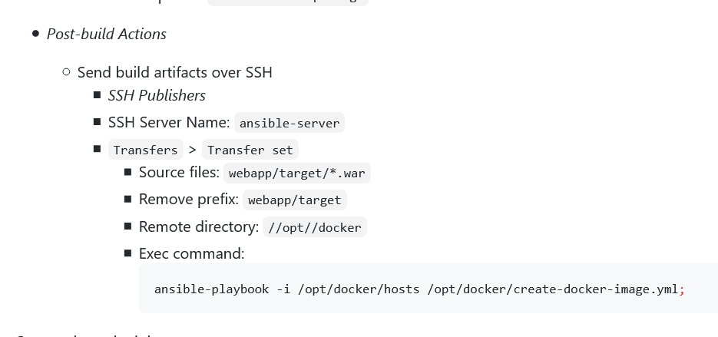

## **What is artifactory ? how did u set it up**

## **U r uploading artifacts to artifactory manually , its showing upload failed , what may be the reason**

## **How jfrog manages jar,var files generated from builds ( multiple times i.e, how the versioning happens in jfrog)?**

## **U have created a custom plugin , how do u install that in jenkins, .hpi format**

<https://www.jenkins.io/doc/book/managing/plugins/#from-the-web-ui-2>

<https://linuxtechlab.com/3-methods-to-install-plugins-on-jenkins-server/>

There are 3 ways =

=== USE CLI

=== USE GUI

=== MANUALLY COPY TO JENKINS PLUGIN FOLDER AND RESTART JENKINS

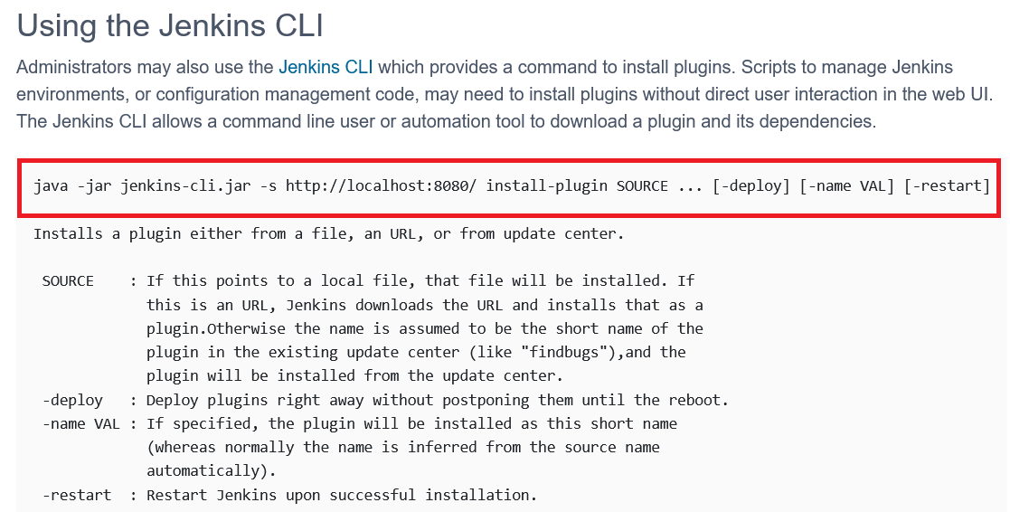

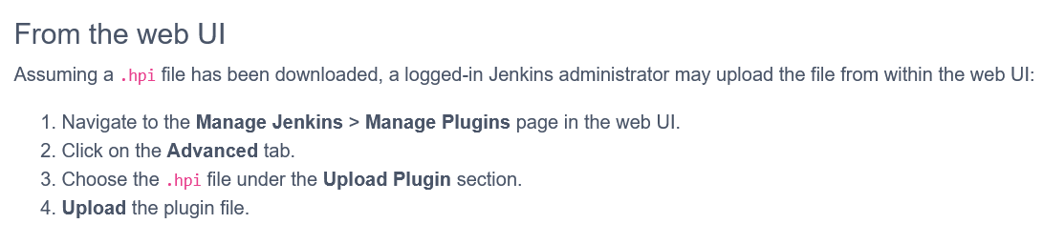

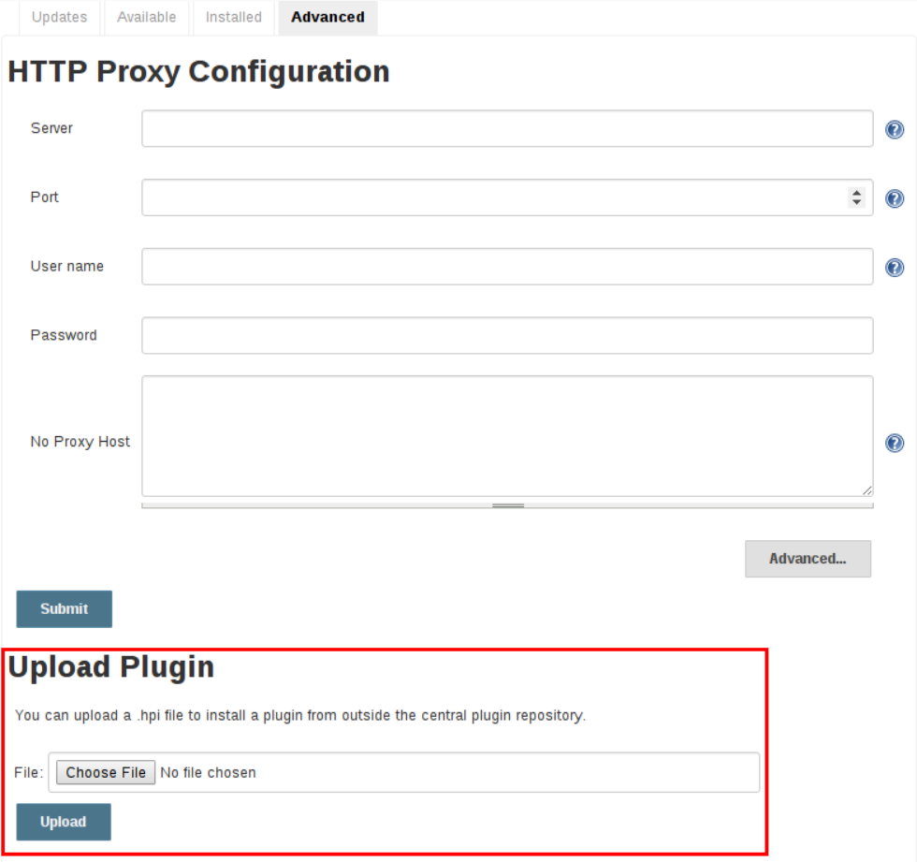

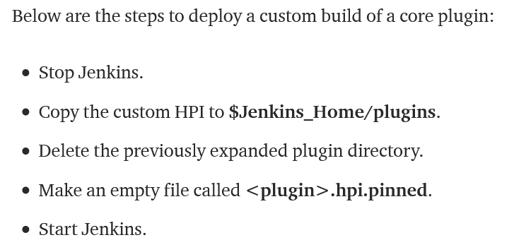

## **How to transfer jenkins from 1 linux vm to other linux vm**

TAKE A AWS SNAPSHOT NIGGA

Or follow here

<https://stackoverflow.com/questions/8724939/how-to-move-jenkins-from-one-pc-to-another>

<https://wiki.jenkins.io/display/JENKINS/Administering+Jenkins>

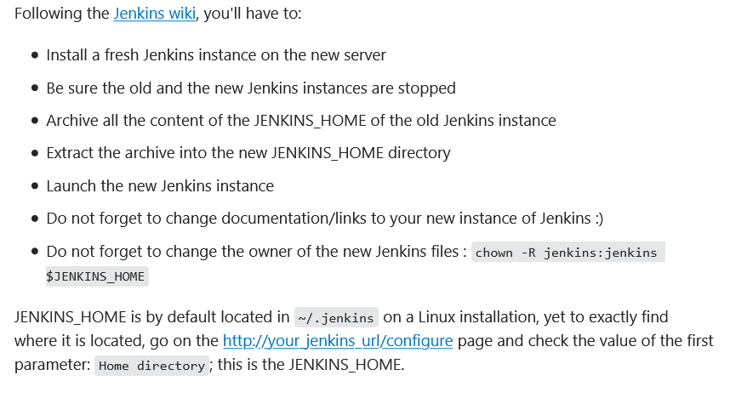

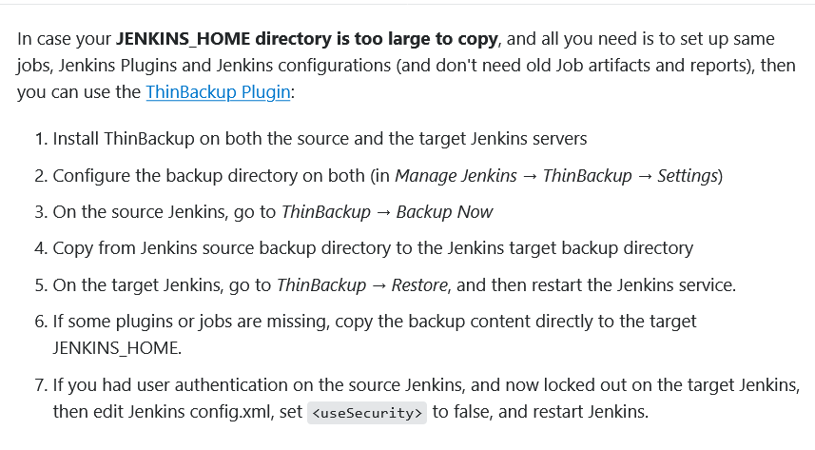

## **Publish over ssh plugin in Jenkins**

USED TO CONFIGURE JENKINS WITH ANIBLE HOST OR DOCKER HOST SO THAT JENKINS BUILD ARTIFACTS ARE SENT TO DOCKER HOST / ANSIBLE HOST OVER SSH FOR DEPLOYMENT

<https://plugins.jenkins.io/publish-over-ssh/>

<https://medium.com/@weblab_tech/how-to-publish-artifacts-in-jenkins-f021b17fde71>

<https://nozaki.me/roller/kyle/entry/articles-jenkins-sshdeploy>

<https://stackoverflow.com/questions/48786702/how-to-use-publish-over-ssh-plugin-in-pipeline>

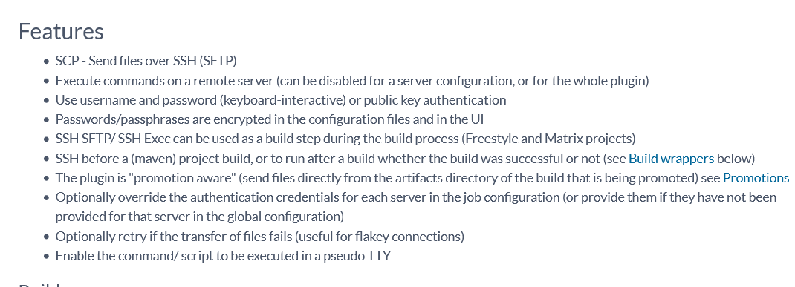

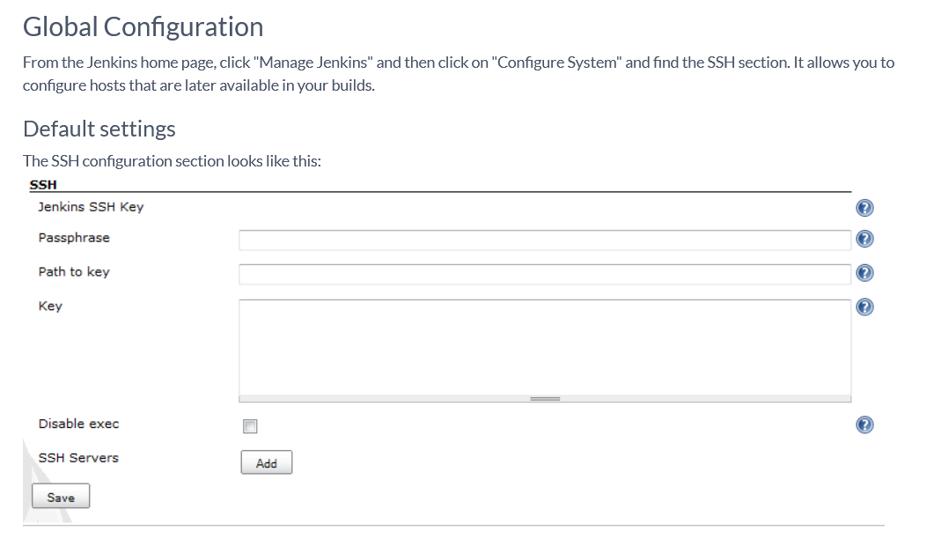

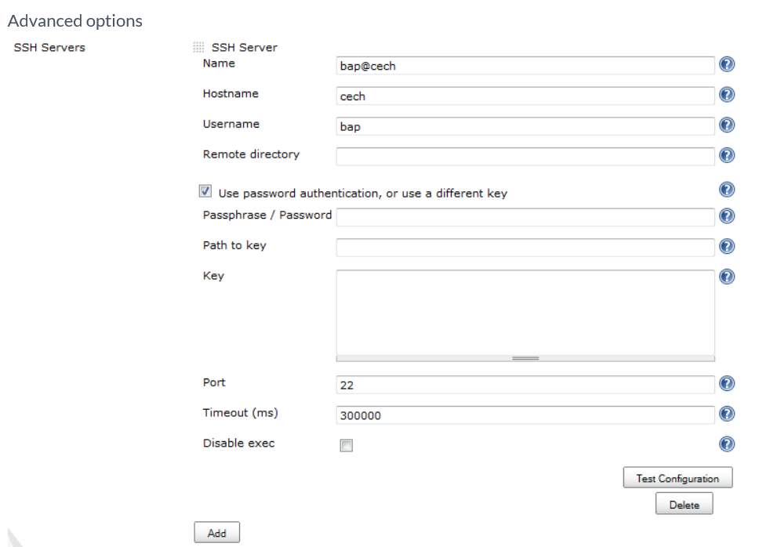

## **Jenkins build environment variables**

<https://stackoverflow.com/questions/10625259/how-to-set-environment-variables-in-jenkins>

<https://www.youtube.com/watch?v=KwQDxwZRZiE>

<https://www.lambdatest.com/blog/set-jenkins-pipeline-environment-variables-list/>

<https://www.lambdatest.com/blog/set-jenkins-pipeline-environment-variables-list/>

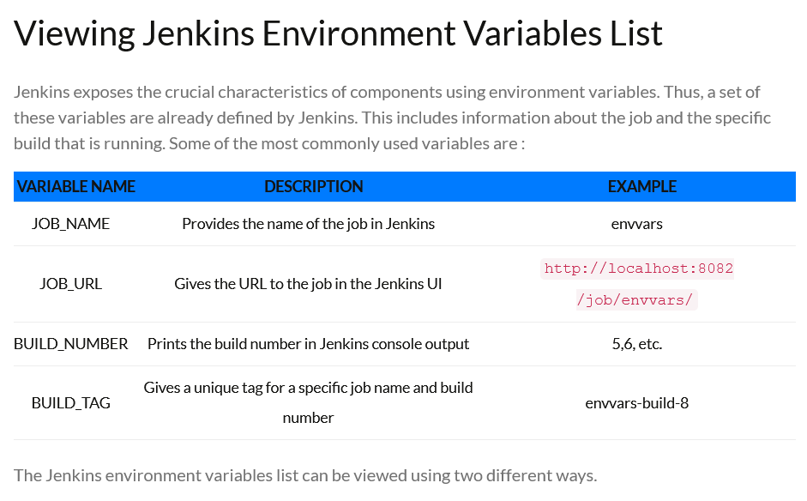

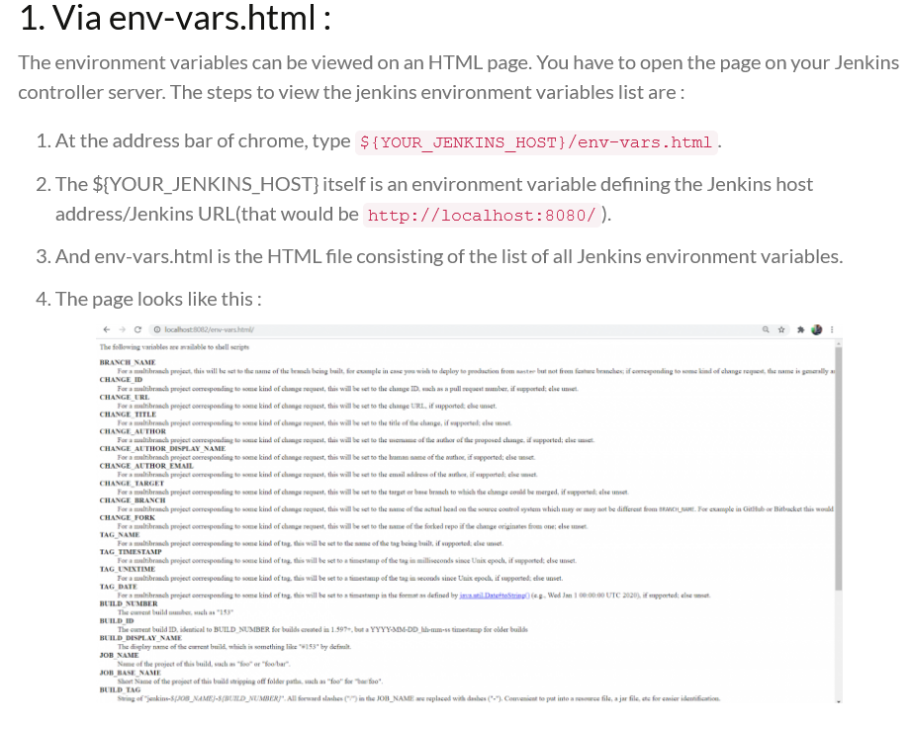

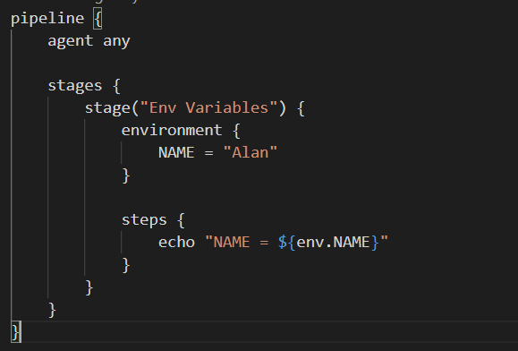

## **Tomcat where files are deployed**

/var/lib/tomcat7/webapps/

## **If tomcat deployment fails , how to troubleshoot**

<https://www.mulesoft.com/tcat/tomcat-memory>

<http://www.inf.fu-berlin.de/lehre/SS03/19560-P/Docs/JWSDP/tutorial/doc/GettingStarted10.html>

## **Build executors**

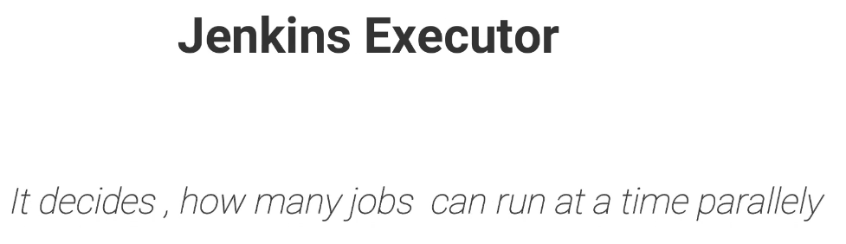

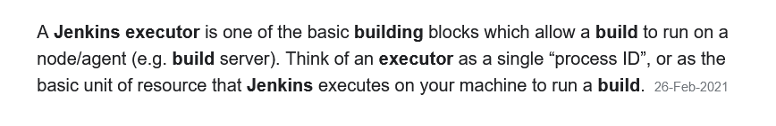

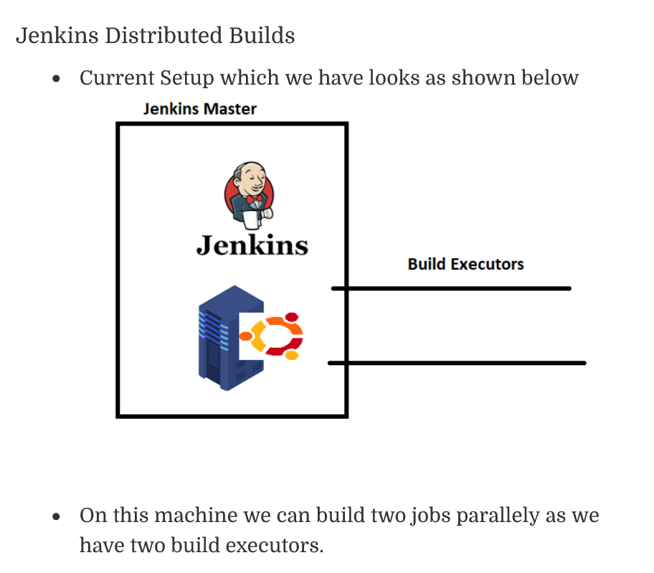

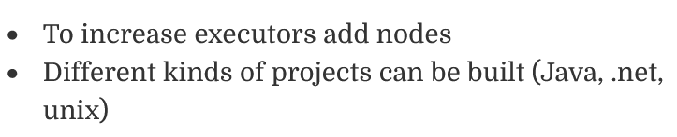

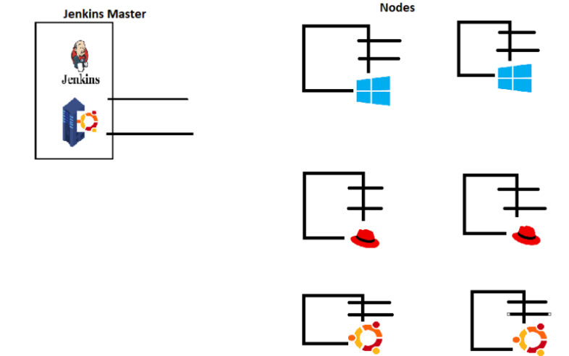

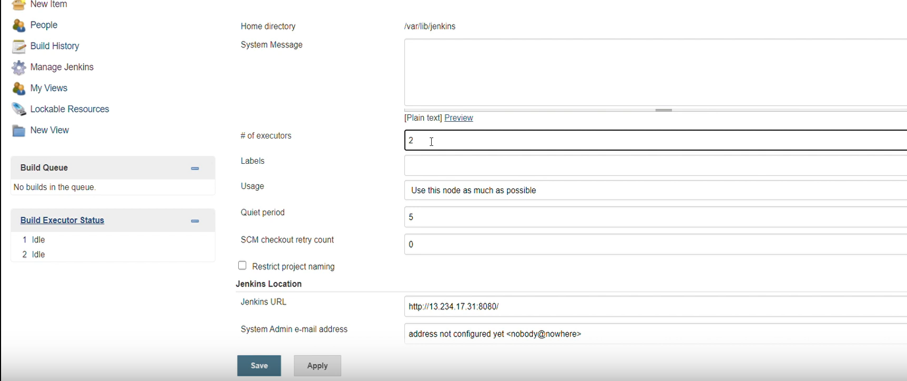

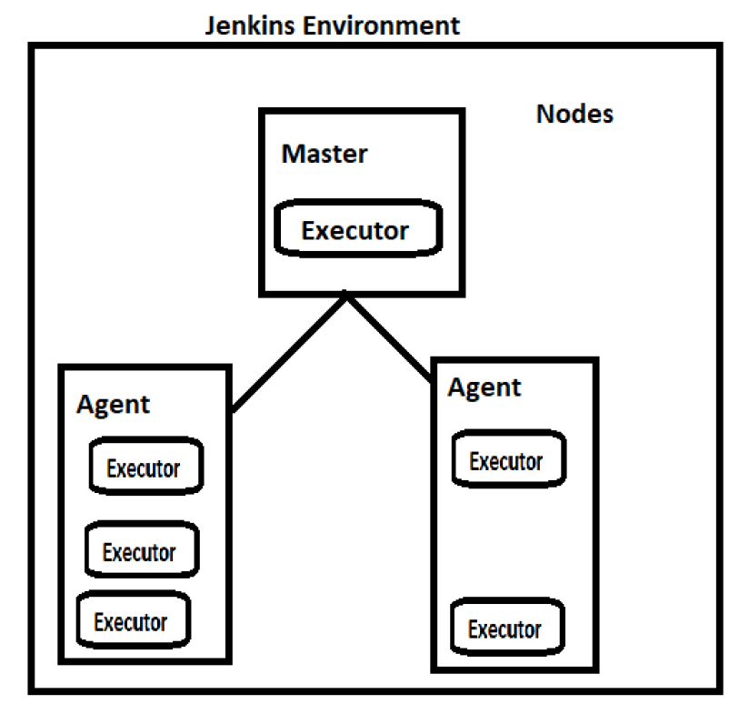

<https://directdevops.blog/2020/05/12/devops-classroom-series-12-may-2020/>

## **Explain multibranch pipeline**

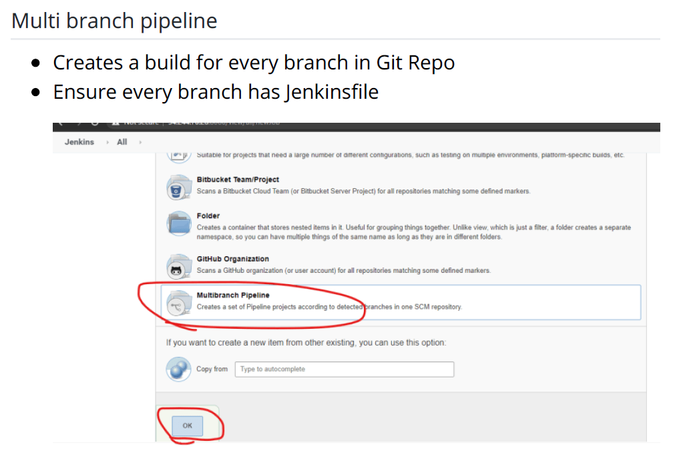

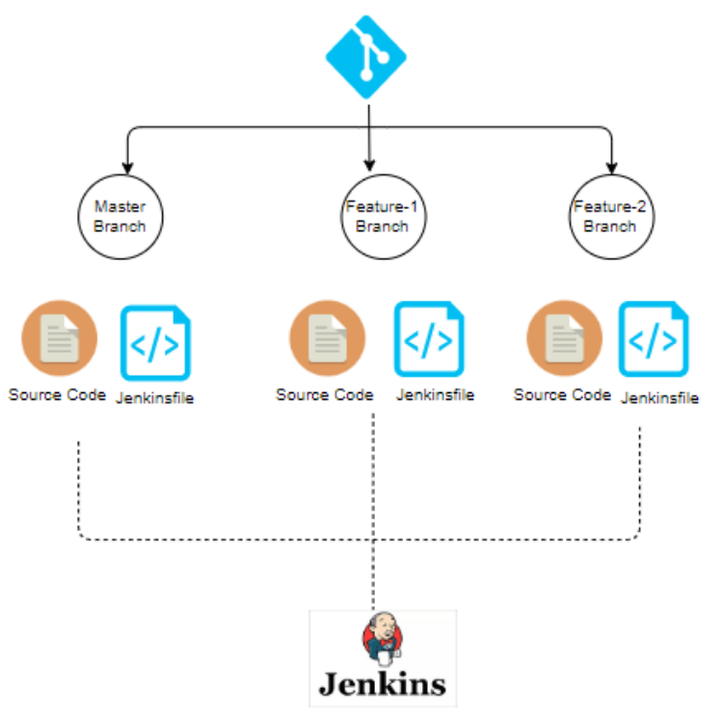

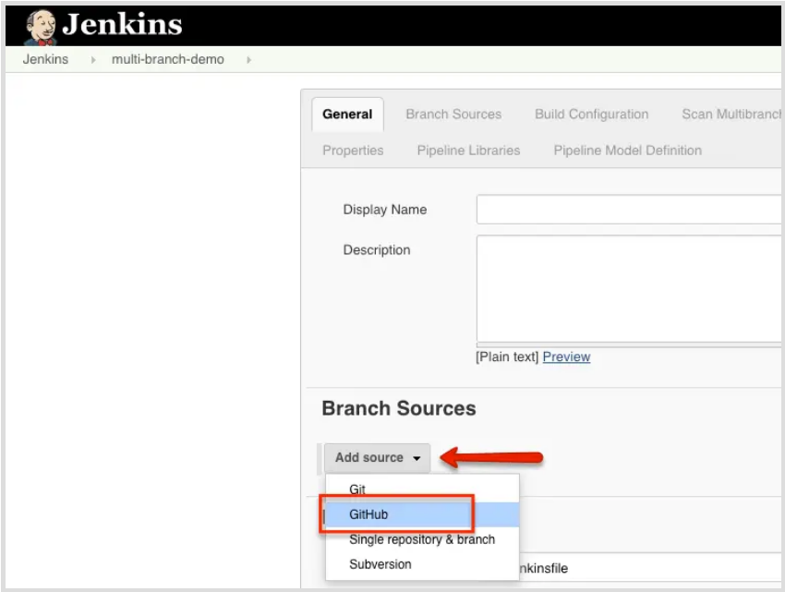

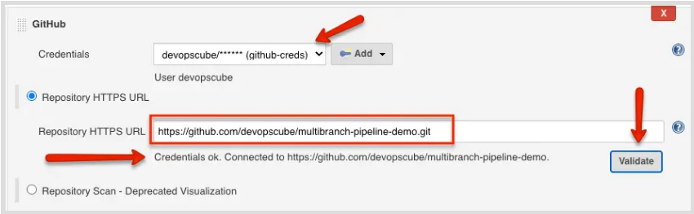

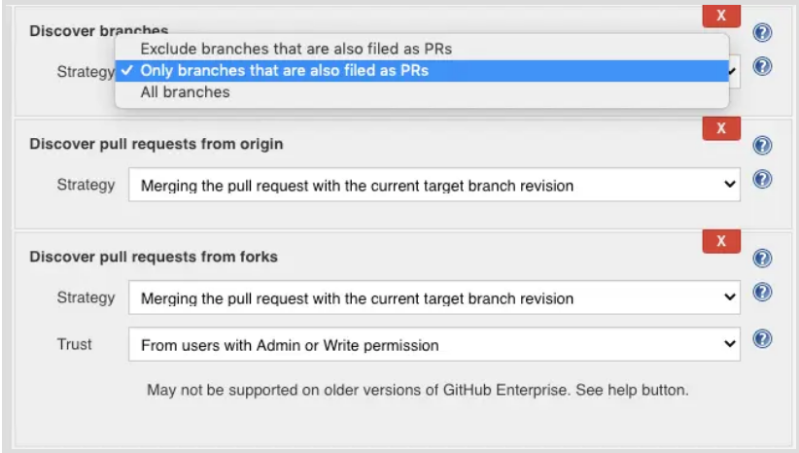

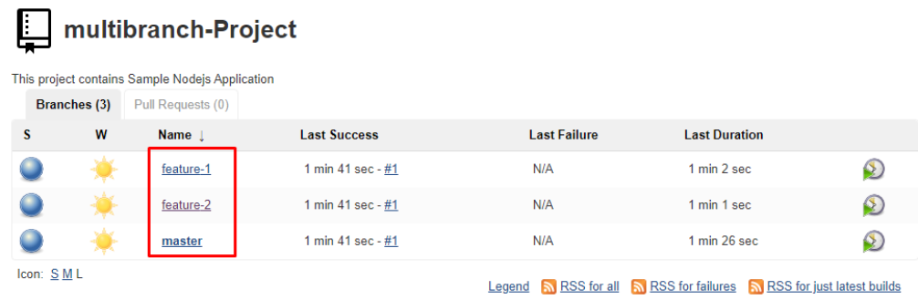

MULTIBRANCH JENKINS PIPELINE CODE IS SAME AS NORMAL ONE

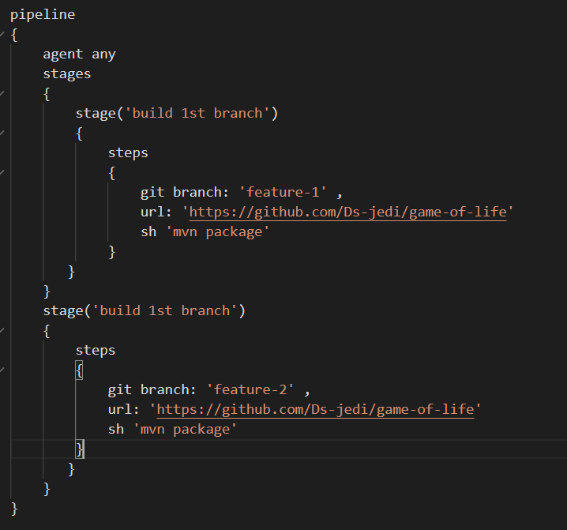

## **Write a sample groovy script**

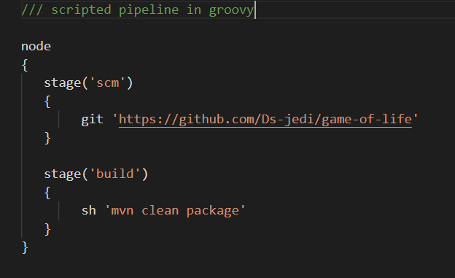

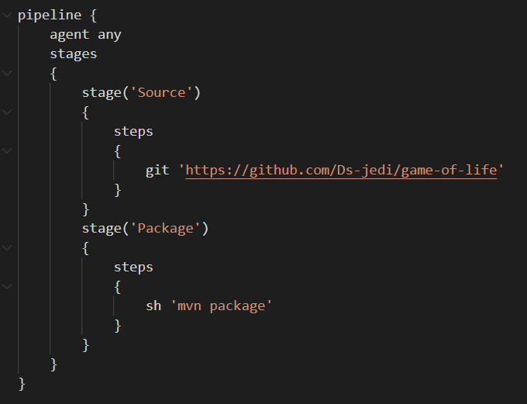

## **What is pollscm in Jenkins**

Poll SCM periodically polls the SCM to check whether changes were made (i.e. new commits) and builds the project if new commits where pushed since the last build, whereas build periodically builds the project periodically even if nothing has changed.

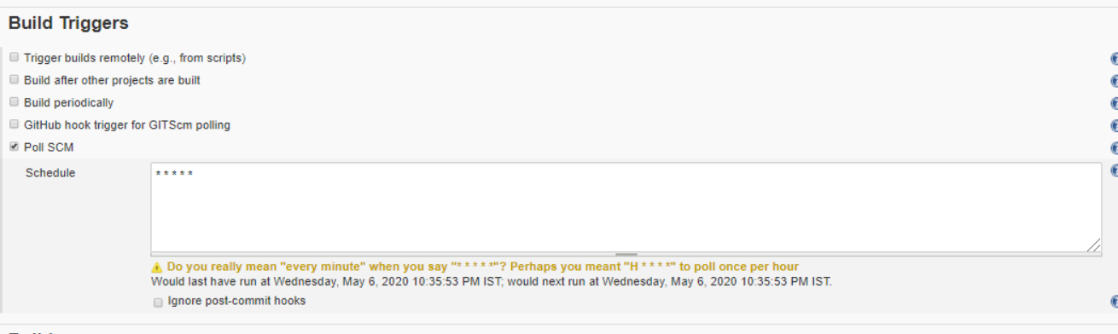

## **How to configure LDAP in Jenkins**

LDAP (Lightweight Directory Access Protocol) is an open and cross platform protocol used for directory services authentication. LDAP provides the communication language that applications use to communicate with other directory services servers.

<https://plugins.jenkins.io/ldap/>

<https://support.cloudbees.com/hc/en-us/articles/235438387-Jenkins-LDAP-Configuration-Troubleshooting?page=12>

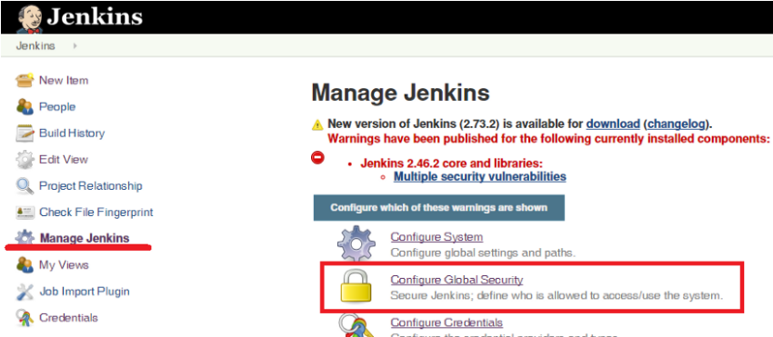

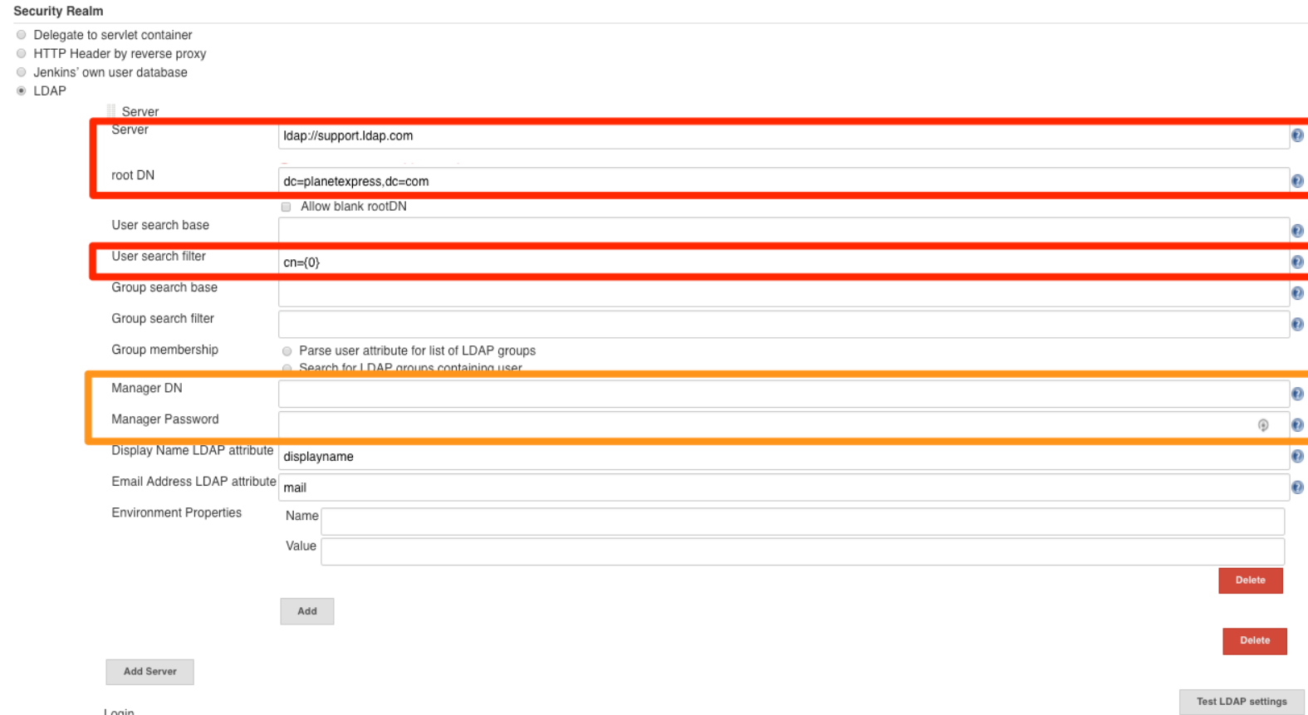

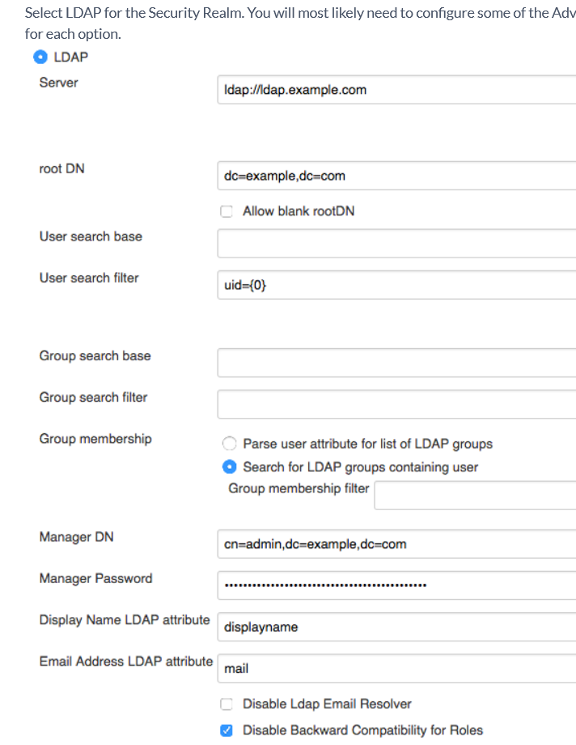

## **Can we configure our personal computer as a slave in Jenkins**

Yes we can do , follow typical master slave config

## **Is it possible to recover deleted jobs in Jenkins**

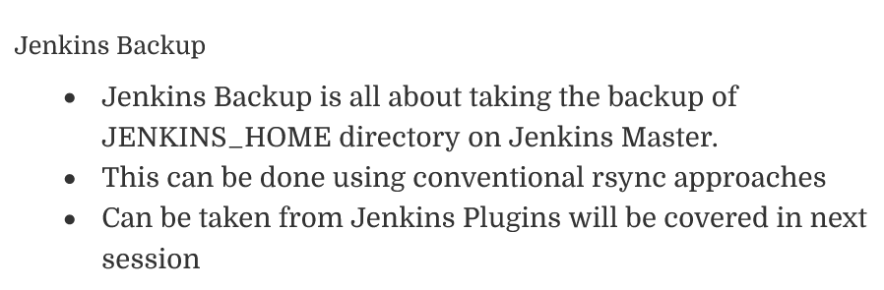

1. Manually take backups of your folder Jenkins_home/jobs

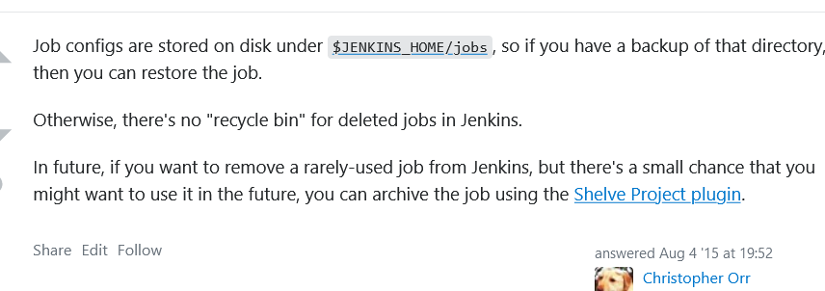

<https://stackoverflow.com/questions/31806108/how-to-retrieve-deleted-jenkins-job>

1. Or use job config history plugin

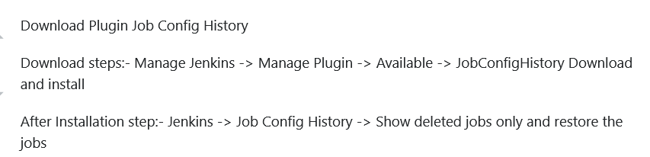

More about this plugin is next question

<https://wiki.jenkins.io/display/JENKINS/JobConfigHistory%20Plugin>

<https://plugins.jenkins.io/jobConfigHistory/>

1. Or take regular snapshots of ur Jenkins instance

<https://subscription.packtpub.com/book/application_development/9781784390891/1/ch01lvl1sec12/disaster-recovery-in-jenkins>

## **Explain the pipeline that u have written from scratch**

<https://directdevops.blog/2020/05/15/devops-classroom-series-15-may-2020/>

<https://directdevops.blog/2020/05/16/devops-classroom-series-16-may-2020/>

<https://www.jenkins.io/doc/pipeline/tour/hello-world/>

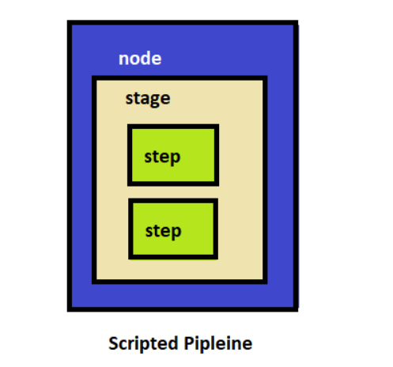

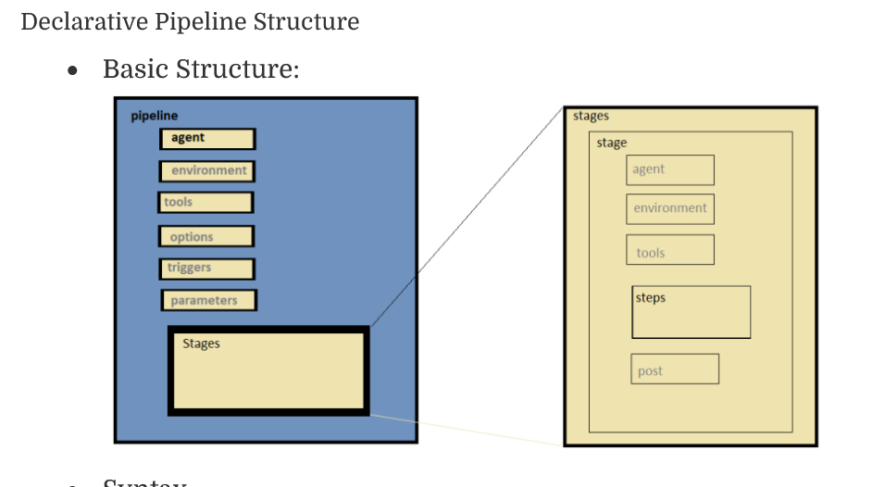

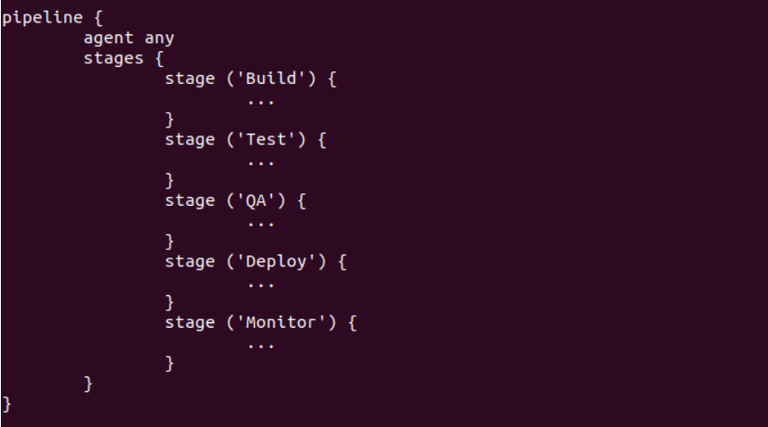

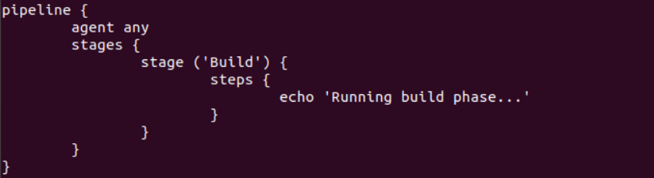

## **Slack integration in Jenkins**

Use slack notification plugin

<https://medium.com/appgambit/integrating-jenkins-with-slack-notifications-4f14d1ce9c7a>

## **Day builds vs nightly builds**

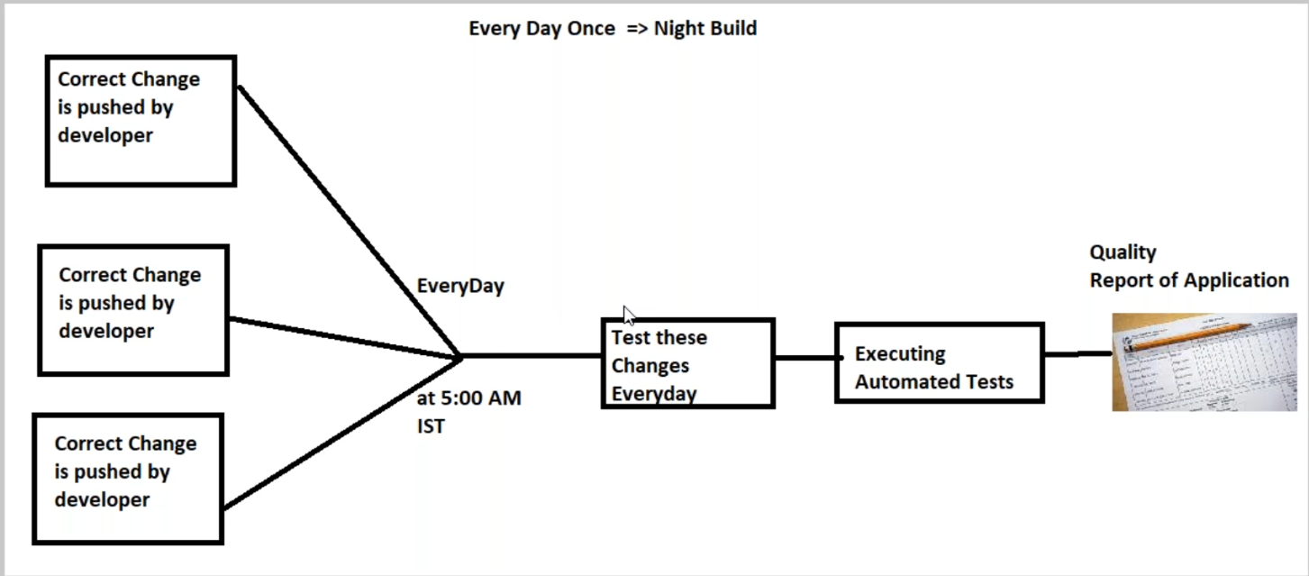

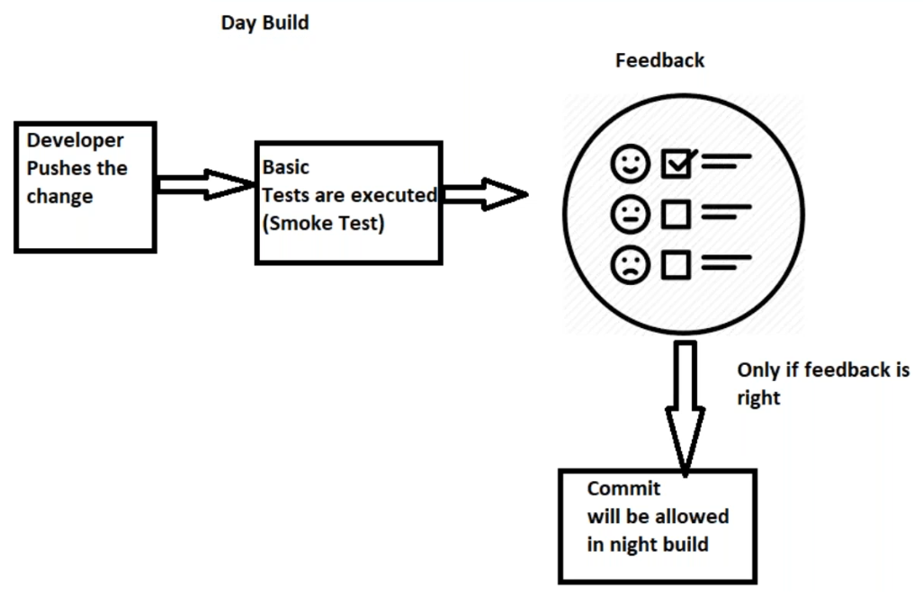

Day build means when developer himself individually builds and run some basic tests before merging his changes to developer branch (in which all devs work are merged)

After day builds are completed all developers merge all their code to developer branch which is build daily at some particular time . this is called nightly build

This decreases of encountering build failures coz each devoper’s code has ben successfully tested in his day builds .

https://stackoverflow.com/questions/417134/continuous-integration-vs-nightly-builds

## **Scenario , every day u need to run a job in jenkins that goes to ur scm and checks total no of java and sql files present. From this job we also want to know how many .java and .sql files have been modified /added/deleted.suppose on day 1 there are 10 .java files and 10 .sql files , and on day 2 developer adds 5 more .java files and 8 more .sql files. Ur jenkins job need to show no of files changes /modified. How do u write a python/shell script for it ? ((Use find command or webhooks to achieve this)) Now the above script that u have written need to find the no of files modified and send it as a html report to all project managers on slack or as an email to all developers . how do u generate those html reports ?**

## **what sort of email plugin have u used ?(editable email notification plugin )**

<https://medium.com/edureka/configure-email-notification-in-jenkins-c31d3a9c9f0a>

<https://medium.com/@gustavo.guss/jenkins-sending-email-on-post-build-938b236545d2>

<https://stackoverflow.com/questions/11884050/send-email-notification-from-jenkins>

## **How did u attach build logs and build url to those emails , also How did u configure which people will receive those emails ( for example email only gets sent to devops and pms) , also how did u pass jenkins build ID to the subject section of that email ? (see 40:00)**

1. U need to have EMAIL EXTENSION PLUGIN installed . THEN ADD THE FOLLOWING

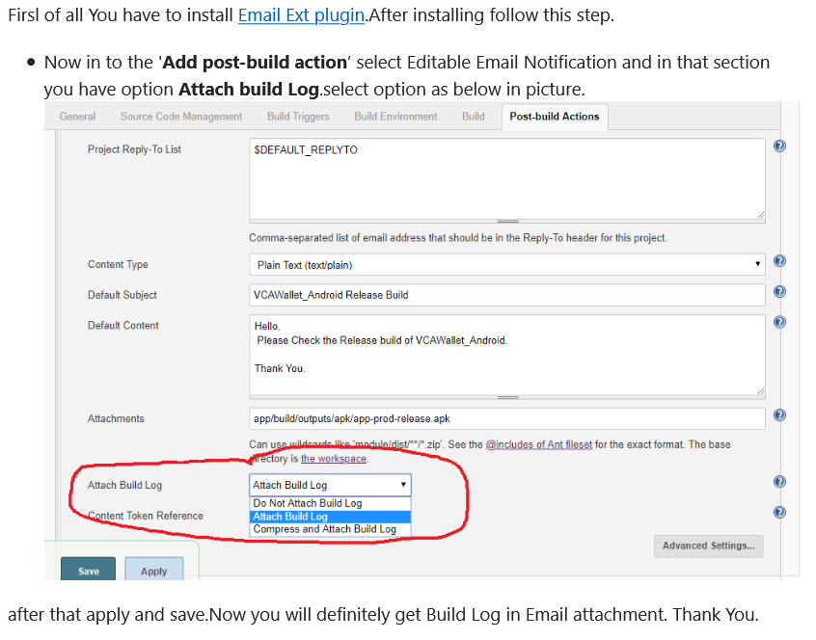

The BUILD LOGS are saved here

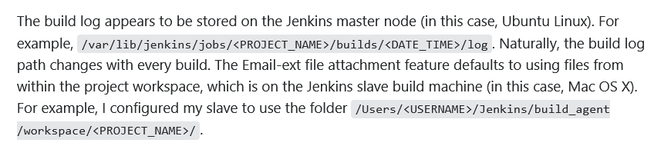

1. TO ADD THIS TO POST BUIULD SECTION IN PIPELINE

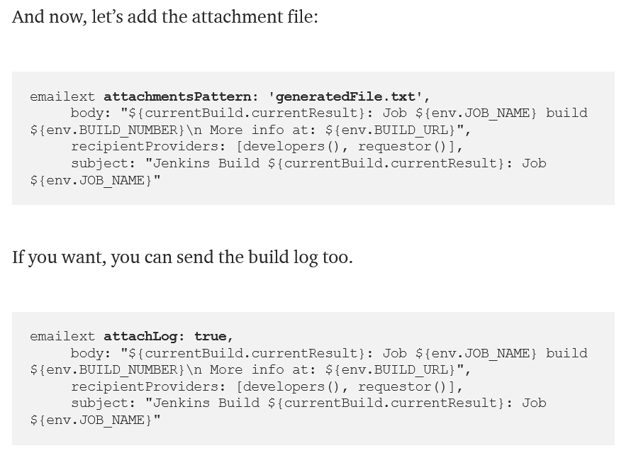

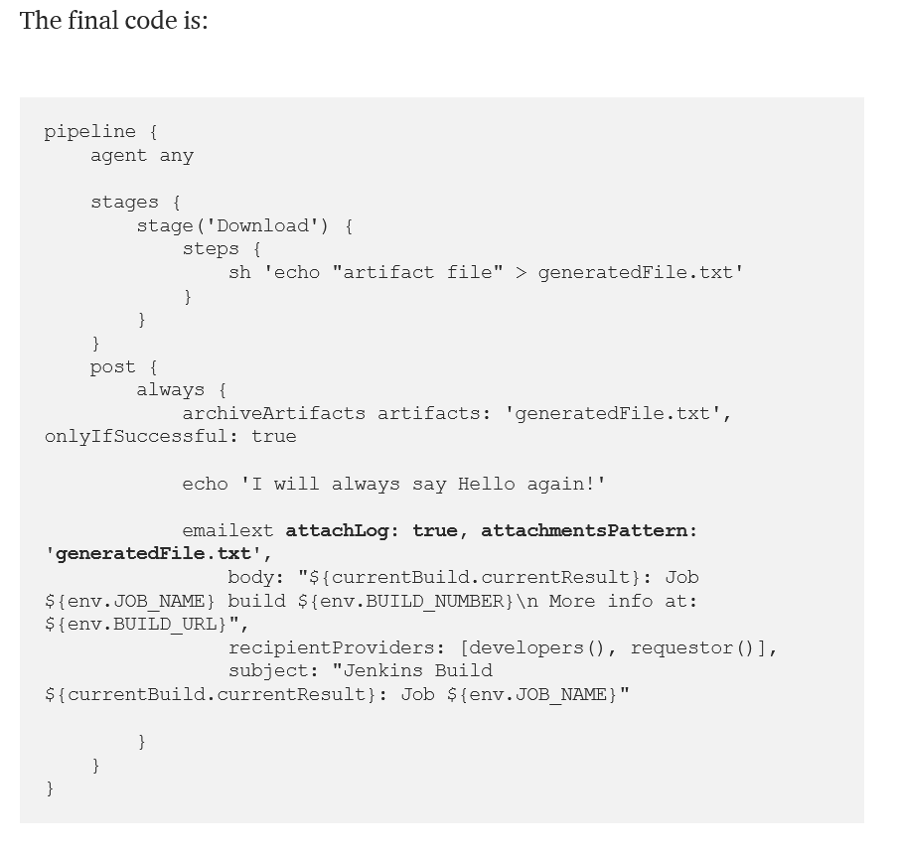

For more info follow here

<https://medium.com/@gustavo.guss/jenkins-send-email-with-attachment-cec1e052583a>

<https://stackoverflow.com/questions/8558324/how-do-i-attach-a-build-log-to-an-e-mail-notification-with-the-jenkins-plugin-em>

## **What is ur backup and recovery strategy for environments that u are supporting for dev and qa**

Take regular snapshots of ur instances in AWS lifecycle manager

## **Current deployment has ton of bugs , we need to roll back to previous build and deploy it again, how to do**

<https://stackoverflow.com/questions/52722666/jenkins-rollback-previous-version-of-deploy>

## **When u do backup and recovery , one of the challenge u will always have this -Suppose u do deployments of database changes daily .lets say , ur developer has introduced a new feature, for which he has made a change in data model like maybe introduced a new column in a table .and then he also has the middle tier code changed for that. Now how are u currently coordinating in ur job , what is the database change and what is the middle tier change , because if u are responsible only for middle tier code how do u know that database change has happened. 47:00 Interview-15 Oracle 4year ex , 55 mins**

## **how did u set up ur deployment tracker**

## **Different types of deployment explain**

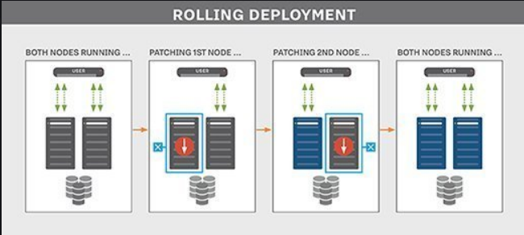

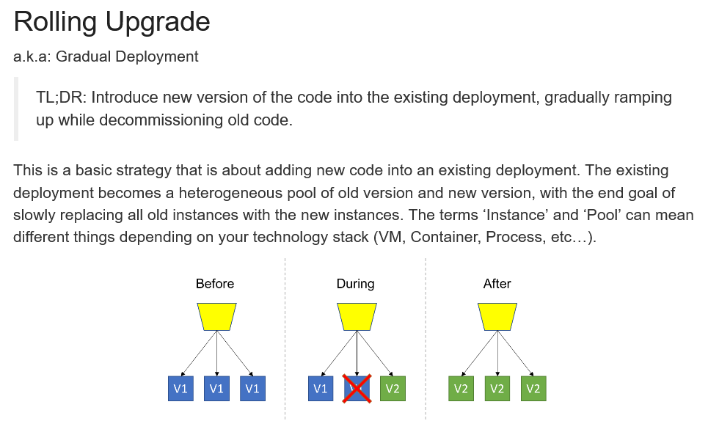

<https://www.cloudbees.com/blog/rolling-deployment>

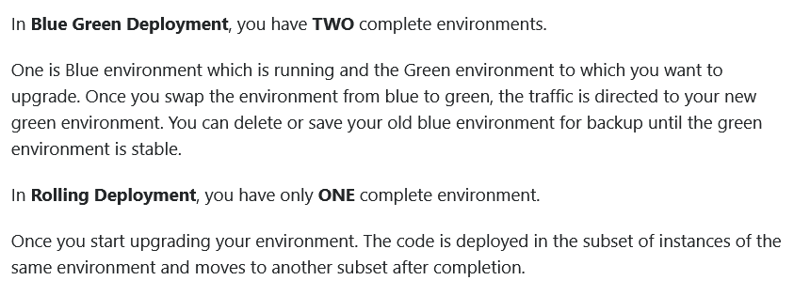

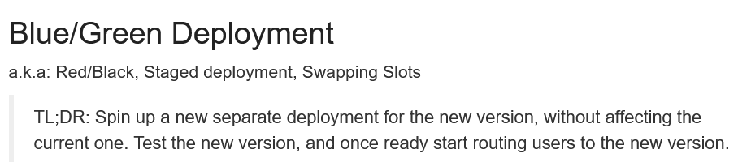

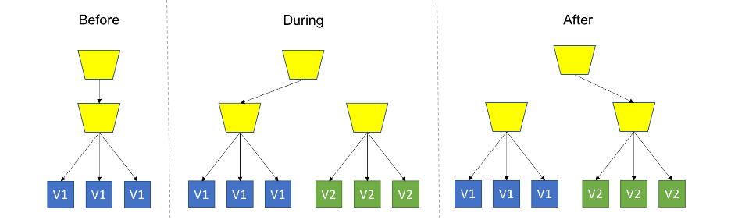

<http://blog.itaysk.com/2017/11/20/deployment-strategies-defined>

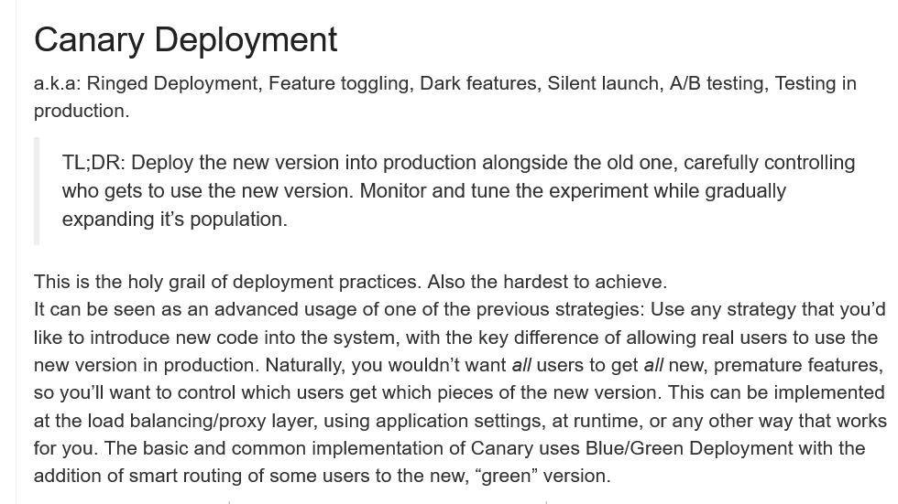

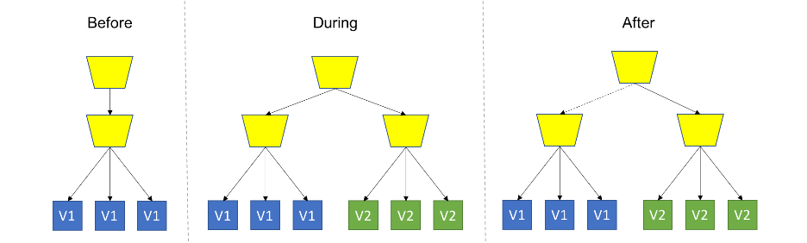

<http://blog.itaysk.com/2017/11/20/deployment-strategies-defined>

## **How did u integrate linter in jenkins**

## **How did u run unit test automatically , how did u release its results to developers?**

## **Can u setup a notification setup in jenkins from scratch for a new job?**

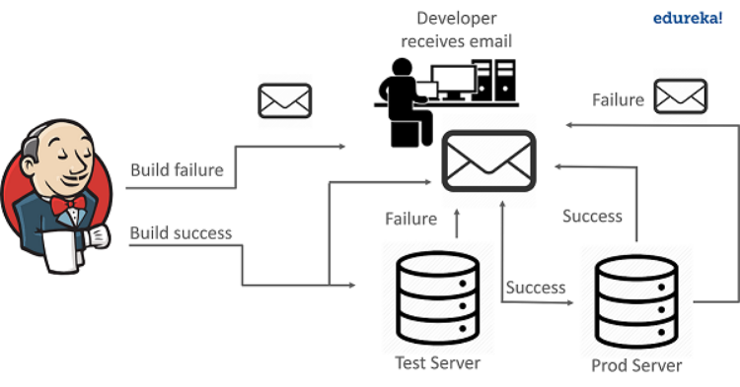

See the previous questions on how to set up email notification

For more info follow here <https://www.edureka.co/blog/email-notification-in-jenkins/>

## **Explain post build process followed in ur company**

## **How many guys in ur devops team ? how did u get ur tasks assigned**

We had a daily standup meeting , where tasks were discussed and later shared in slack channel

## **SLA, SLO followed in ur organization**

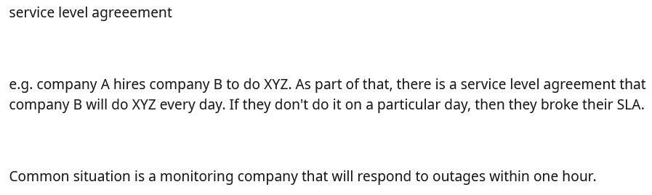

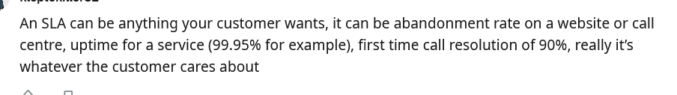

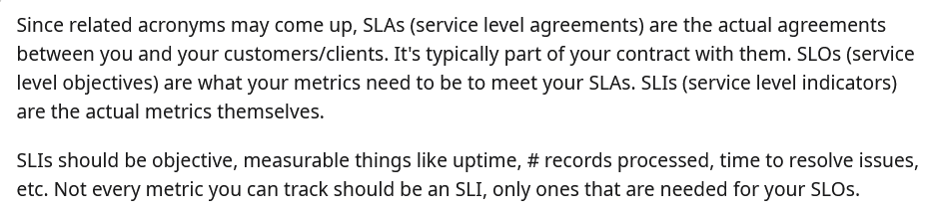

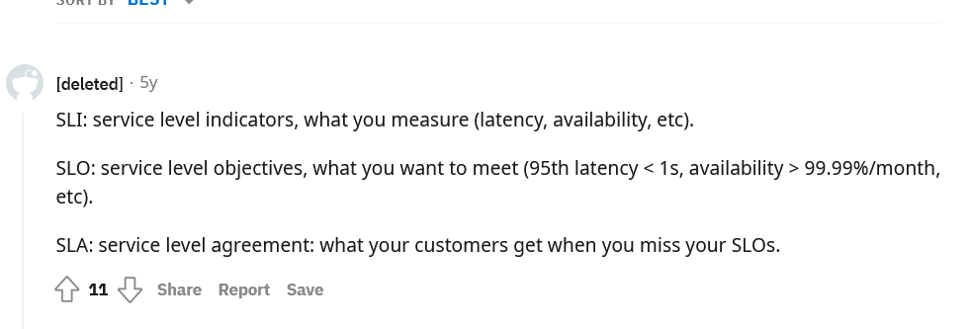

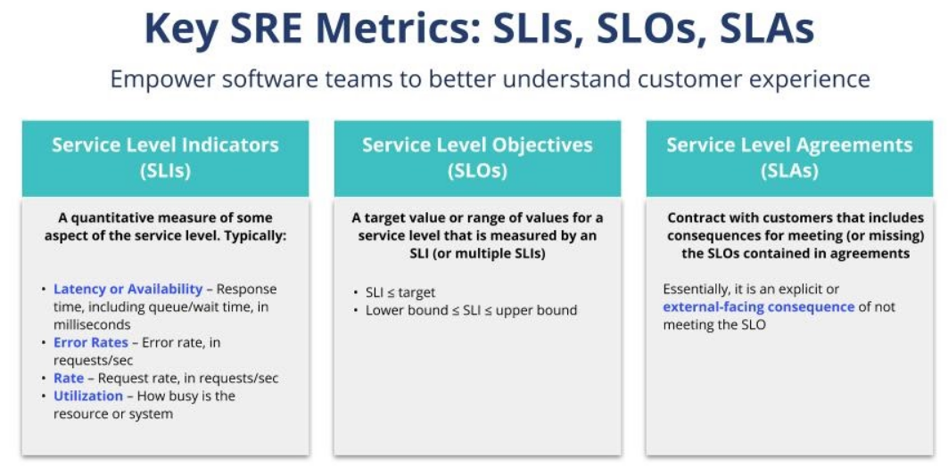

<https://www.datadoghq.com/blog/slo-monitoring-tracking/>

<https://cloud.google.com/blog/products/devops-sre/sre-fundamentals-slis-slas-and-slos>

## **ELI5 what is devops**

## **How to install Jenkins**

<https://directdevops.blog/2021/02/09/devops-classroom-series-09-feb-2021/>

<https://www.jenkins.io/doc/book/installing/linux/#debianubuntu>

## **If u want to change jenkins port from 8080 to 9000 , what to do(change settings in jenkins.xml or use a command)**

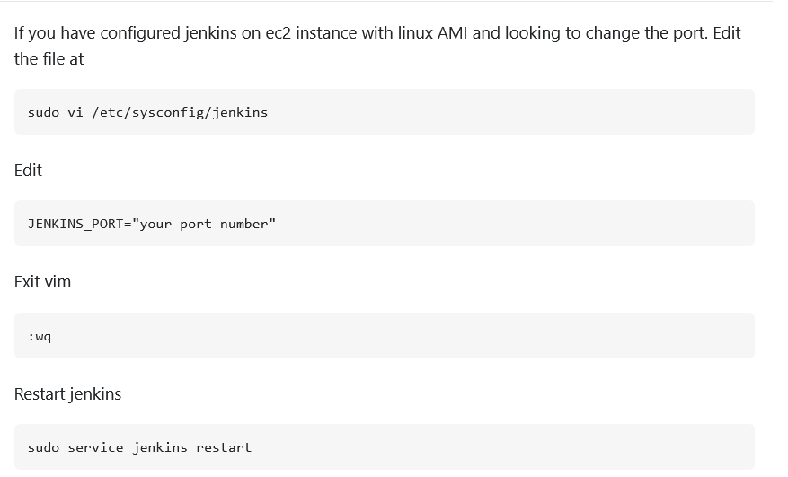

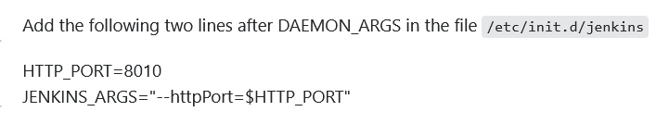

## **If u have 2 jobs in jenkins, and u want to pass system variables from 1 jenkin job to another , what to do**

INSTALL PARAMETERIZED TRIGGER PLUGION FOLLOW THIS VIDEO HERE  
<https://plugins.jenkins.io/parameterized-trigger/>

<https://www.youtube.com/watch?v=JqVHdiWAyYQ>

FOR PIPELINE FOLLOW THIS VIDEO

<https://www.youtube.com/watch?v=qDVqezp3mOw>

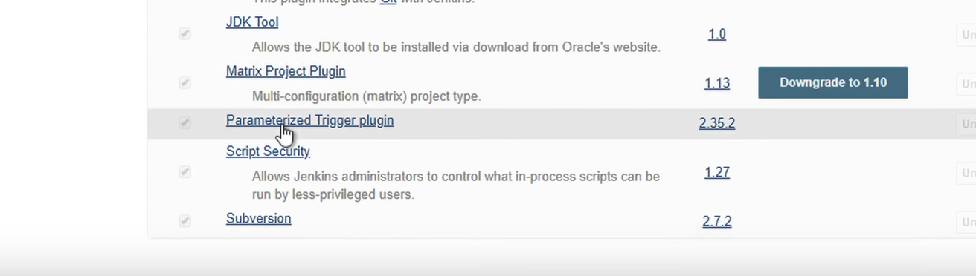

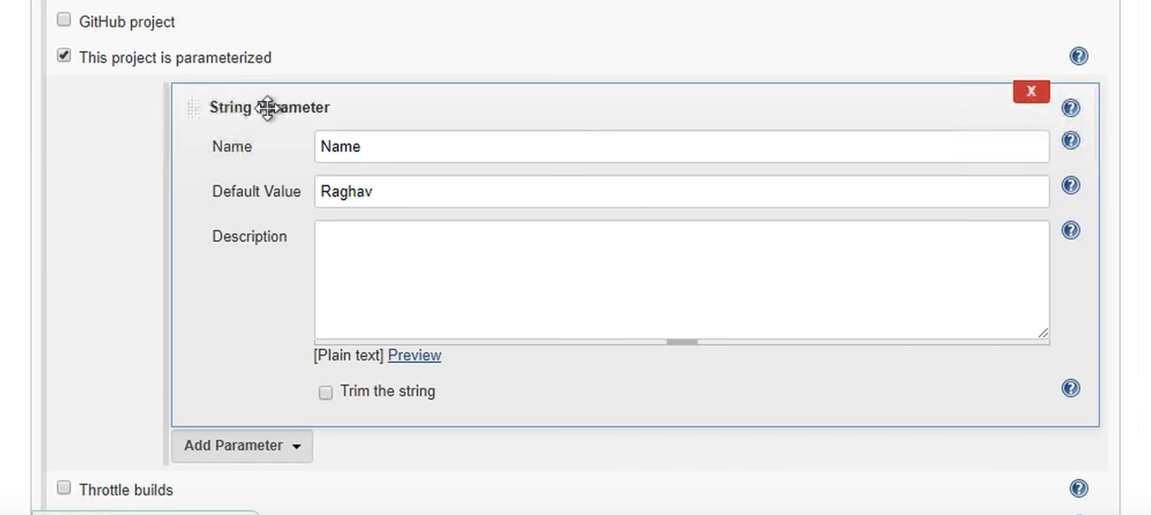

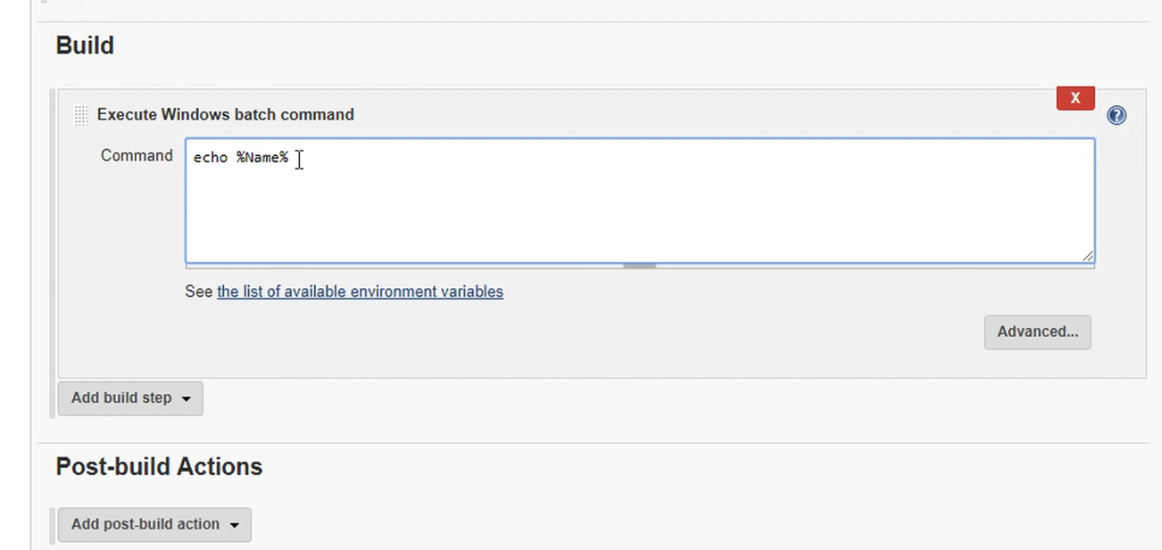

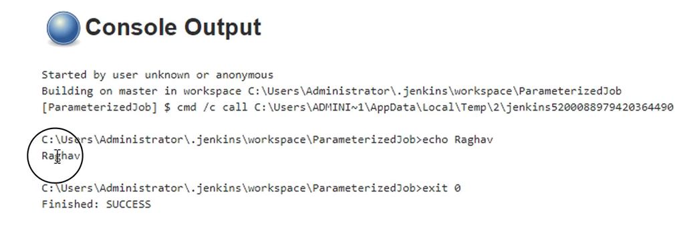

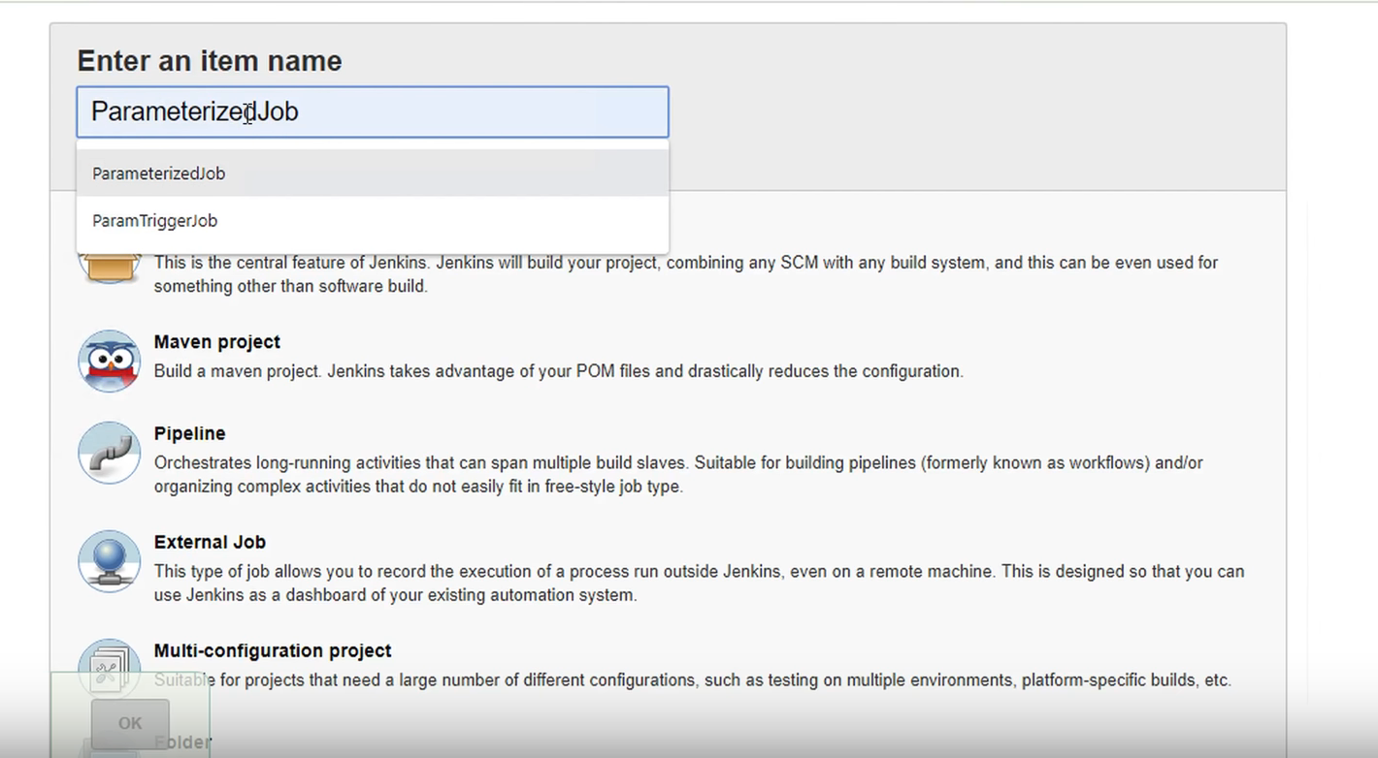

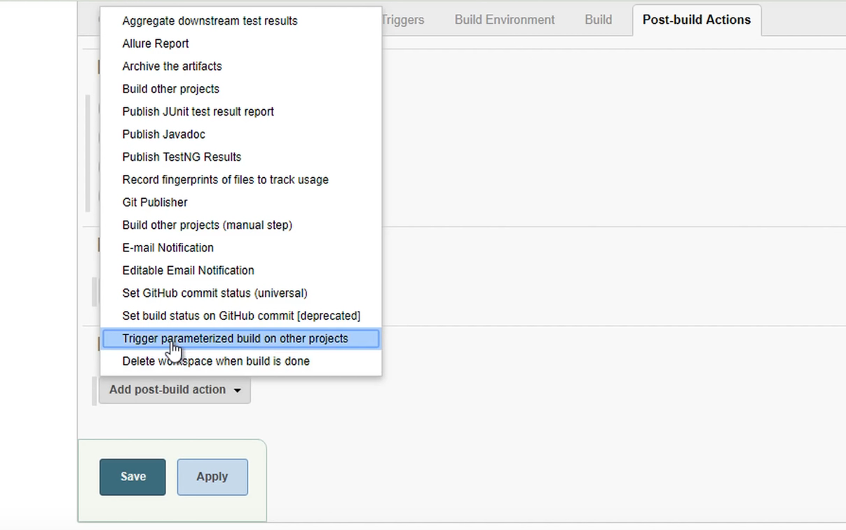

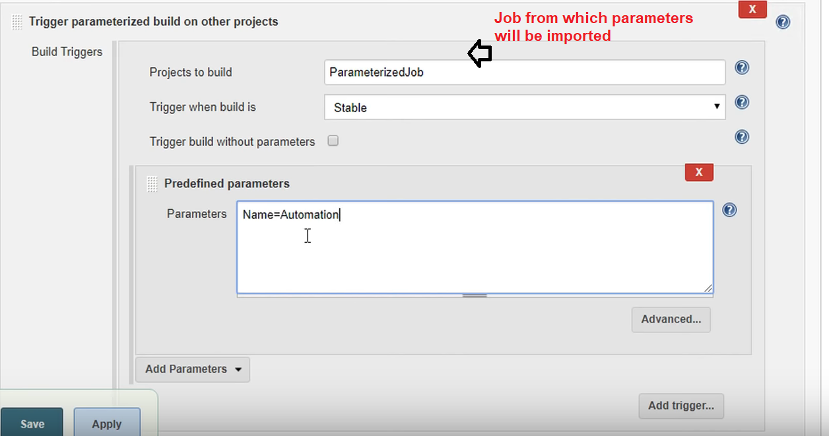

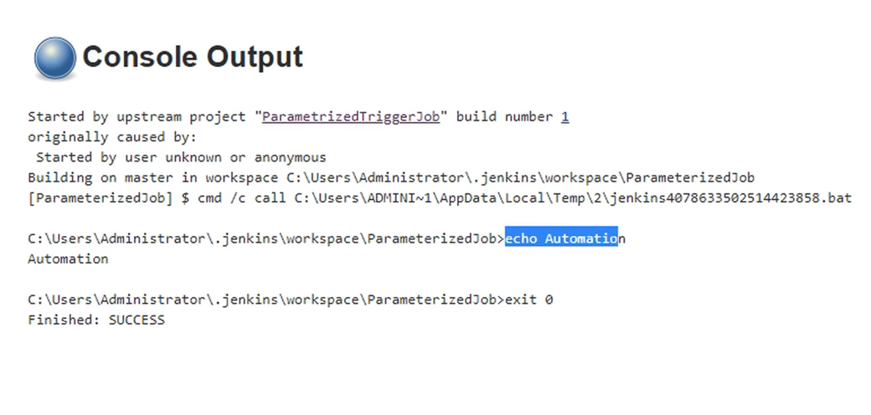

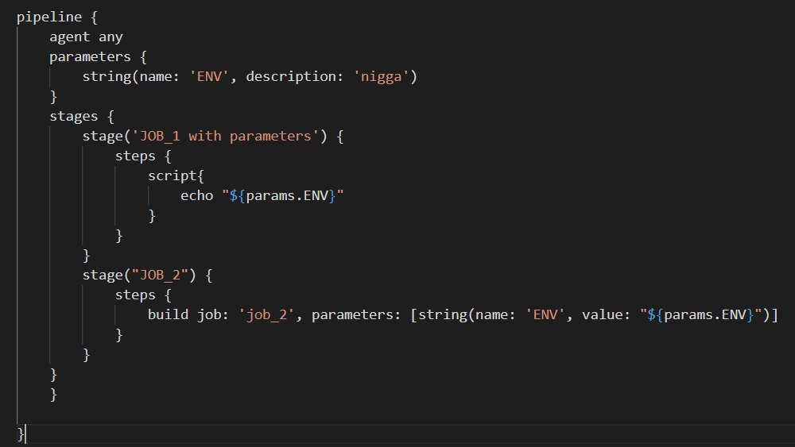

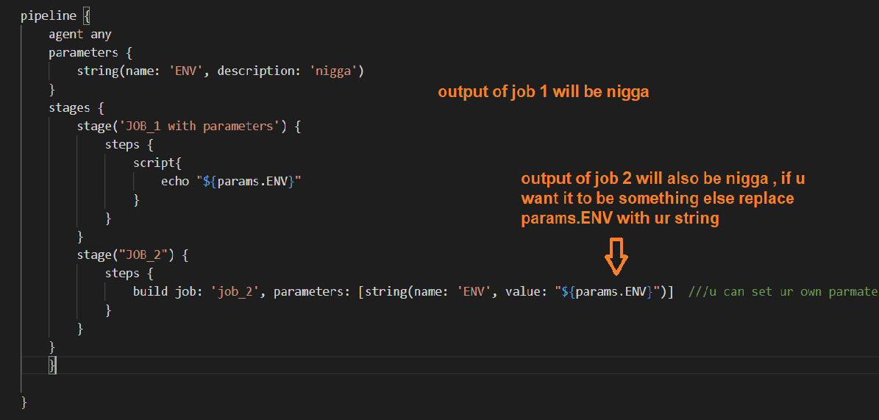

## **U have 1 scheduled job in jenkins , and u want to search code from multiple scm repos (one is github , other may be bitbucket) in a single job , what to do**

<https://stackoverflow.com/questions/40224272/using-a-jenkins-pipeline-to-checkout-multiple-git-repos-into-same-job/40225216>

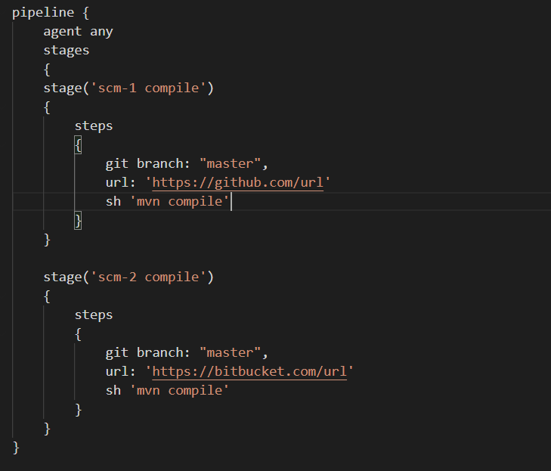

IF u want to create sub folders for each scm then add this

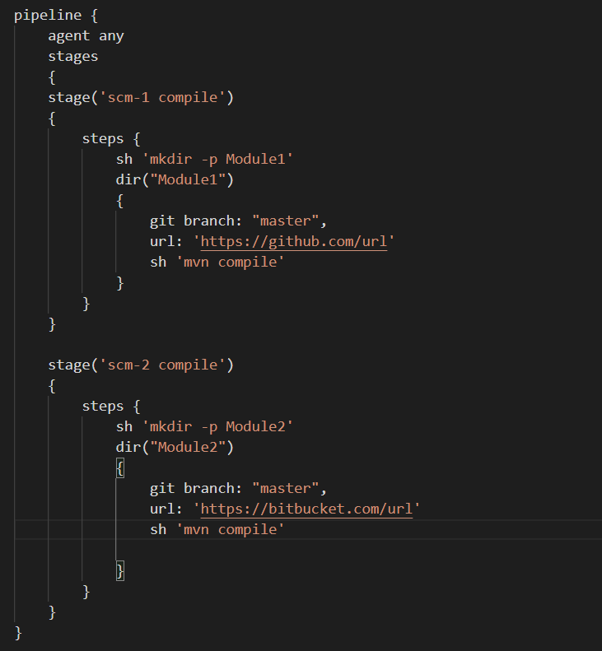

1. Have u work on any apis in jenkins

## **Jenkins is install on a ec2 instance . u dont have access to that instance . u just have access to jenkins dashboard whichu are using from another instance , now u want to restart the jenkins server after installing a plugin , whats ur line of action ( use jenkins restapi)**

## **Explain what is upstream downstream jobs**

<https://directdevops.blog/2020/05/17/devops-classroom-series-17-may-2020/>



THIS IS CALLED UPSTREAM JOBS

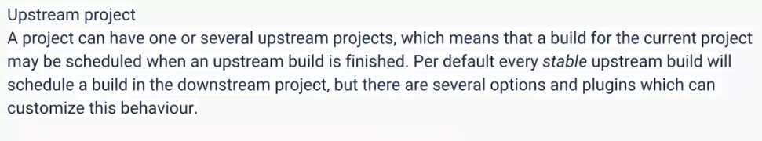

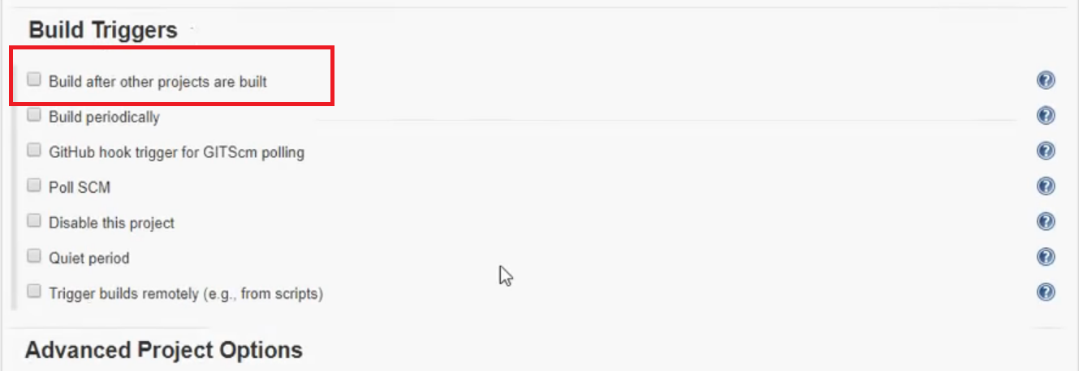

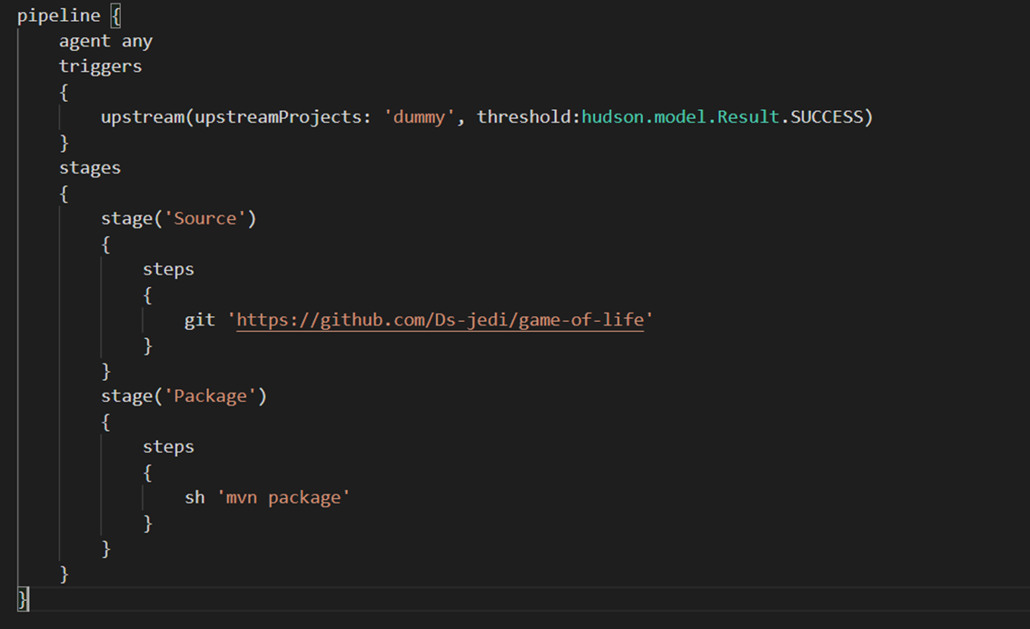



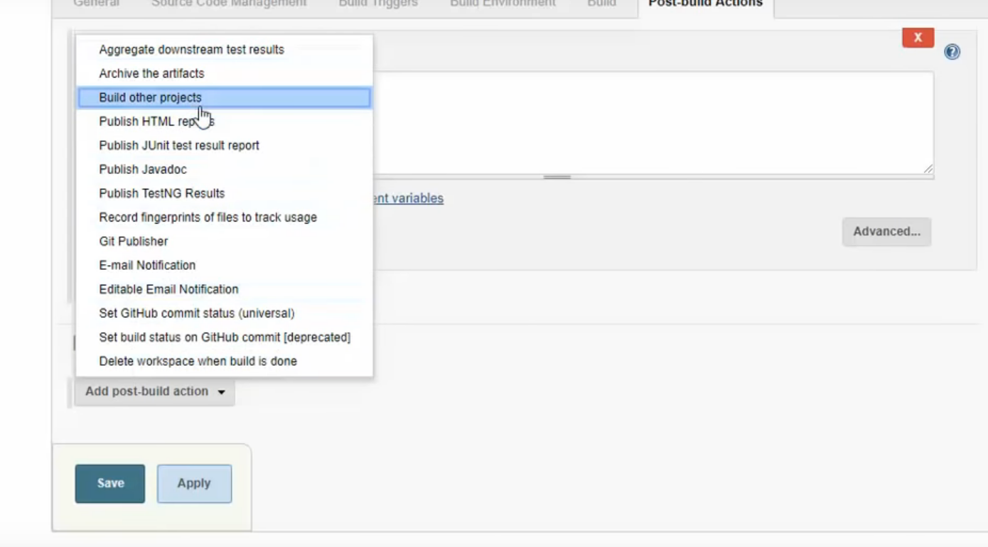

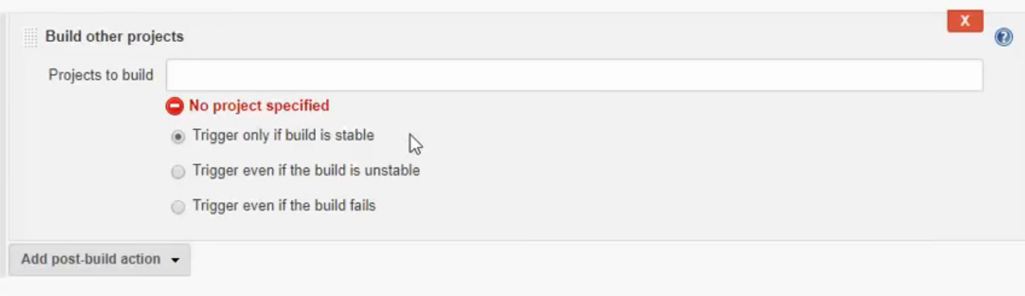

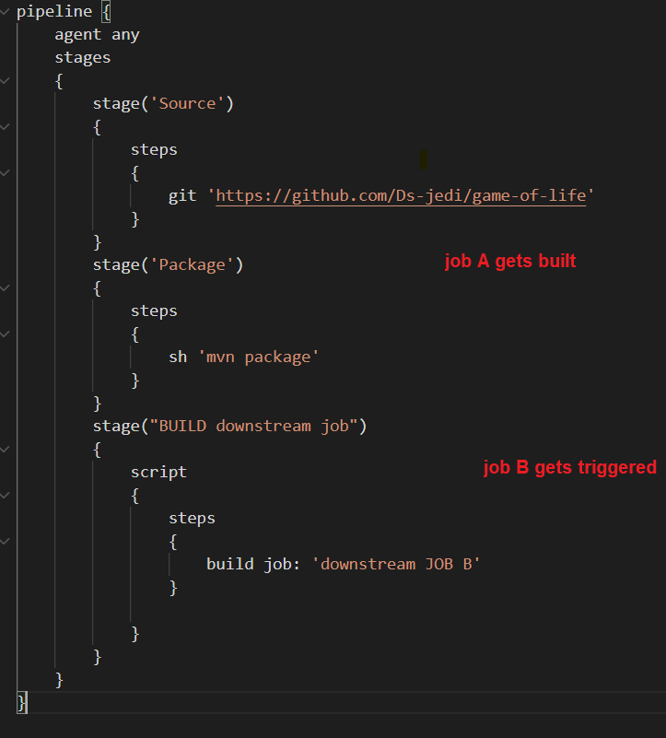

## **What is the use of jenkins?**

JENKINS IS A JUST A SCHEDULER ON STEROIDS

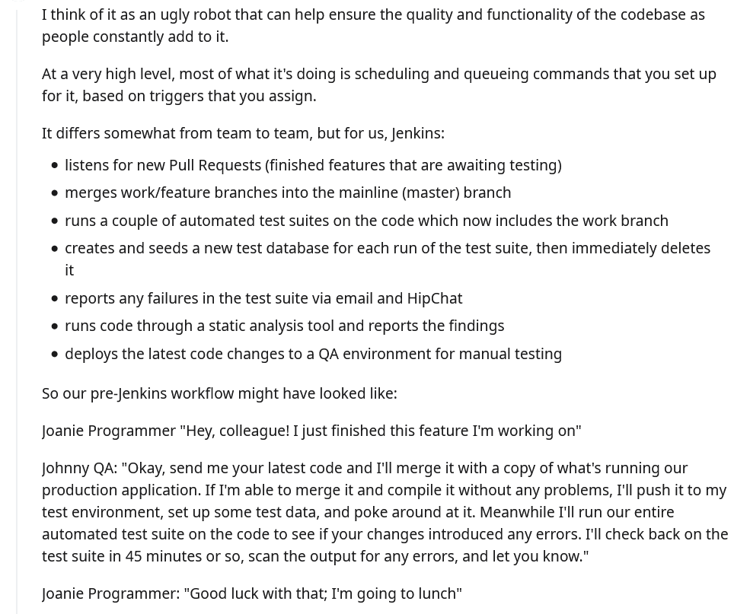



## **how to secure jenkins. About jenkins security**

<https://wiki.jenkins.io/display/jenkins/standard+security+setup>

<https://www.softwaretestinghelp.com/jenkins-security-tutorial/>

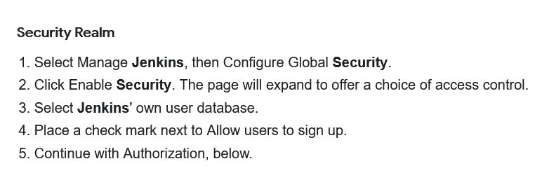

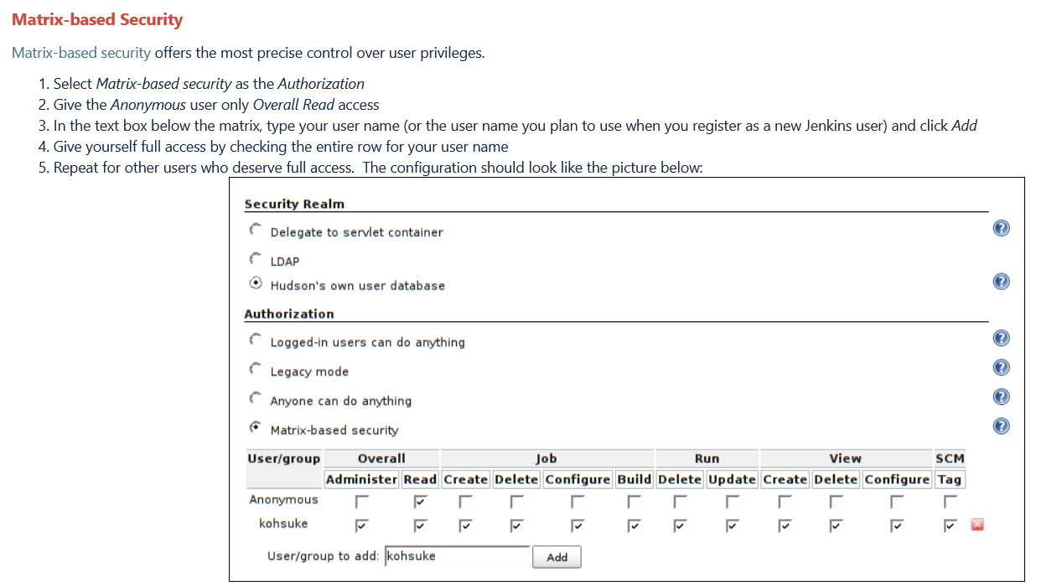

## **How jenkins recognises the change or a new commit in git? commit id in jenkins(VCS too)**

## **Migration from jenkins server and taking backups ( ./jenkins file reference)**

Already done , follow question 1

## **How many developers are there in QA and dev team?**

## **How will jenkins know that developers did the commit?**

Poll scm

## **How the trigger happens in jenkins when the commit happens?Explain that.**

Use poll scm

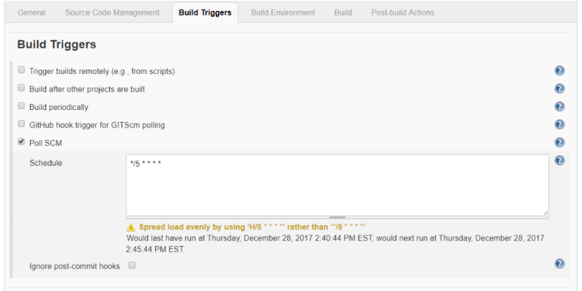

## **Is there any other way in git to call other than jenkins calling git(pollscm)?(refering to hooks and services). How to authenticate those in jenkins?**

<https://blog.knoldus.com/jenkins-build-triggers/>

<https://www.toolsqa.com/jenkins/jenkins-build-jobs/>

web hooks

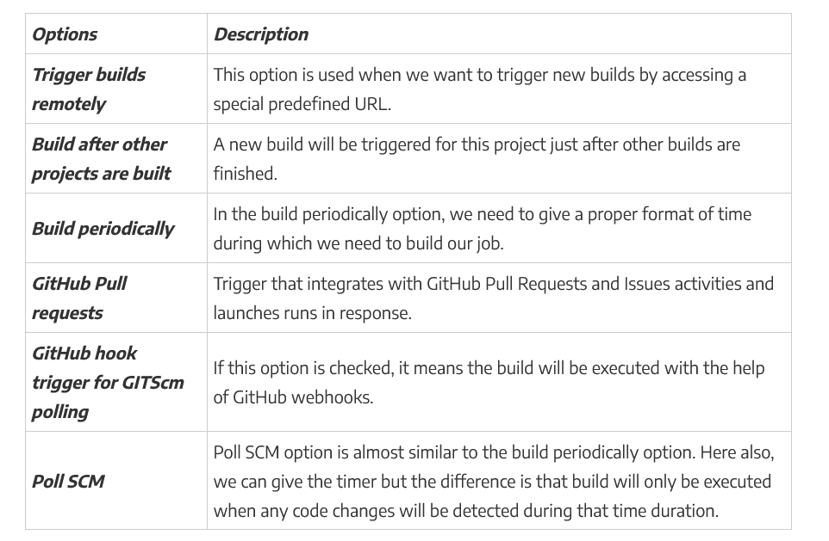

## **How do you control the packaging manifesto?( java files in this case)**

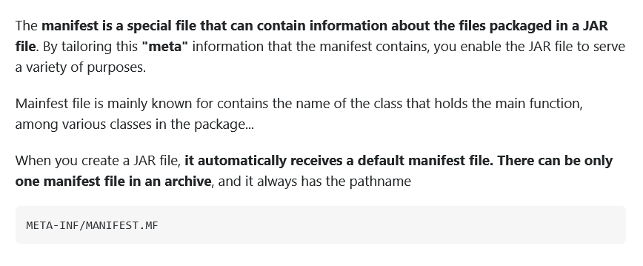

## **How to link sub-module to parent pom?**

<https://stackoverflow.com/questions/54111350/how-to-specify-the-parent-pom-to-a-submodule-of-a-project/54112748>

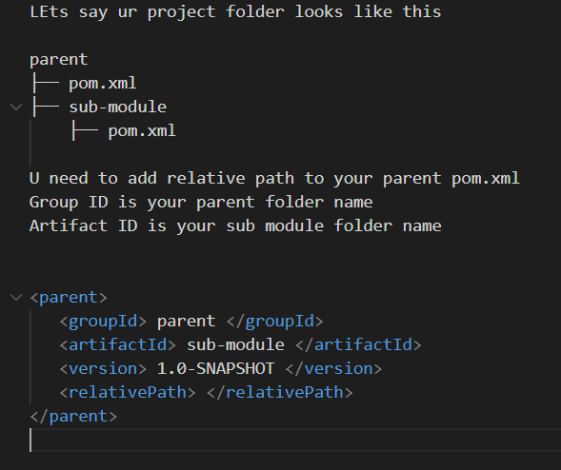

## **What type of jobs have you configured in your projects?**

Freestyle , pipeline , multibrach stuffs I have done

## **Where the jenkinsfile is loaded?**

Usually Jenkinsfile is stored in ur git project folder , if u create manualy through UI it is present in Jenkins home directory /var/lib/Jenkins

## **How the link happens between ansible and jenkins?**

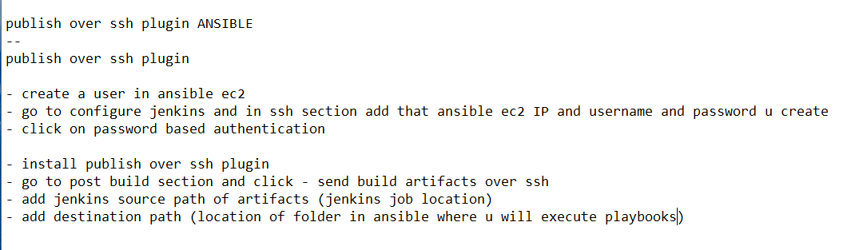

publish over ssh plugin ANSIBLE

--

publish over ssh plugin

- create a user in ansible ec2

- go to configure jenkins and in ssh section add that ansible ec2 IP and username and password u create

- click on password based authentication

- install publish over ssh plugin

- go to post build section and click - send build artifacts over ssh

- add jenkins source path of artifacts (jenkins job location)

- add destination path (location of folder in ansible where u will execute playbooks)

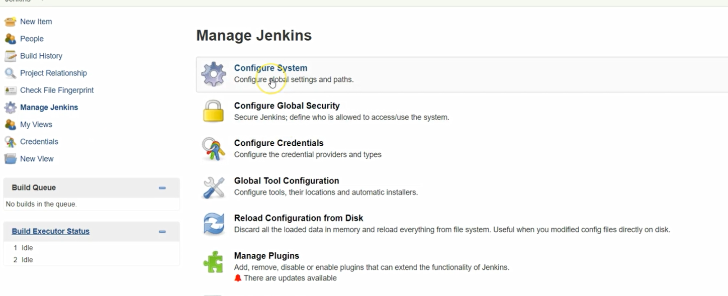

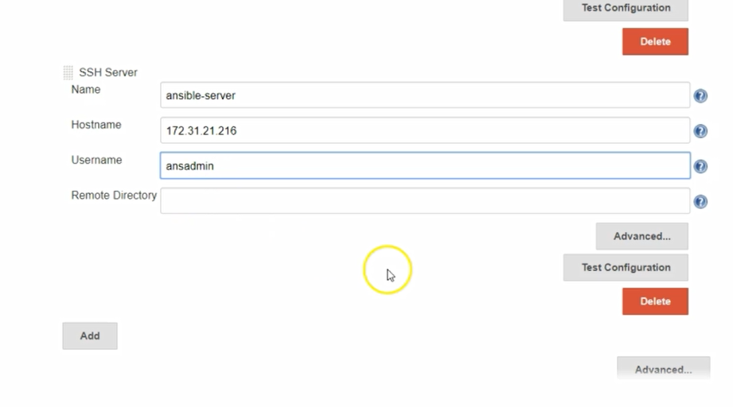

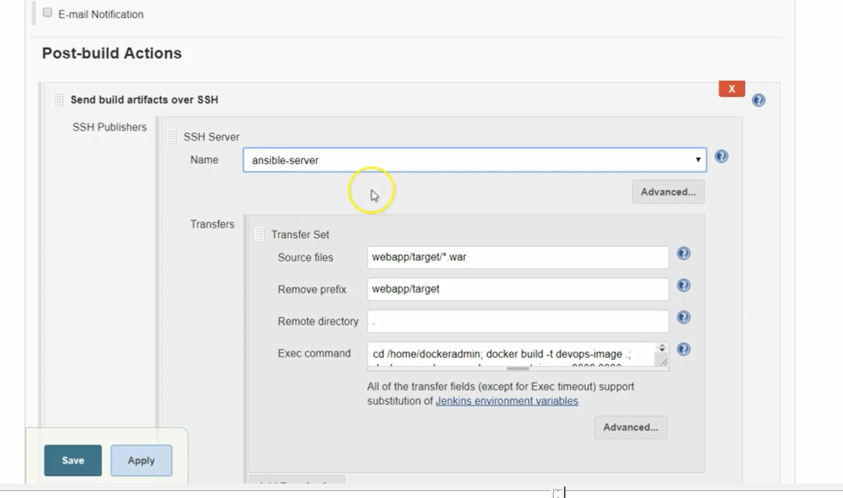

OR USE ANSIBLE PLUGIN FOLLOW HERE

<https://medium.com/appgambit/ansible-playbook-with-jenkins-pipeline-2846d4442a31>

## **Have you done any deployment automation?**

## **Have you worked on seed jobs in jenkins?**

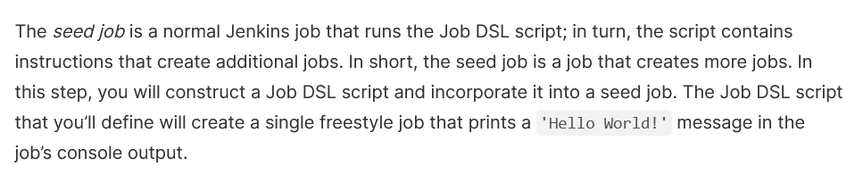

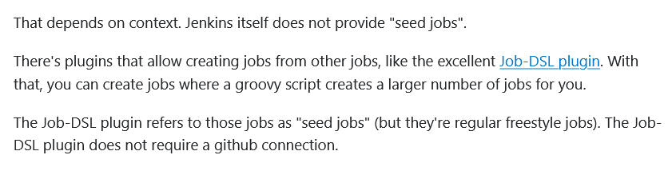

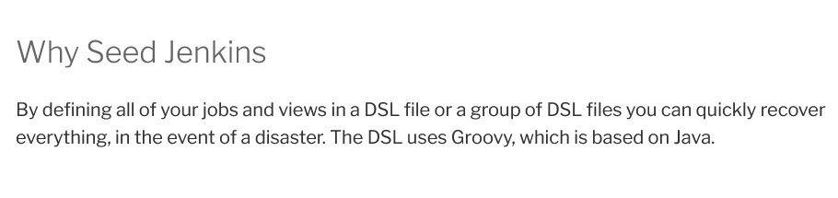

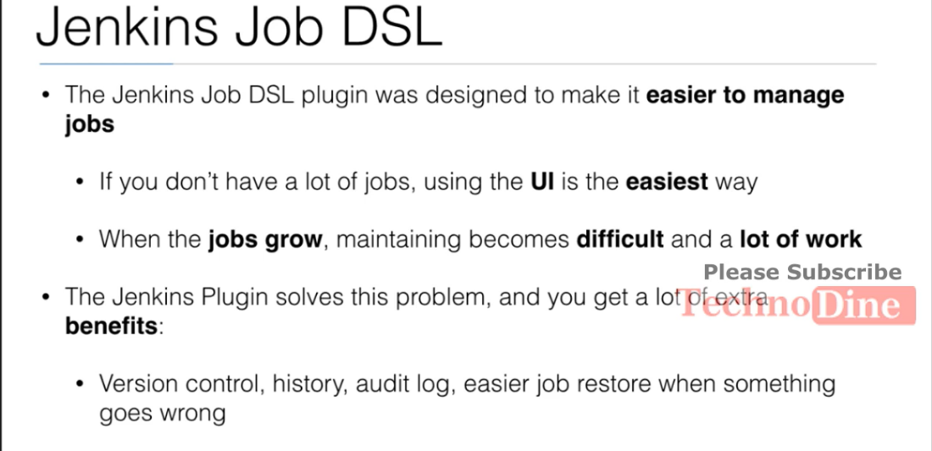

For more info follow here <https://www.serverlab.ca/tutorials/dev-ops/automation/how-to-seed-jenkins-build-jobs/>

<https://www.digitalocean.com/community/tutorials/how-to-automate-jenkins-job-configuration-using-job-dsl>

<https://www.youtube.com/watch?v=NfsU3tzoDa0>

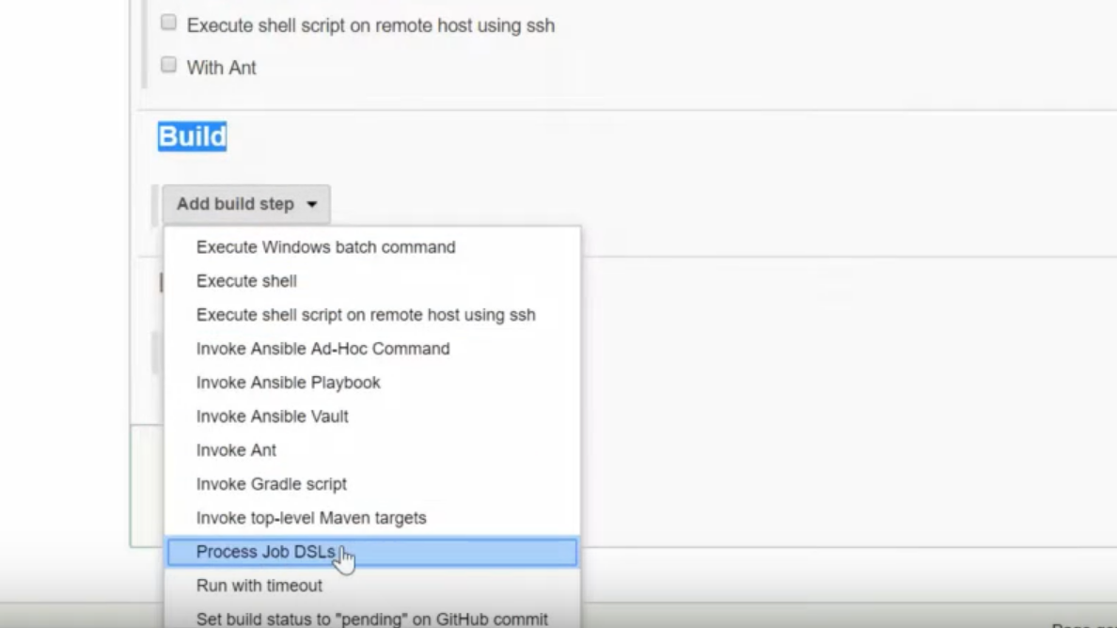

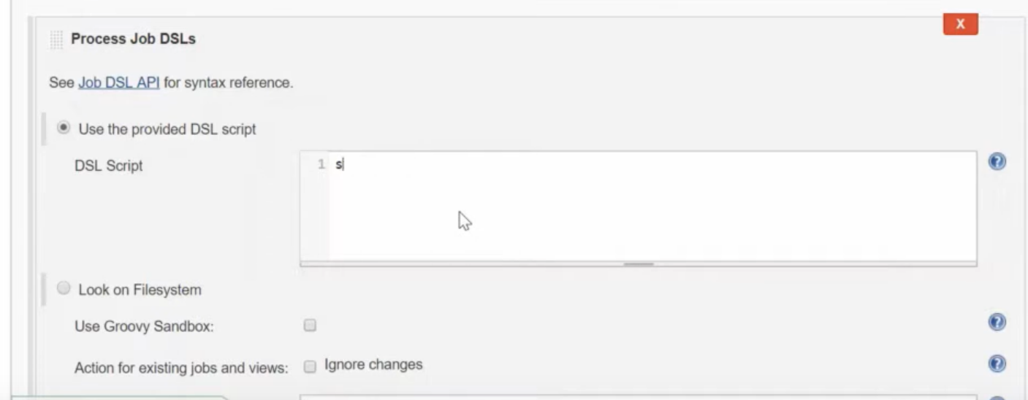

## **How to save only last 5 builds of jenkins job?**

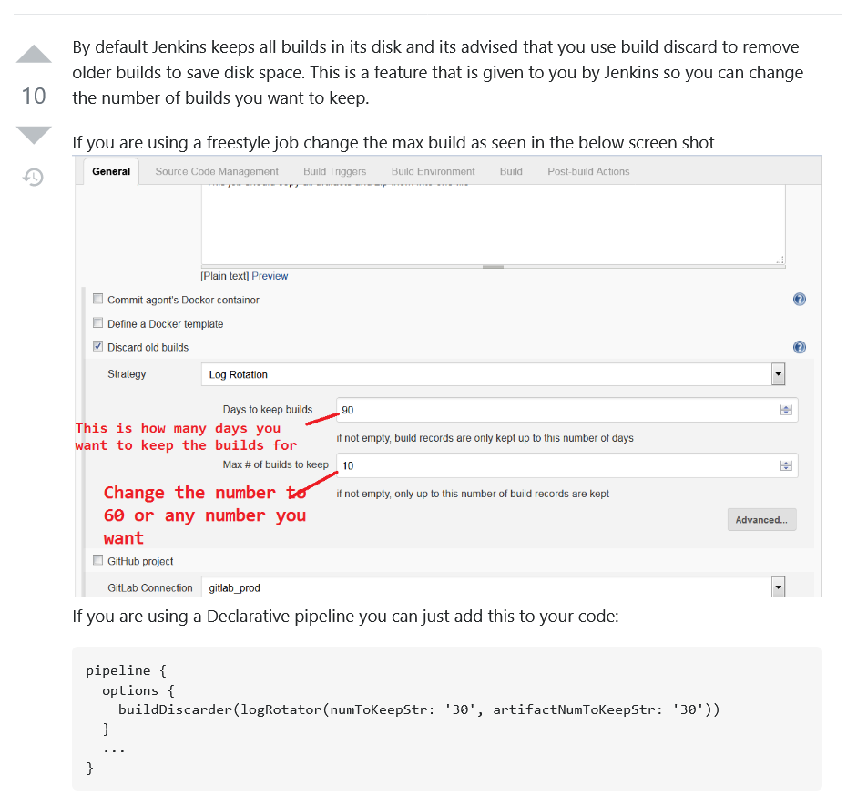

## **How would you login back if you forget the jenkins password?**

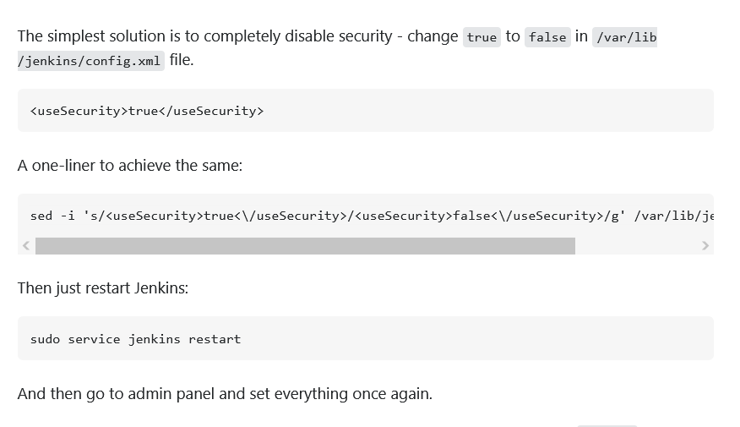

For more info follow <https://stackoverflow.com/questions/6988849/how-to-reset-jenkins-security-settings-from-the-command-line>

<https://www.serverlab.ca/tutorials/linux/administration-linux/how-to-reset-jenkins-admin-users-password/>

## **Have you worked on commit based job in jenkins? What all configurations you need to do in jenkins and github?**

1. Use poll scm
2. Use git webhooks

<https://stackoverflow.com/questions/30576881/jenkins-build-when-a-change-is-pushed-to-github-option-is-not-working>

<https://learning-continuous-deployment.github.io/jenkins/github/2015/04/17/github-jenkins/>

## **What is the best approach to run multi jobs with same configurations but different names in jenkins?**

## **How can you copy job which is created in your local jenkins instance to others’ local jenkins instance?**

Use job import plugin

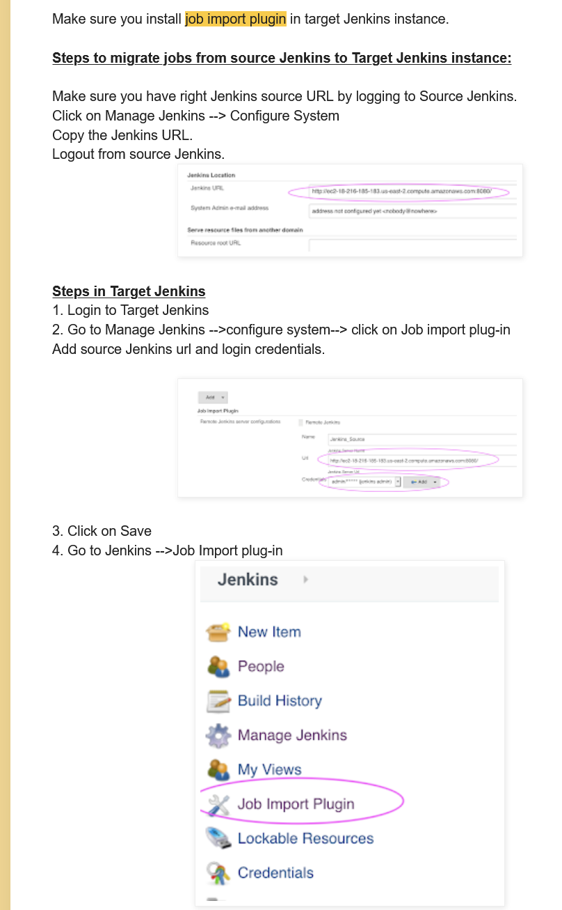

<https://medium.com/@prachimore/migrate-jobs-from-one-jenkins-build-server-to-another-4ea0a29e9e45>

<https://www.coachdevops.com/2020/06/migrate-jenkins-jobs-from-one-server-to.html>

or copy the jobs folder from 1 instance to another using scp

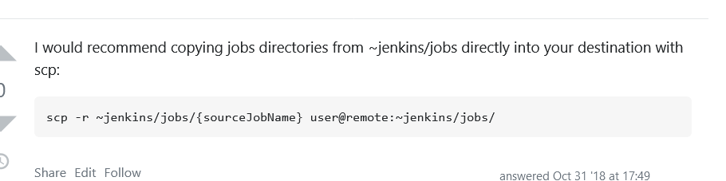

## **Where you use the artifactory plugin? (in reference to pom.xml)**

<https://www.jfrog.com/confluence/display/JFROG/Maven+Repository#MavenRepository-DeployingArtifactsThroughArtifactory>

<https://directdevops.blog/2020/05/17/devops-classroom-series-17-may-2020/>

## **Have you done any automated unit testing or, code review tool?**

We used sonarcube

SonarQube is a Code Quality Assurance tool that collects and analyzes source code, and provides reports for the code quality of your project.

## **How to push and how to push notification to developers, when the build fails?**

<https://www.jenkins.io/blog/2016/07/18/pipeline-notifications/>

<https://stackoverflow.com/questions/42577953/how-to-send-notifications-in-jenkins-pipeline-when-build-recovers>

<https://medium.com/@arun.dev/get-email-notification-for-jenkins-build-failure-and-success-d59154dc639a>

## **Did you use or integrate any tracking system in your pipeline system?What kind of documentation you maiintain as part of this?**

<https://www.jenkins.io/doc/book/system-administration/monitoring/>

## **How you invoke the ansible to do the deployment in jenkins?**

Make sure that ansible is installed on server which Jenkins is managing, and enter the same ansible commands in Jenkins job descriptions

## **What is cloudbees version of jenkins? Have you worked on that?**

## **What is meant by Promoting the build?**

Basically it means if 1 build completes , then the artifacts are passed down to another downstream job for further use .

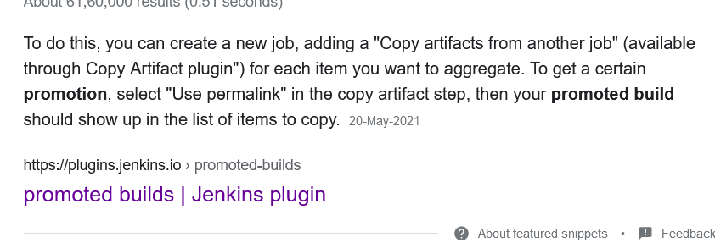

This plugin allows you to distinguish good builds from bad builds by introducing the notion of 'promotion'.Put simply, a promoted build is a successful build that passed additional criteria (such as more comprehensive tests that are set up as downstream jobs.) The typical situation in which you use promotion is where you have multiple 'test' jobs hooked up as downstream jobs of a 'build' job. You'll then configure the build job so that the build gets promoted when all the test jobs passed successfully. This allows you to keep the build job run fast (so that developers get faster feedback when a

build fails), and you can still distinguish builds that are good from builds that compiled but had runtime problems.

<https://plugins.jenkins.io/promoted-builds/>

<https://stackoverflow.com/questions/15126059/how-to-promote-a-specific-build-number-from-another-job-in-jenkins>

## **How to change the jenkins port number and home directory?**

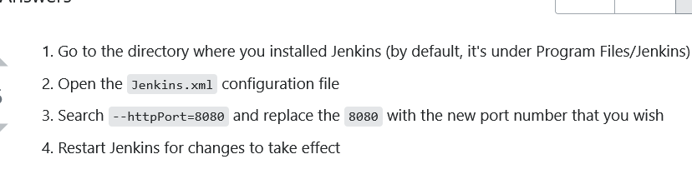

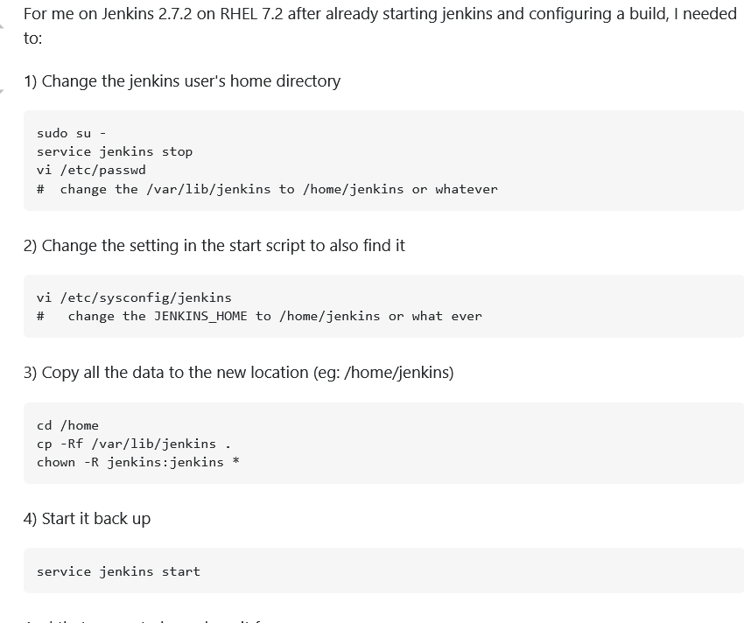

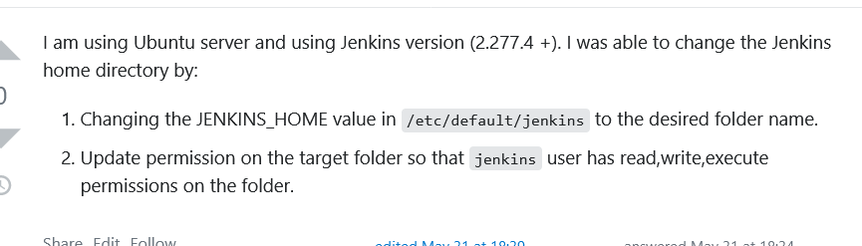

<https://dzone.com/articles/jenkins-02-changing-home-directory>

<https://stackoverflow.com/questions/13192322/how-to-change-home-directory-of-jenkins/39260807>

## **What kind of technology stacks or servers is there in your current project?**

## **LTS version of jenkins meaning**

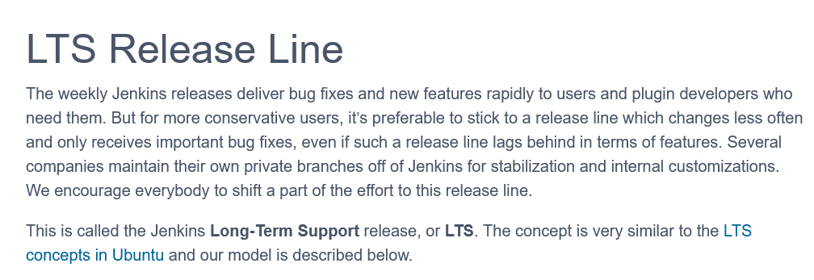

<https://www.jenkins.io/download/lts/>

1. Explain the basic structure of jenkins directory

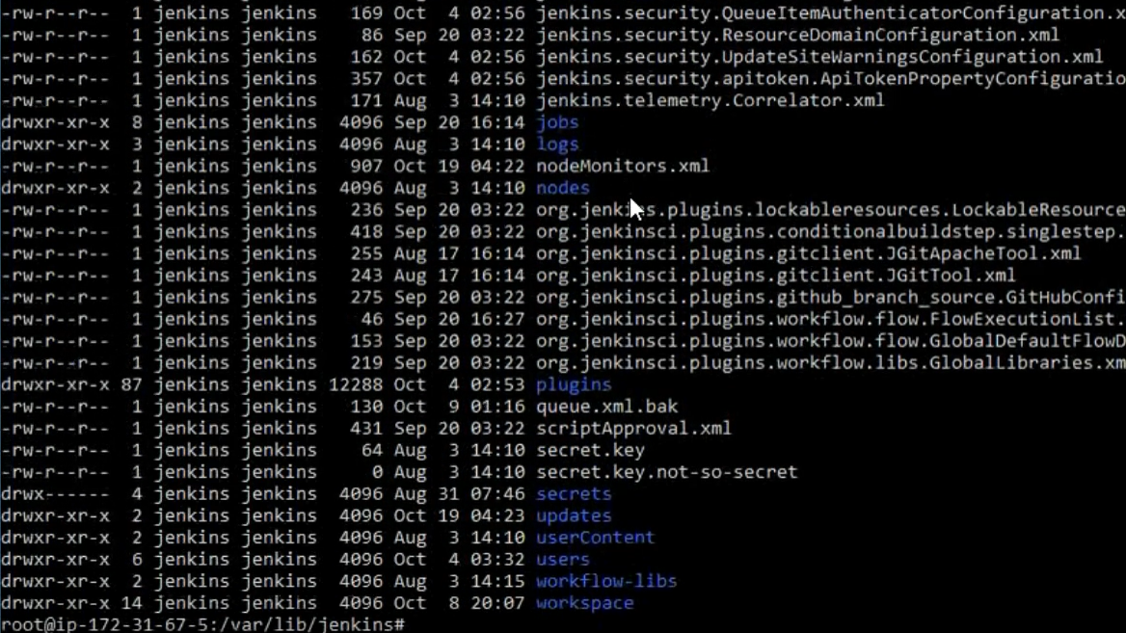

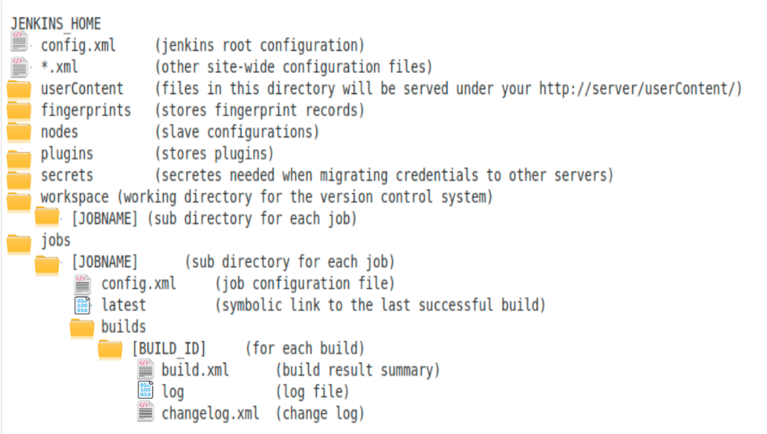

## **Workflow lib in Jenkins**

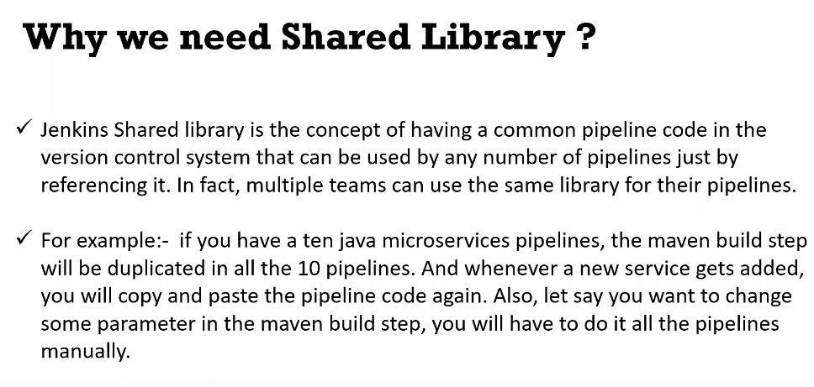

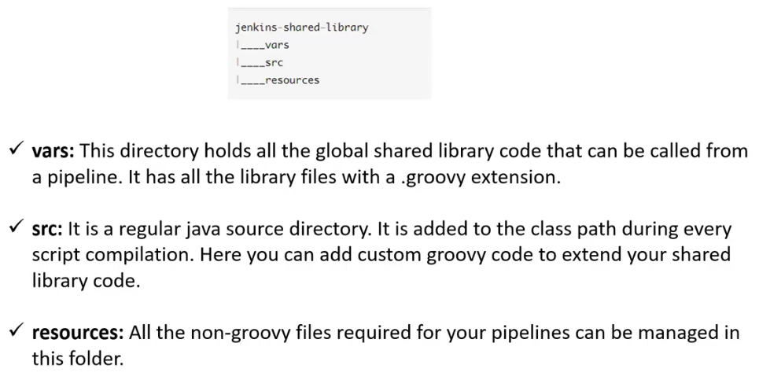

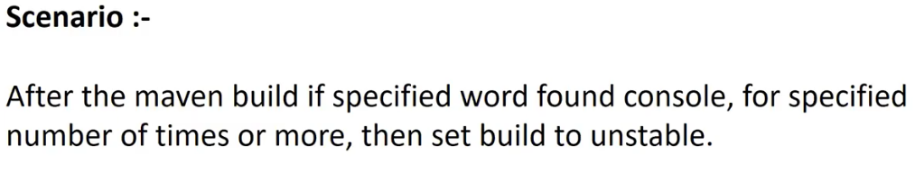

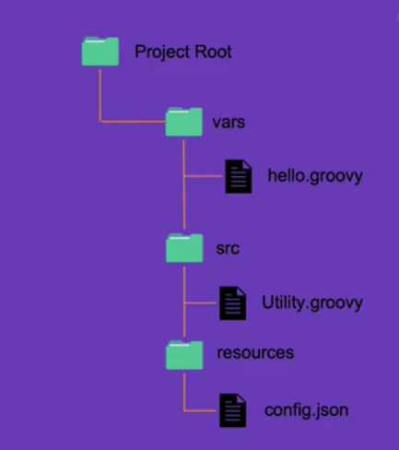

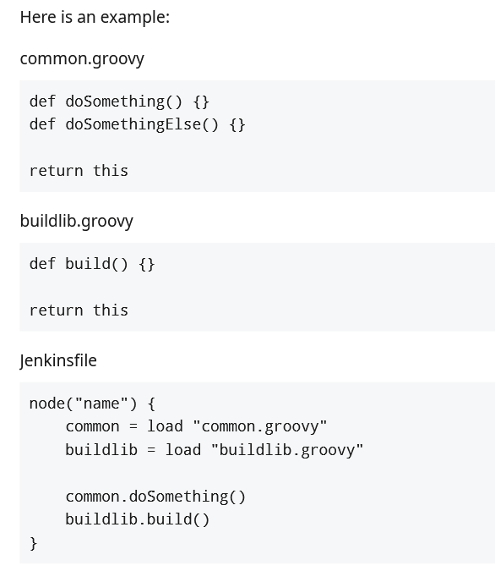

<https://www.jenkins.io/doc/book/pipeline/shared-libraries/>

<https://www.youtube.com/watch?v=bGDyGH13k1g>

## **You have 2 folders fold1 and fld2.Is it possible to restrict some users to fold1 and some to fold2 in jenkins?**

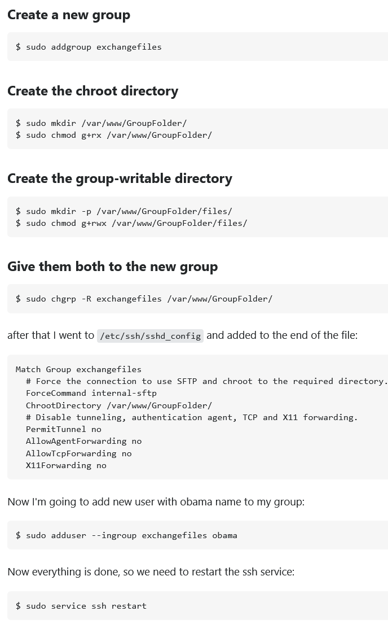

## **From how many servers your application/product is being deployed right now? (may be 400-500). Are the builds manual or auto( environment depending)?**

## **Do you know how to generate webhooks?**

<https://www.blazemeter.com/blog/how-to-integrate-your-github-repository-to-your-jenkins-project>

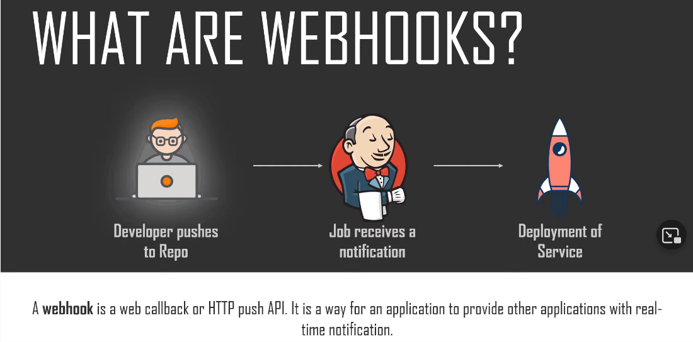

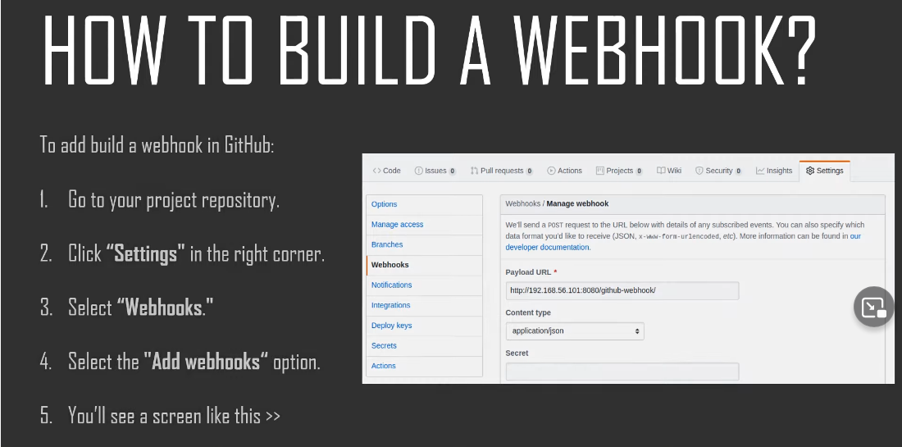

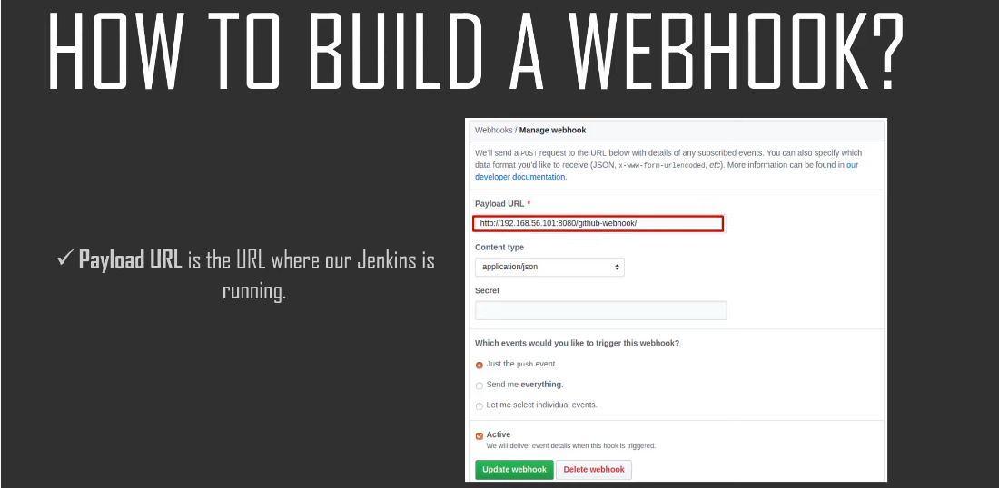

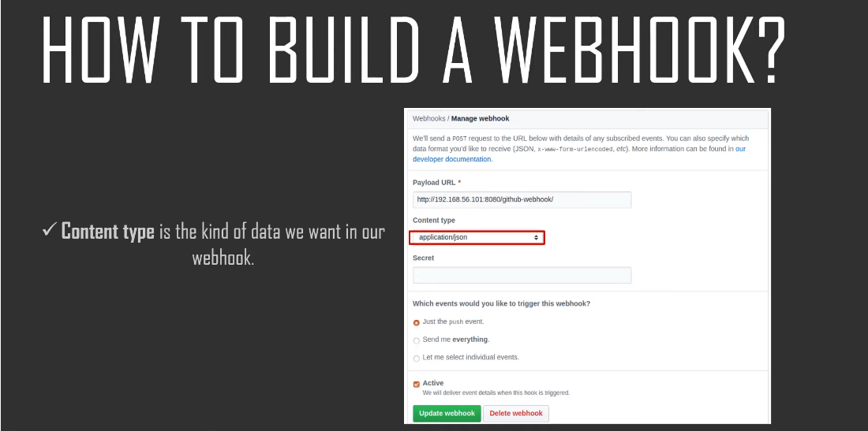

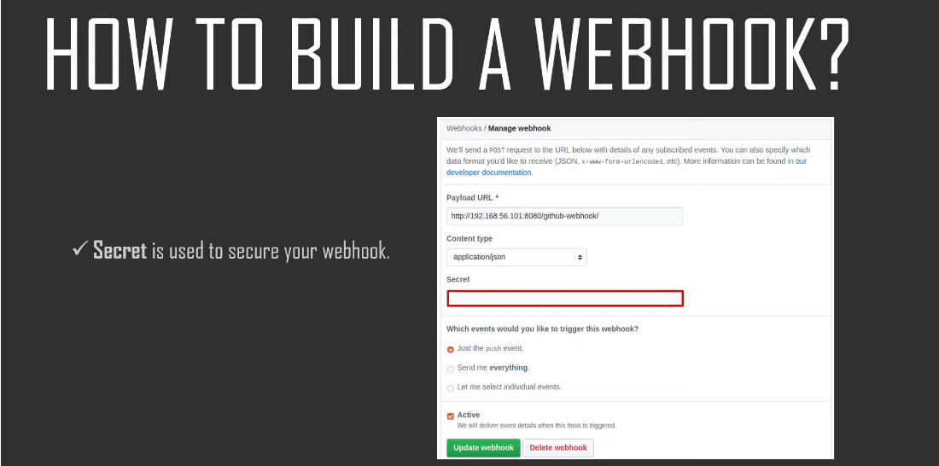

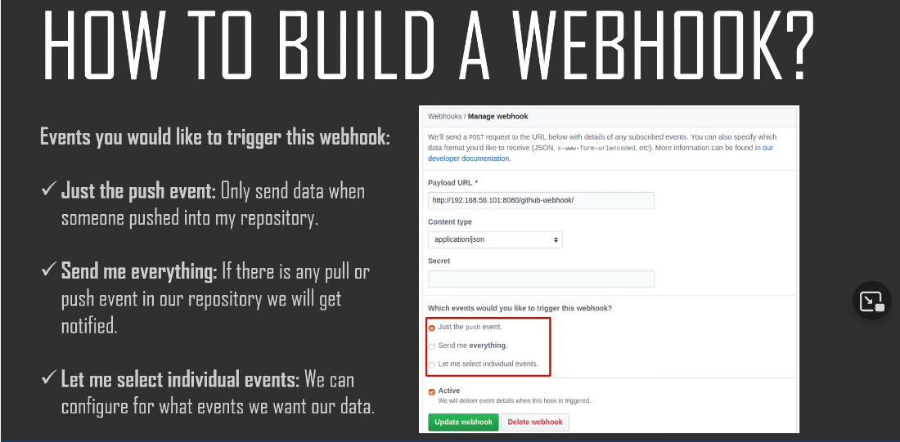

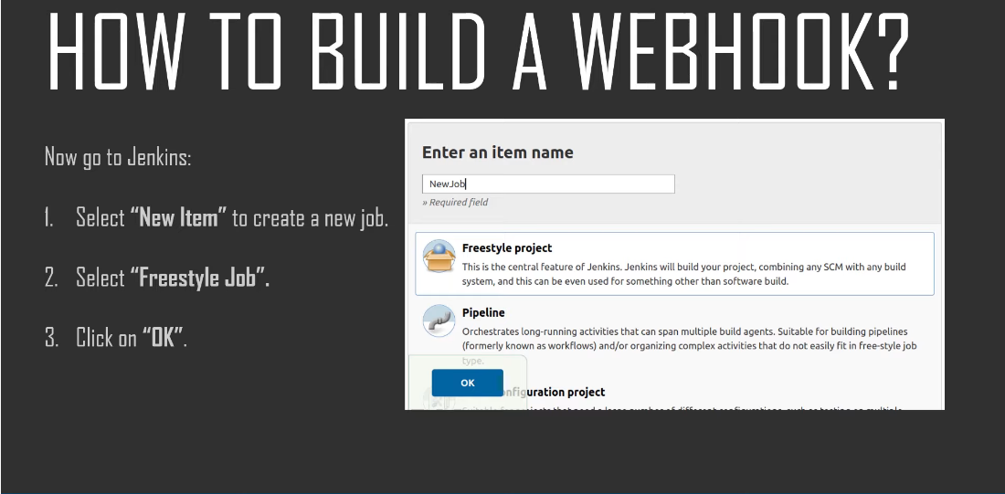

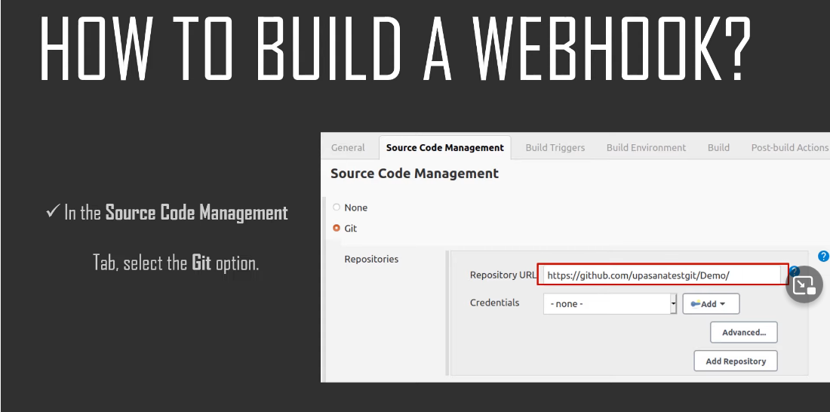

## **How do you mail in jenkins?( plugin or what**

<https://directdevops.blog/2020/05/15/devops-classroom-series-15-may-2020/>

<https://www.edureka.co/blog/email-notification-in-jenkins/>

<https://medium.com/@gustavo.guss/jenkins-sending-email-on-post-build-938b236545d2>

## **How can I access the jenkins specific env. Variables in my workspace variables in any jenkins scipts or, execute shell?**

<https://www.youtube.com/watch?v=KwQDxwZRZiE>

<https://www.jenkins.io/doc/book/pipeline/jenkinsfile/#using-environment-variables>

<https://www.jenkins.io/doc/pipeline/tour/environment/>

to set environment variables , see the above youtube video or go to my github

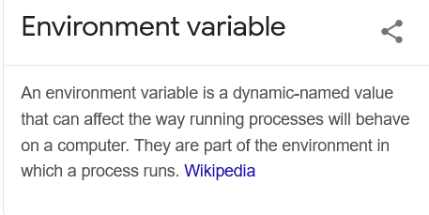

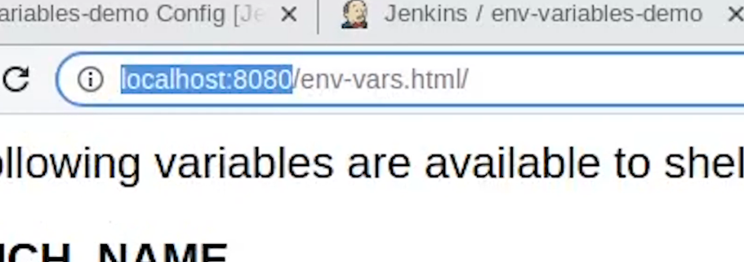

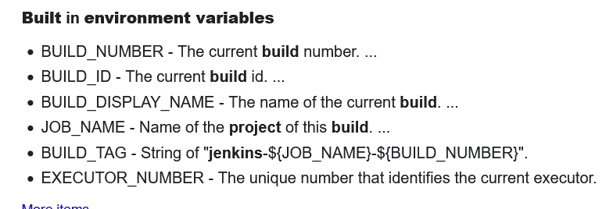

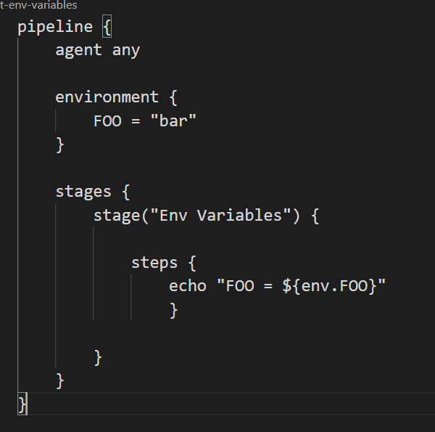

## **How to integrate jenkins and git ( explain the pipeline and webhooks too)? What for independent jobs? Do we require pipeline here?**

1. 1st do it manually through UI

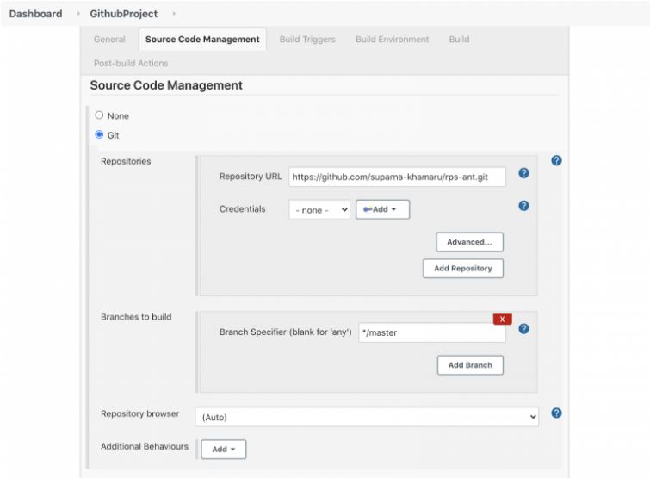

1. Use pipeline

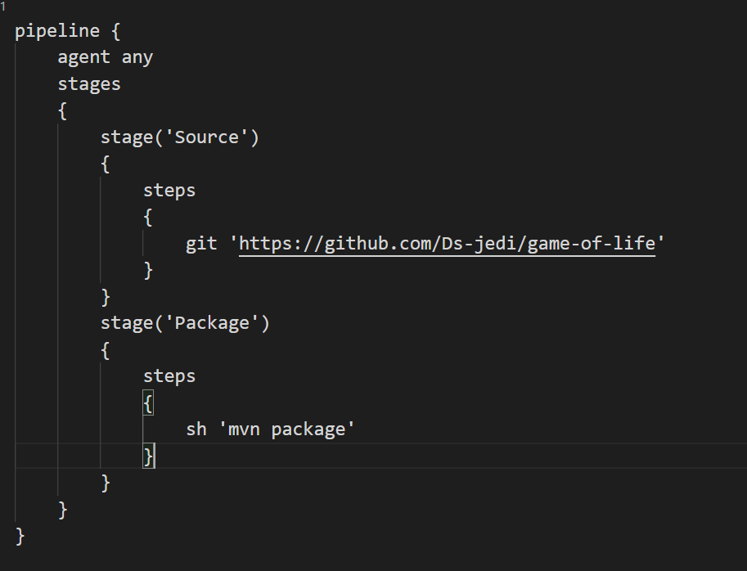

<https://www.lambdatest.com/blog/how-to-setup-continuous-integration-with-git-jenkins/>

<https://www.blazemeter.com/blog/how-to-integrate-your-github-repository-to-your-jenkins-project>

## **Tell me about your integration tests.**

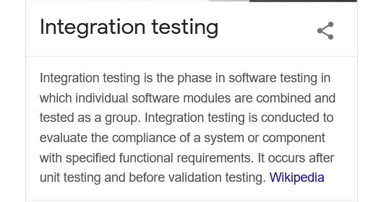

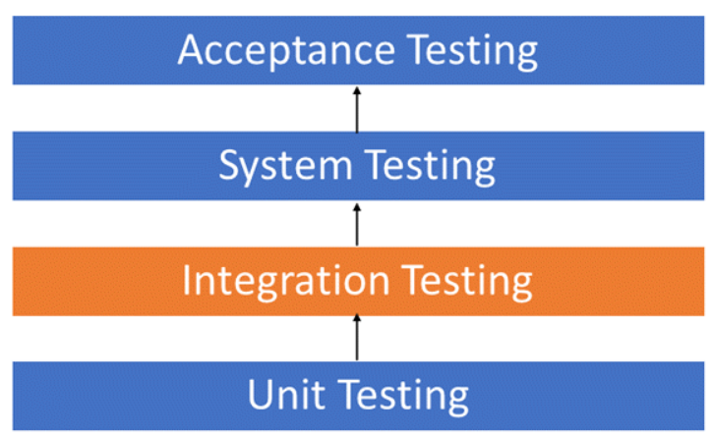

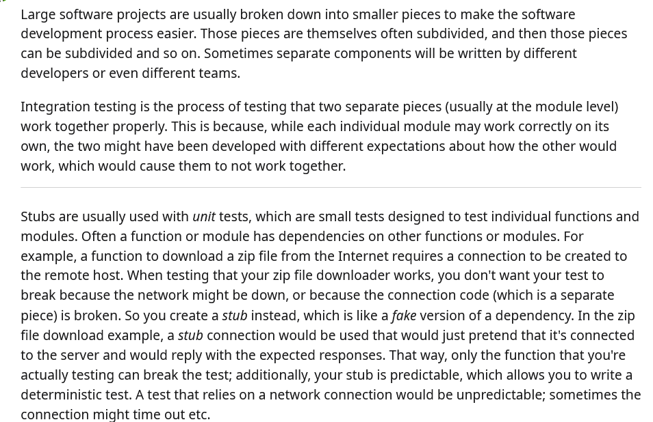

## **Can we use jenkins to run successful integration test cases?**

## **How to run test cases using jenkins?( like selenium tests)**

## **What to do when you scale up no. of jobs in jenkins even you have 1000 nos of jobs ? ( increasing slaves)**

Just add more slaves

## **Is there any notification in jenkins master when one of its slaves goes down?**

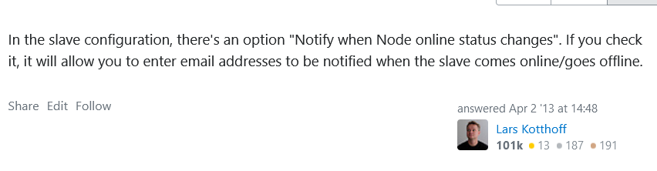

## **Is there any facility to spine up a new slave when one goes down?**

## **How to monitor the activities of other users in jenkins as a jenkins administrator? ( Job config history plugin)**

Every job created in Jenkins has its own config.xml file.

Config.xml file contains all configurations about the job and its change history

Job config history plugin take these data and shows in a GUI mode

<https://wiki.jenkins.io/display/JENKINS/JobConfigHistory%20Plugin>

<https://plugins.jenkins.io/jobConfigHistory/>

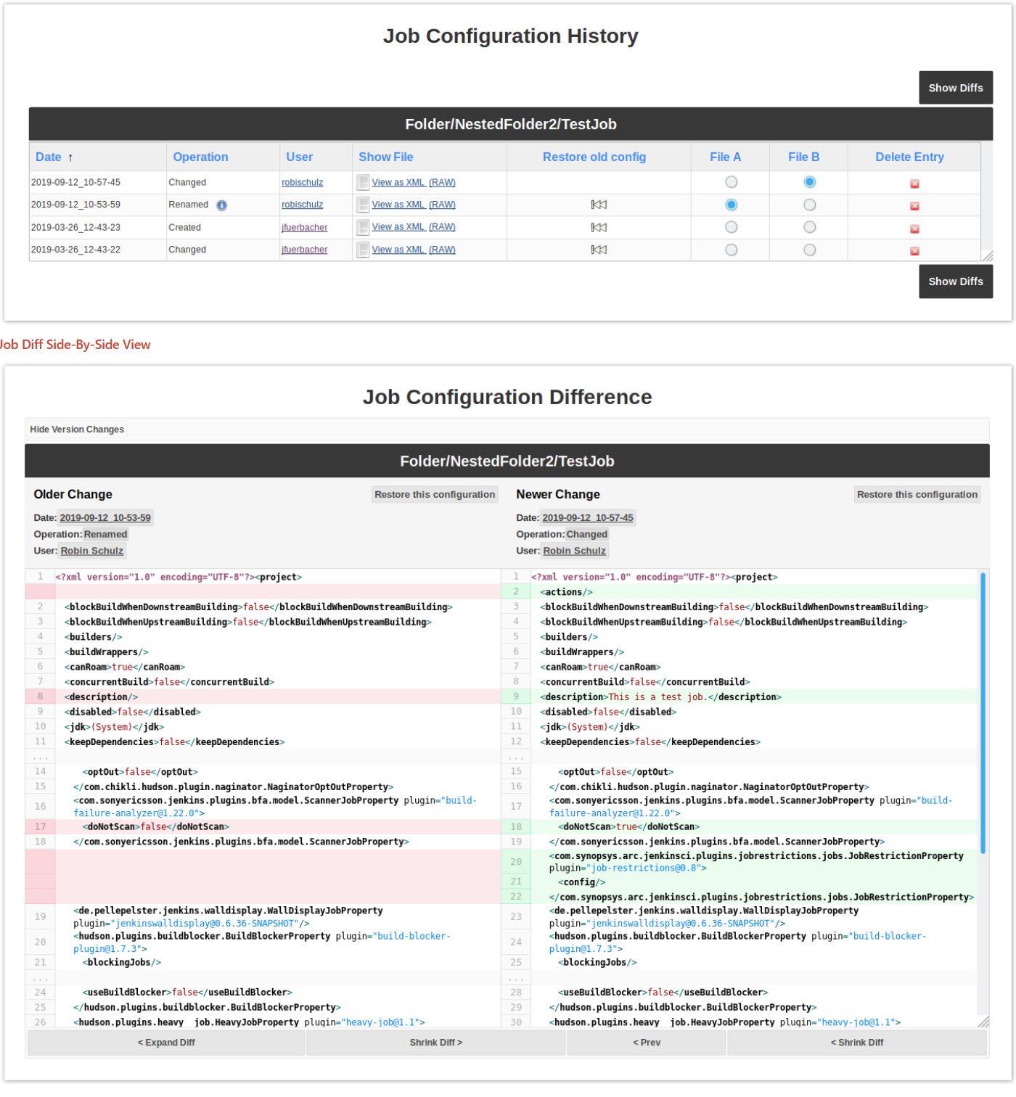

1. How tomcat will deploy the jar/war files after jenkins build job in jenkins in the pipeline? How will you do it?

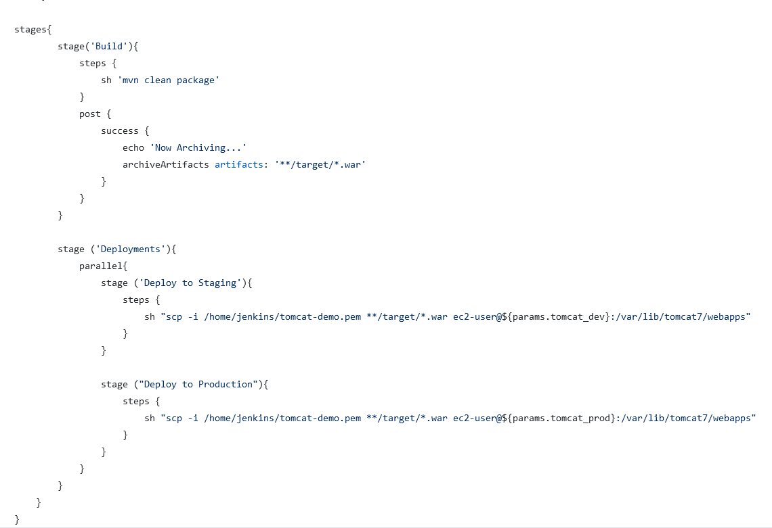

## **Have you worked on Jenknsfile? can we use docker container as a node in Jenkinsfile? Who will handle docker container creation and deletion? If i am building a maven project always docker container is fresh instance it will try to download dependency from repository, what measures you will take to reduce build time?**

<https://devopscube.com/docker-containers-as-build-slaves-jenkins/>

## **you want to create 50 freestyle jobs with same configurations, but only change is job name. how would you achieve the same?**

## **How can you copy job from your local jenkins instance to other local jenkins instance?**

Use job import plugin , follow question 7

## **How to Downgrade plugins in Jenkins?**

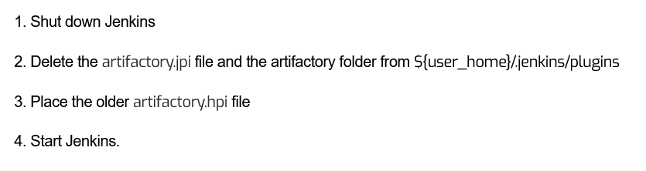

## **Have you worked on Jenkinsfile? Can we use different nodes for each stage**

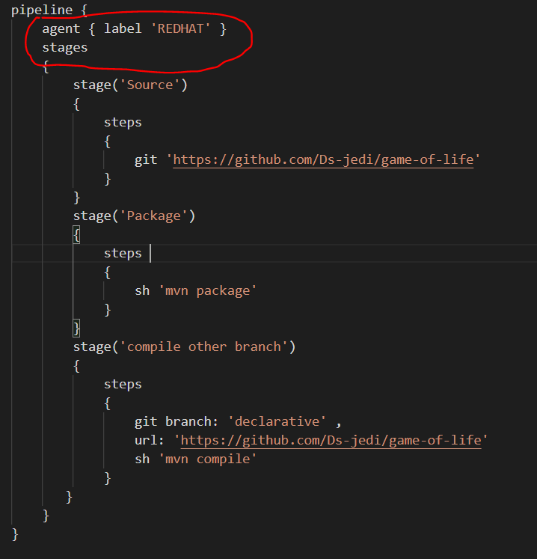

To run ur stages on specific node , change ur node label in agent section of pipeline

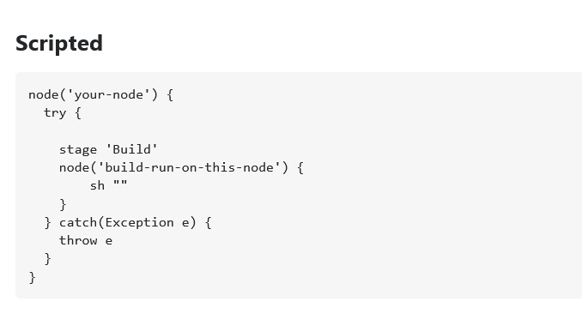

<https://stackoverflow.com/questions/42652533/limiting-jenkins-pipeline-to-running-only-on-specific-nodes/55180237>

<https://serverfault.com/questions/359793/tell-jenkins-to-run-a-specific-project-on-a-particular-slave-node>

## **Can you list few ways by which we can trigger our build in Jenkins? What is the difference between Build Periodically and Poll SCM?**

You can use build triggers option in manage jobs section , poll scm, build periodically and git webhooks also .

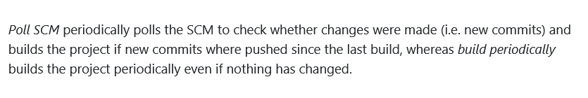

## **How to set Jenkins build to fail based specific word in console output ?**

There are 2 steps –

1. Use post build task or textfinder plugin

<https://plugins.jenkins.io/postbuild-task/>

<https://plugins.jenkins.io/text-finder/>

1. Write a Jenkins pipeline script in which , a console logs are getting saved to a log file

usingTee command , and then grep to find that particular string exits or not.If it exits

, then fail the build

<https://stackoverflow.com/questions/13802256/jenkins-plugin-to-fail-build-based-on-console-output/13803510>

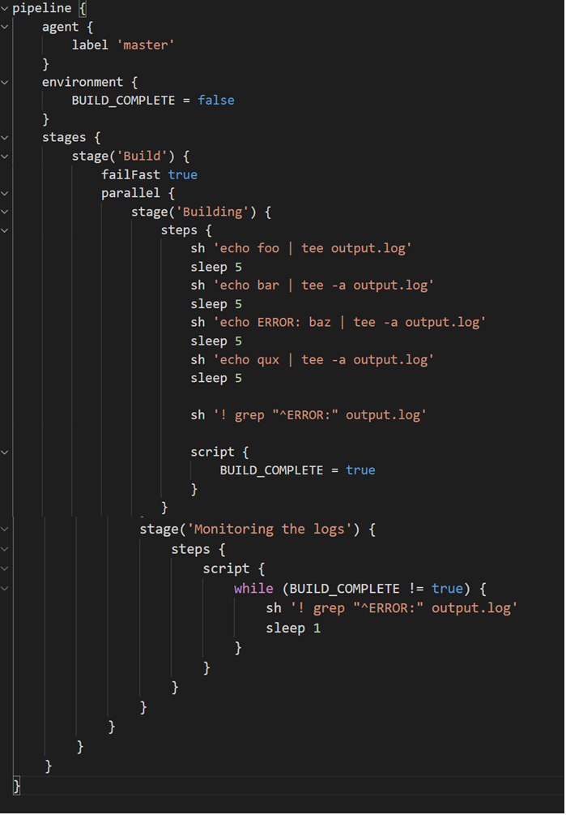

## **What are active and reactive parameters (Dynamic parameterization) in Jenkins ?**

<https://www.youtube.com/watch?v=bYi4IXep2mk>

Suppose u pass 3 parameters qa,prod,dev . If u select qa , then it will ask u to select qa1,qa2,qa3 etc.

If u select dev , then it will ask u to select dev1,dev2,dev3.

Basically ur CHOICE 1 will determine what ur CHOICE 2 is . Active parameter is choice 1 . and reactive parameters are choice 2 which are determined by what u selected in choice 1

<https://stackoverflow.com/questions/43410204/active-choices-reactive-reference-parameter-in-jenkins-pipeline>

<https://plugins.jenkins.io/uno-choice/>

## **How to customize the build number display to something else in Jenkins job page?**

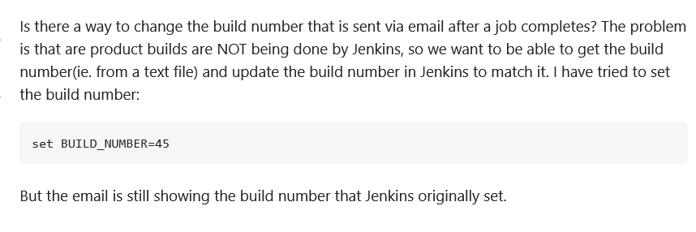

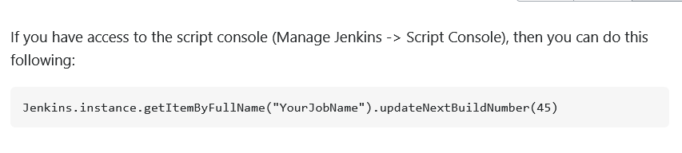

U can change the build number above by setiing any value

## **What is shared library in Jenkins ?**

Follow ques 19 , workflow directory in jenkins